7.02 Transformations and congruence
Year 8 Maths · Worksheet · Level 1 · Warm-up
Name: ____________________ Date: ______________
This worksheet practises recognising congruent figures, making them with translations, reflections and rotations, and using matching sides and angles to find unknowns. Tip: congruent figures are exact copies. If you traced one, the tracing would fit exactly on top of the other, even if you had to flip it over.

 Understanding
- Is each pair of shapes congruent? Write Yes or No.
- 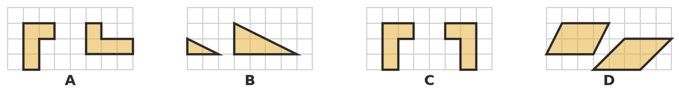
- A ______________ B ______________ C ______________ D ______________
- Complete each sentence.
  - Congruent figures have exactly the same ______________ and the same ______________
  - The symbol ≅ means ______________
  - Three transformations that always make a congruent image are ______________, ______________ and ______________
- Shape A has been moved to B, C and D. Name the transformation used each time: translation, reflection or rotation.
- 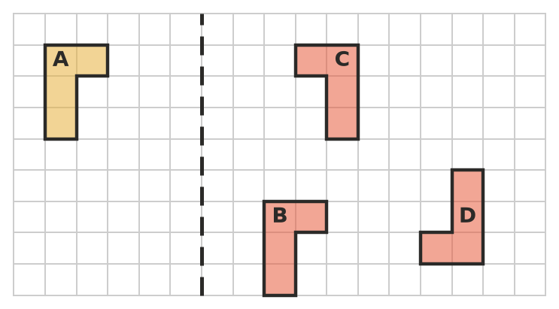
  - A to B: ______________
  - A to C: ______________
  - A to D: ______________

 Fluency
- Translate triangle ABC 4 units right and 2 units down. Label the image A′B′C′.
- 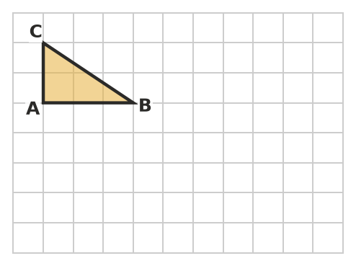
- Is triangle A′B′C′ congruent to triangle ABC? Explain. ______________
- Reflect the shape in the dashed mirror line.
- 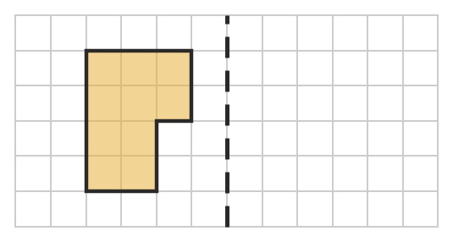
- Triangle ABC is congruent to triangle DEF. Point A matches D, B matches E and C matches F.
- 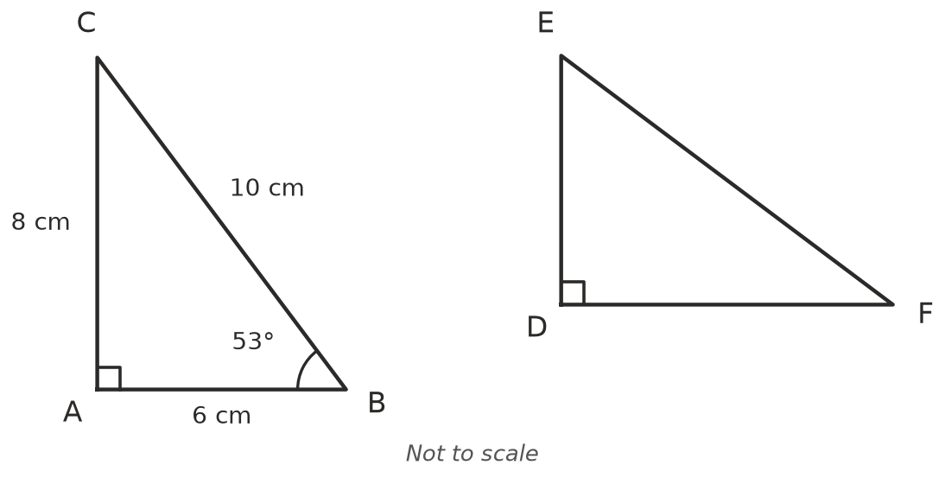
  - DE = ______________ b) EF = ______________ c) DF = ______________
  - ∠E = ______________ e) ∠F = ______________
- Triangle PQR ≅ triangle XYZ. The vertices are written in matching order. Complete the table.
In triangle PQR | P | Q | R | side PQ | side QR | ∠R
Matches in triangle XYZ

- Quadrilateral ABCD ≅ quadrilateral PQRS.
- 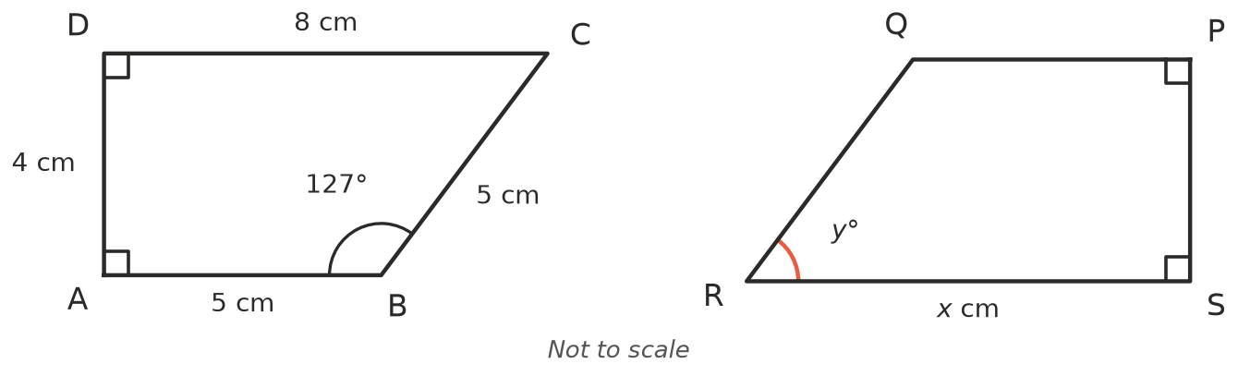
  - Find $x$. ______________
  - Find $y$. Hint: the angles of a quadrilateral add to 360°. ______________
  - How long is PQ? ______________

 Reasoning
- Explain why a shape and an enlargement of it (twice as big) are not congruent.

- Sam says, “Any two squares are congruent.” Is he right? Explain.

 Problem solving
- Rotate triangle ABC 180° about the origin. Label the image A′B′C′.
- 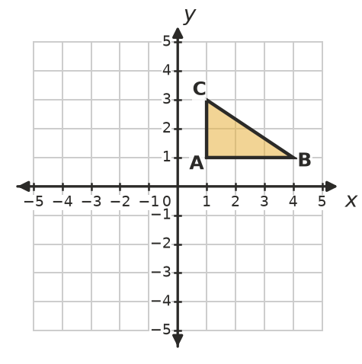
  - Write the coordinates of A′, B′ and C′. ______________
  - How long is A′B′? How do you know without measuring? ______________
- Ruby cuts a rectangle along one of its diagonals to make two triangles.
  - Are the two triangles congruent? ______________
  - Which transformation moves one triangle exactly onto the other? ______________

