7.01 Angles and triangles
Year 8 Maths · A5 question sheet · Level 3 · Challenge
This worksheet practises angle reasoning in triangles with algebra, parallel lines and isosceles triangles, and proving angle facts. Tip: in a multi-step problem, mark each angle on a copy of the diagram in your book as you find it, and give a reason for every step.

 Understanding
- This diagram proves that the angles of a triangle add to 180°. The line DE passes through A and is parallel to BC.
- 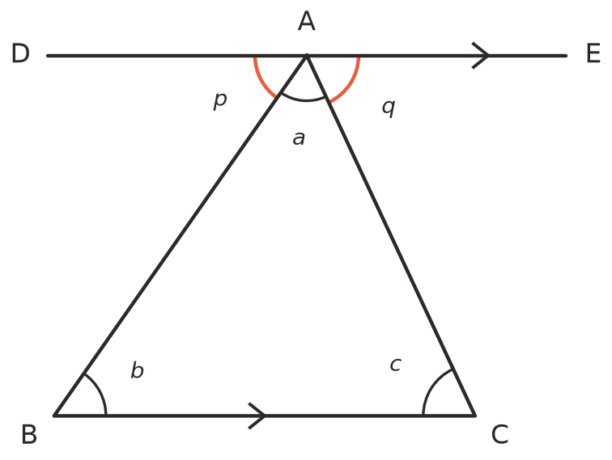
  - $p=b$ because
  - $q=c$ because
  - $p+a+q$ = 180° because
  - So $a+b+c$ = ______________ because
- Two sides of a triangle are 5 cm and 9 cm. The third side is $x$ cm.
  - Write the range of possible values of $x$ as an inequality.
  - The triangle is isosceles. What could $x$ be?
  - Could the triangle have a perimeter of 28 cm? Explain.

 Fluency
- Write an equation and solve it to find $x$. Then write the size of every interior angle.
- 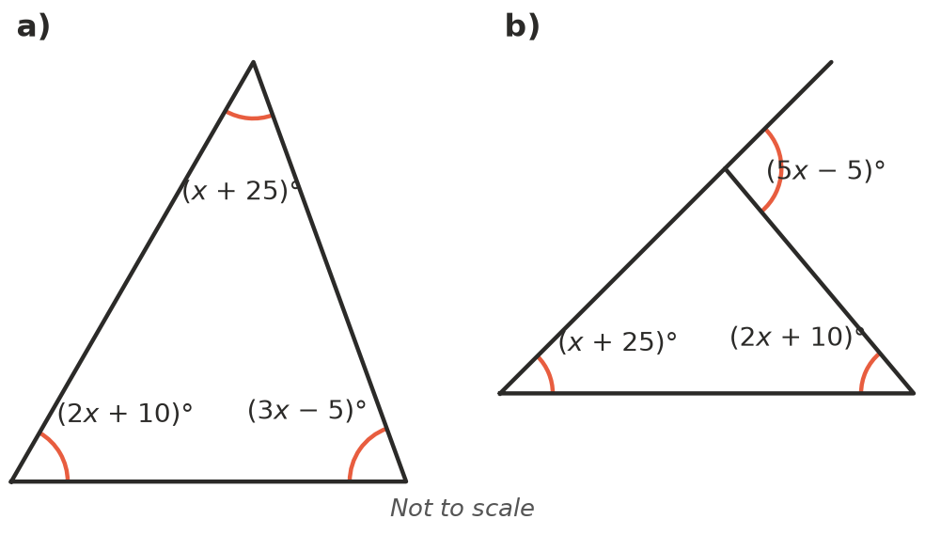
  - $x$ = ______________ Angles:
- 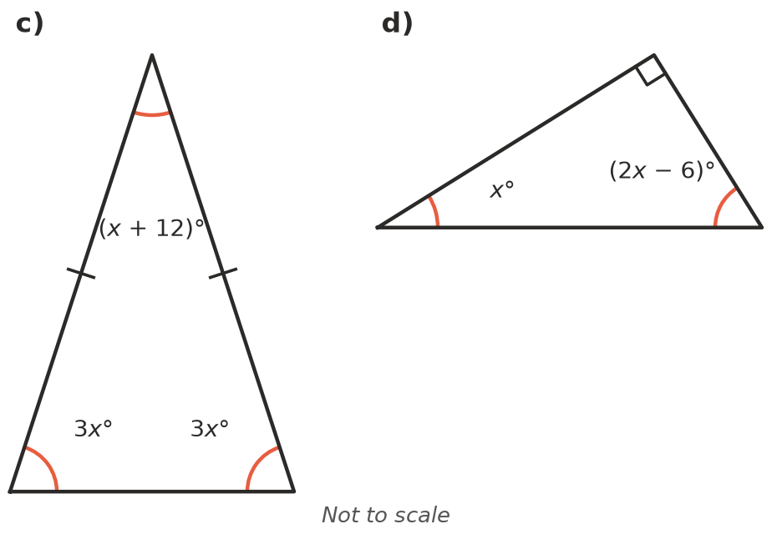
  - $x$ = ______________ Angles:
  - $x$ = ______________ Angles:
  - $x$ = ______________ Angles:
- The two lines with arrows are parallel. Find $x$, giving a reason for each step.
- 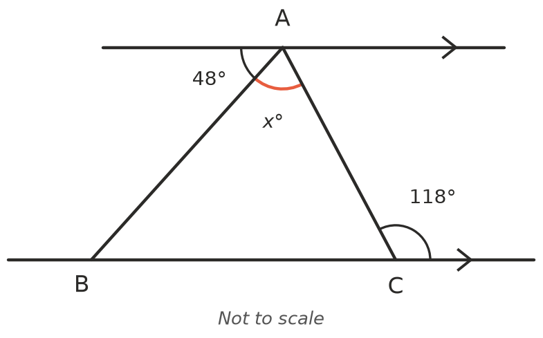
- $x$ =
- Find $x$, the size of ∠BDC. Hint: imagine the line BC. First find ∠ABC + ∠ACB, then ∠DBC + ∠DCB.
- 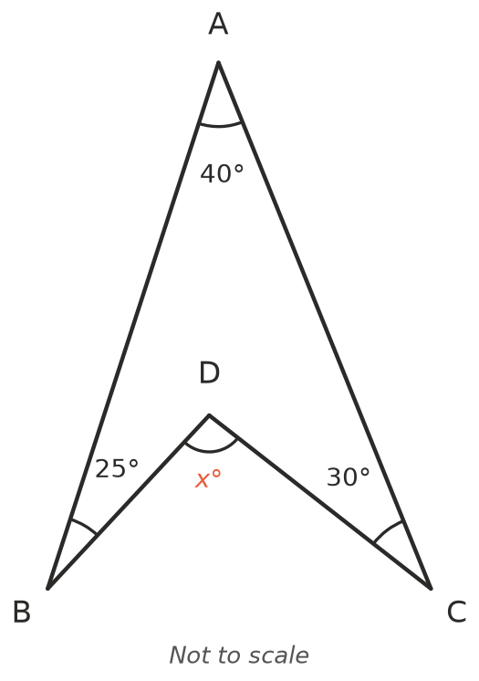
- $x$ =

 Reasoning
- In triangle ABC, ∠A = 36° and D is a point on AC so that AD = BD = BC.
- 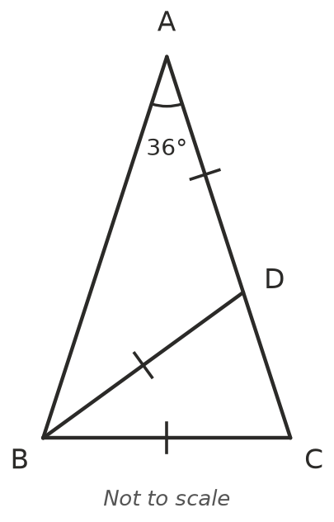
  - Find ∠ABD. Give a reason.
  - Find ∠BDC. Give a reason.
  - Find ∠C and ∠DBC.
  - Find ∠ABC. What does this tell you about the sides AB and AC?
- A triangle has one exterior angle at each corner. Prove that the three exterior angles add to 360°. Hint: call the interior angles $a$, $b$ and $c$.
- Explain why every triangle has at least two acute angles.
- Jess measures three sticks as 4.2 cm, 5.9 cm and 10.1 cm and says they will make a very thin triangle. Explain why she is wrong.

 Problem solving
- An isosceles triangle has a perimeter of 30 cm, and every side is a whole number of centimetres. List all the possible triangles. (Hint: there are more than five.)
- The angles of a triangle are in the ratio 2 : 3 : 5. Find the angles and name the triangle by its angles and by its sides.
- In an isosceles triangle, the exterior angle at the top is 4 times the interior angle at the top. Find all three interior angles.
- The five points of a star have the angles shown. Find $x$. Then explain why the five angles of any star like this add to 180°. Hint: use the exterior angle fact on two of the small triangles.
- 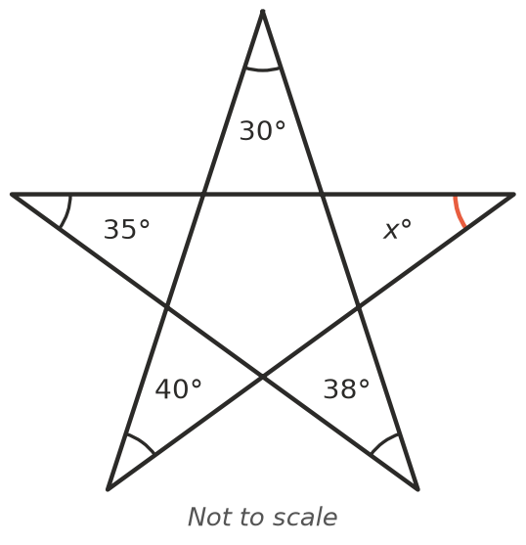
- $x$ =

