7.01 Angles and triangles
Year 8 Maths · A5 question sheet · Level 2 · Core
This worksheet practises finding unknown angles in triangles, using exterior angles, isosceles triangles and parallel lines, and checking which side lengths can make a triangle. Tip: write the angle fact you use beside each step, for example “angle sum of a triangle” or “exterior angle of a triangle”.

 Understanding
- In the diagram, side QR has been extended to S.
- 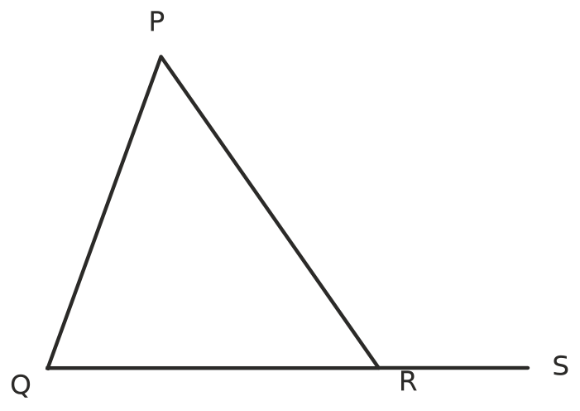
  - Name the exterior angle at R, using three letters.
  - Which two interior angles are opposite this exterior angle?
  - Complete the rule: ∠PRS = ______________ +
- Could these side lengths make a triangle? Write Yes or No and show the check.
Side lengths | Check
6 cm, 8 cm, 13 cm
5 cm, 7 cm, 12 cm
9 cm, 9 cm, 17 cm
4 cm, 10 cm, 5 cm
2.5 cm, 3.5 cm, 5 cm

- Is each triangle possible? Write Yes or No. If it is impossible, give a reason.
Triangle | Possible?
a right-angled isosceles triangle
a triangle with two obtuse angles
an equilateral triangle with a 70° angle
an obtuse-angled isosceles triangle

 Fluency
- Find the value of $x$ in each triangle.
- 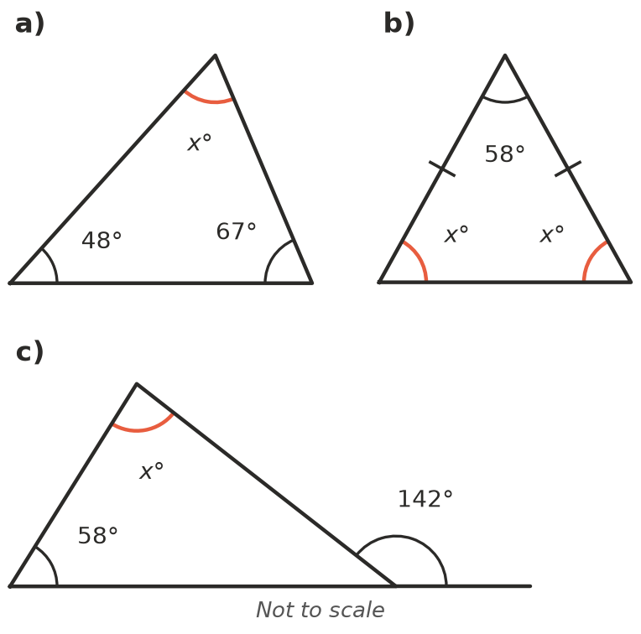
- 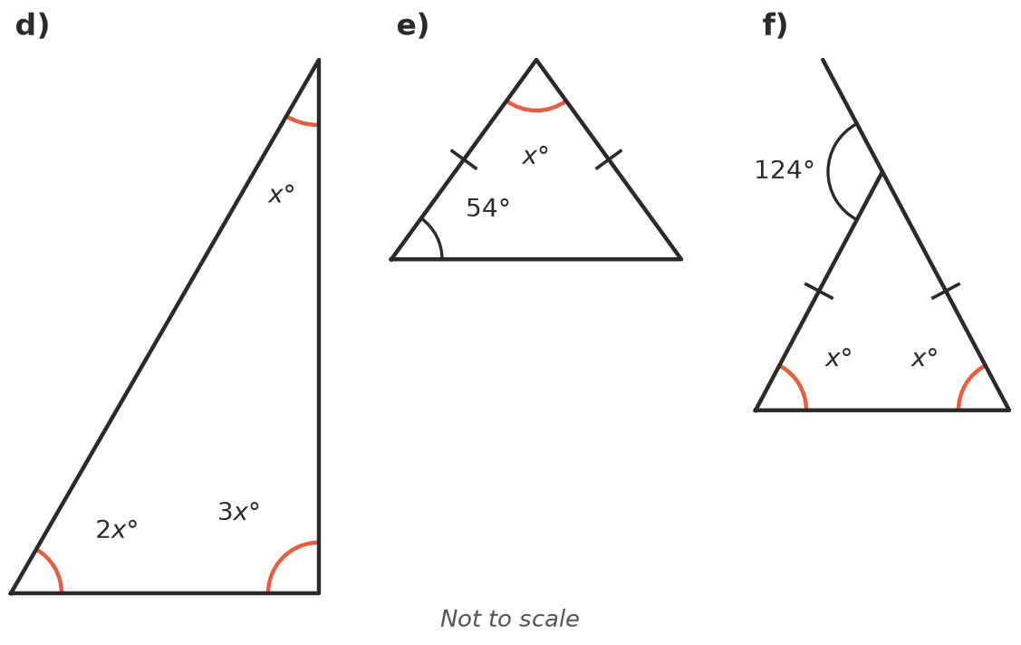
  - $x$ = ______________ b) $x$ = ______________ c) $x$ =
  - $x$ = ______________ e) $x$ = ______________ f) $x$ =
- The line through C is parallel to AB. Find $a$, $b$ and $c$. Give a reason for each.
- 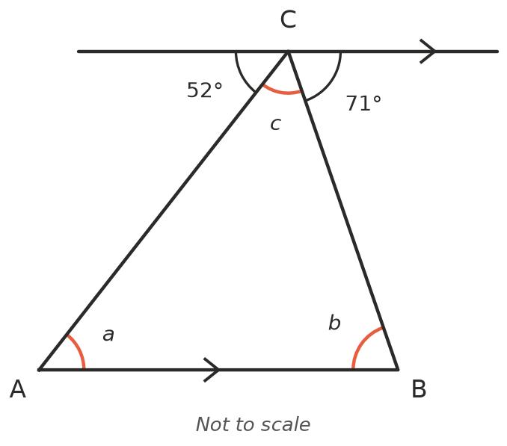
  - $a$ = ______________ because
  - $b$ = ______________ because
  - $c$ = ______________ because
- Write an equation and solve it to find $x$. Then write the size of every angle in the triangle.
- 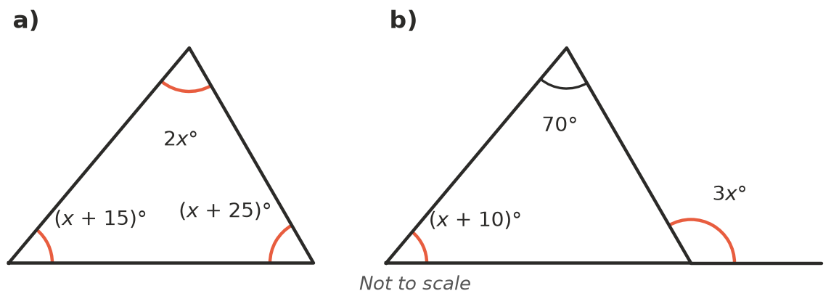
  - $x$ = ______________ Angles:
  - $x$ = ______________ Angles:
- Find $x$. Hint: the two straight lines cross to make vertically opposite angles.
- 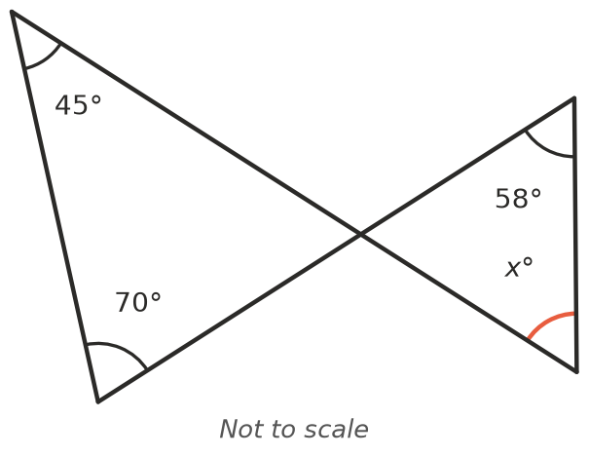
- $x$ =

 Reasoning
- Complete this explanation of why an exterior angle equals the two opposite interior angles added together. Triangle ABC has side BC extended to D.
  - ∠ACD + ∠ACB = 180° because
  - ∠A + ∠B + ∠ACB = 180° because
  - So ∠ACD = ______________ +
- One angle of an isosceles triangle is 40°. Find the two different sets of angles the triangle could have. Then explain why there is only one possible set when one angle is 100°.
- Kai says that the exterior angle of a triangle is always obtuse. Is he right? Explain, using an example.

 Problem solving
- A roof truss is an isosceles triangle with a vertical post from the top to the middle of the base. The angle at the top of the truss is 116°.
- 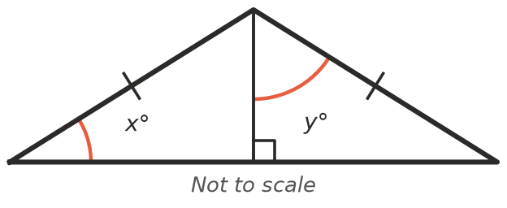
  - Find $x$.
  - Find $y$.
- Two sides of a triangle are 7 cm and 11 cm. The third side is a whole number of centimetres.
  - What is the shortest the third side could be?
  - What is the longest the third side could be?
  - How many different lengths are possible?
- In triangle ABC, the point D is on BC, and AD = DC.
- 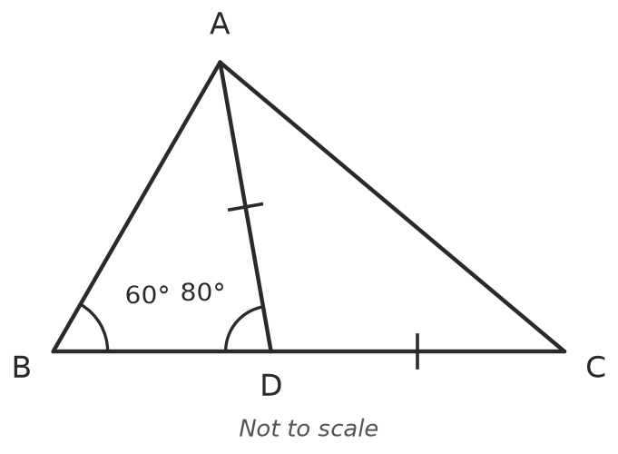
  - Find ∠BAD.
  - Find ∠C.
  - Find ∠BAC, and check that the angles of triangle ABC add to 180°.

