7.01 Angles and triangles
Year 8 Maths · A5 question sheet · Level 1 · Warm-up
This worksheet practises the angle facts for triangles: the three angles add to 180°, an exterior angle equals the two opposite inside angles added together, and the base angles of an isosceles triangle are equal. Tip: tick marks show equal sides. The angles opposite equal sides are equal too.

 Understanding
- Complete each fact.
  - The three angles of a triangle add to
  - Angles on a straight line add to
  - Each angle of an equilateral triangle is
  - An exterior angle of a triangle equals the sum of the two ______________ interior angles.
- Could these be the three angles of a triangle? Write Yes or No, and the angle sum.
Angles | Angle sum
50°, 60°, 70°
90°, 45°, 45°
100°, 50°, 40°
30°, 30°, 110°

- In any triangle, each side must be shorter than the other two sides added together. Could these side lengths make a triangle? Write Yes or No.
  - 3 cm, 4 cm, 5 cm
  - 2 cm, 3 cm, 6 cm
  - 5 cm, 5 cm, 9 cm
  - 4 cm, 4 cm, 8 cm

 Fluency
- Find the value of $x$.
- 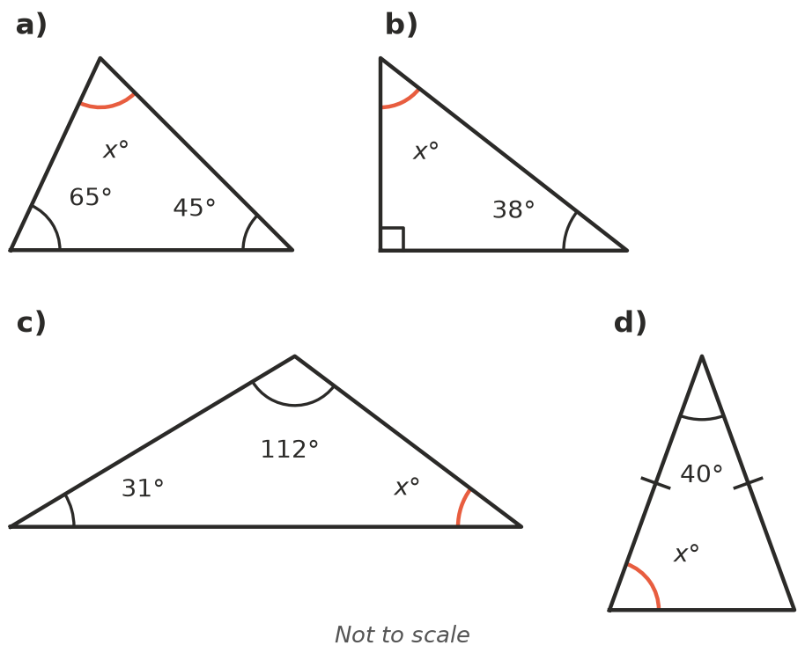
  - $x$ = ______________ b) $x$ = ______________ c) $x$ = ______________ d) $x$ =
- One side of each triangle has been extended to make an exterior angle. Find $x$.
- 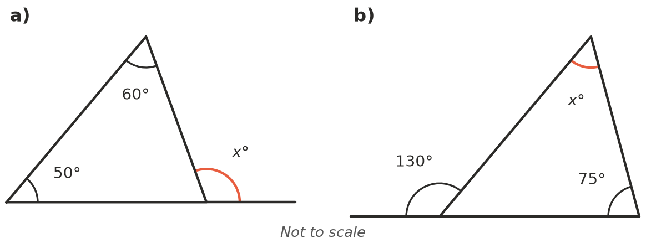
  - $x$ =
  - $x$ =
- Each triangle is isosceles. Find $x$.
- 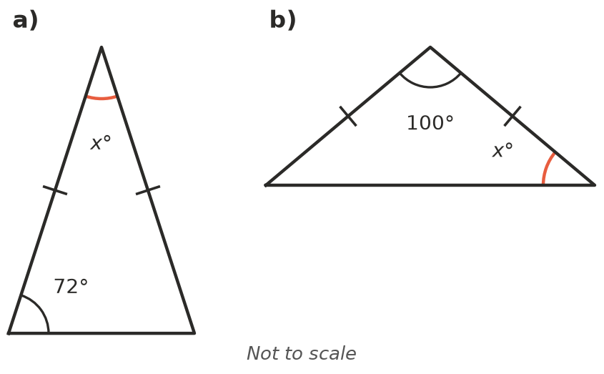
  - $x$ =
  - $x$ =
- Two angles of a triangle are given. Find the third angle.
  - 35° and 85°
  - 90° and 17°
  - 120° and 28°

 Reasoning
- Explain why a triangle cannot have two right angles.
- Mia says she can make a triangle from straws that are 3 cm, 5 cm and 9 cm long. Explain why she cannot.

 Problem solving
- The roof of a shed is an isosceles triangle. The angle at the top is 110°. Find $x$, the angle where the roof meets the wall.
- 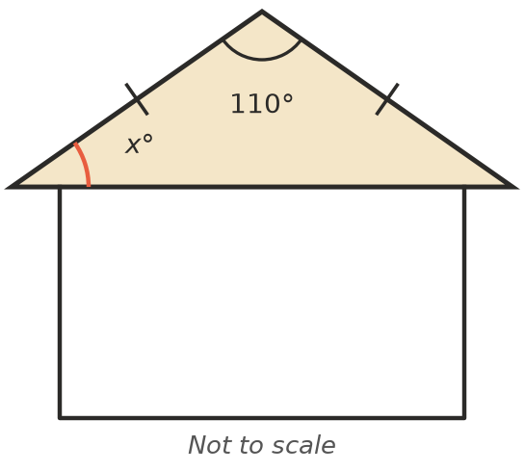
- $x$ =
- Find $x$. Hint: first find the inside angle next to the 140° angle.
- 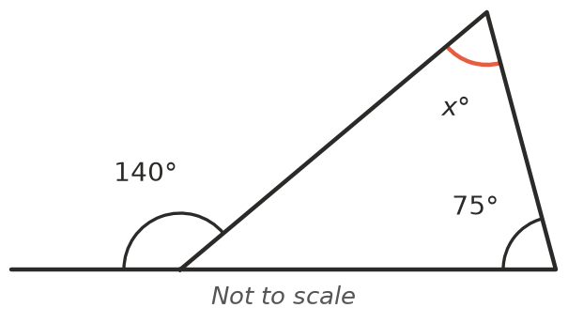
- $x$ =
- The triangle is equilateral. Find the exterior angle $x$.
- 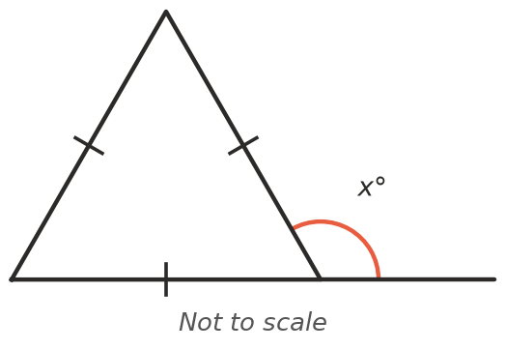
- $x$ =

