5.06 Numeric factors
Year 8 Maths · A5 question sheet · Level 2 · Core
This worksheet practises factorising expressions by taking out the highest common factor (HCF). Tip: an expression is fully factorised when the terms left inside the brackets have no common factor except 1. If the first term is negative, you can take out a negative factor: $−6x−18=−6(x+3)$.

 Understanding
- Find the HCF of each set of terms.
  - $12x$ and 18
  - $20a$ and −15
  - $14m$, $21n$ and 35
  - $24p$ and $36q$
- Use $4(2x−5)$ and $8x−20$ to explain the difference between expanding and factorising.

 Fluency
- Factorise fully.
  - $8x+12$ =
  - $15a−25$ =
  - $18m+27n$ =
  - $42−28k$ =
  - $16x+24y−40$ =
  - $30p−45q+15$ =
  - $36a+48b$ =
- Factorise by taking out a negative factor.
  - $−6x−18$ =
  - $−10a+15$ =
  - $−4m−20n$ =
- The HCF of these terms includes a letter. Factorise fully.
  - $x^{2}+5x$ =
  - $6a^{2}−9a$ =
  - $4mn+10m$ =

 Reasoning
- Leo factorises $9x−12$ as $3(3x−12)$. Expand his answer to show that it is wrong, then give the correct answer.
- Find the missing terms.
  - $□(5a−2)=35a−14$, so □ =
  - $6(□)=24x+30$, so □ =
  - $−3(□)=−12y+21$, so □ =
- Five consecutive whole numbers are $n$, $n+1$, $n+2$, $n+3$ and $n+4$.
  - Write their sum as a simplified expression, then factorise it.
  - Use your answer to explain why the sum of any five consecutive whole numbers is 5 times the middle number.

 Problem solving
- This rectangle has an area of $(6x+15)$ cm² and a width of 3 cm.
- 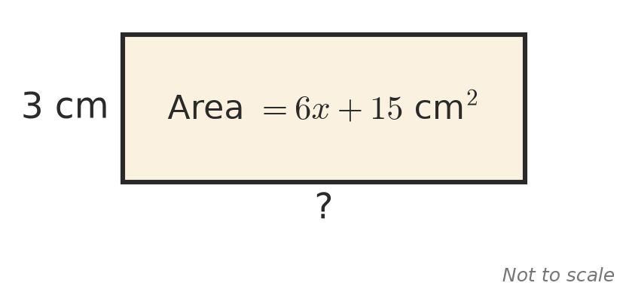
  - Find an expression for its length.
  - Write a simplified expression for its perimeter.
- A bus for a church camp costs $24c+96$ dollars. The cost is shared equally by 24 people. Write an expression for the cost per person.
- Use factorising to work these out without a calculator.
  - 13 × 27 + 13 × 73 =
  - 45 × 17 − 45 × 7 =
- Factorise the top of each fraction, then simplify.
  - $\frac{8x+12}{4}$ =
  - $\frac{15a−10}{5}$ =

