5.06 Numeric factors
Year 8 Maths · A5 question sheet · Level 1 · Warm-up
This worksheet practises factorising: the opposite of expanding. Tip: find the highest common factor (HCF) of the numbers, write it outside the brackets, then divide each term by it. For example, $6x+9=3(2x+3)$. Check by expanding: $3(2x+3)=6x+9$.

 Understanding
- Find the highest common factor (HCF) of each set of numbers.
  - 6 and 10
  - 12 and 18
  - 15 and 25
  - 8, 12 and 20
- Copy and fill in the missing term.
  - $4x+12=4(x+□)$, so □ =
  - $5a−15=5(a−□)$, so □ =
  - $6m+18=□(m+3)$, so □ =
  - $10y+4=2(□+2)$, so □ =

 Fluency
- Factorise.
  - $3x+6$ =
  - $5a+20$ =
  - $7m−14$ =
  - $4y+10$ =
  - $9k−12$ =
  - $8p+8$ =
  - $12−6t$ =
- Factorise.
  - $10x+15y$ =
  - $6a−9b$ =
  - $4m+8n+12$ =

 Reasoning
- Kim factorises $12x+18$ as $2(6x+9)$.
  - Expand her answer to check that it is equal to $12x+18$.
  - Explain why her answer is not fully factorised, and factorise it fully.
- Is $4(3a−5)$ the factorised form of $12a−20$? Expand to show how you know.
- Which is the fully factorised form of $15x+10$?
  - $5(3x+10)$
  - $5(3x+2)$
  - $15(x+10)$
  - $3(5x+2)$

 Problem solving
- This rectangle has an area of $(4x+20)$ cm² and a width of 4 cm.
- 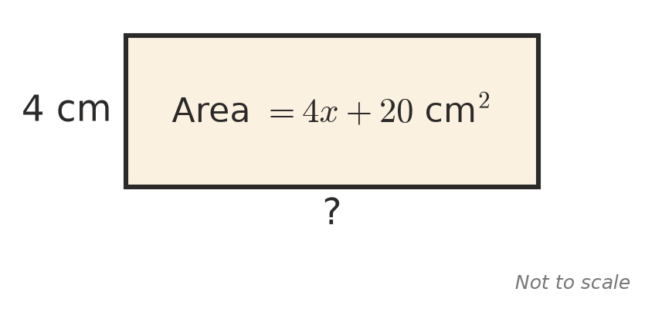
- Find an expression for its length.
- Use factorising to work these out in your head.
  - 7 × 13 + 7 × 7 = 7 × (13 + 7) =
  - 9 × 26 + 9 × 74 =
- Six friends share the cost of a meal equally. The total cost is $6p+30$ dollars. Write an expression for the amount each friend pays.
- Write an expression with two terms that factorises to give 4 outside the brackets.

