5.05 The distributive law
Year 8 Maths · A5 question sheet · Level 3 · Challenge
This worksheet stretches your expanding skills with longer expressions, fractions, and two pairs of brackets multiplied together. Tip: to expand $(x+2)(x+5)$, multiply each term in the first brackets by each term in the second: $x×x+x×5+2×x+2×5$.

 Understanding
- This rectangle is $(x+4)$ wide and $(x+3)$ tall.
- 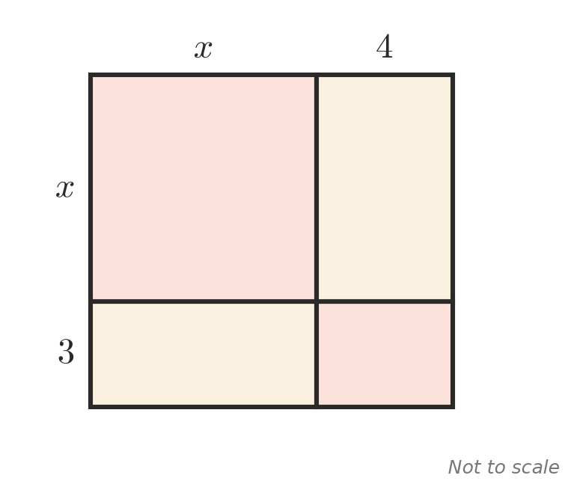
  - Write the area of each of the four parts.
  - Use your answer to expand and simplify $(x+4)(x+3)$.
- Explain why $−(a−b)=b−a$.

 Fluency
- Expand and simplify.
  - $5(2x−3)−4(3x−2)$ =
  - $3a(a−2b)−2b(4a−b)$ =
  - $−4m(2m−3)+5(m^{2}−2m)$ =
  - $\frac{1}{2}(6x+4)−\frac{2}{3}(9x−3)$ =
  - $2x(x^{2}−3x+4)$ =
  - $8−3(2−y)+2(y−1)$ =
- Expand and simplify.
  - $(x+2)(x+5)$ =
  - $(a+6)(a−1)$ =
  - $(2m+3)(m+4)$ =
  - $(y−3)(y−4)$ =

 Reasoning
- Find the whole numbers $a$ and $b$ that make $a(x+3)+b(x−2)=7x+1$ true for every value of $x$.
- Think of a number. Double it, add 7, then multiply by 3. Finally, subtract 6 times the number you first thought of. Use algebra to show that the answer is always the same, and find it.
- Expand $(n+1)^{2}−n^{2}$. Use your answer to explain why the difference between two consecutive square numbers is always odd.

 Problem solving
- A photo that is $x$ cm by $(x+5)$ cm has a frame 2 cm wide all the way around it.
- 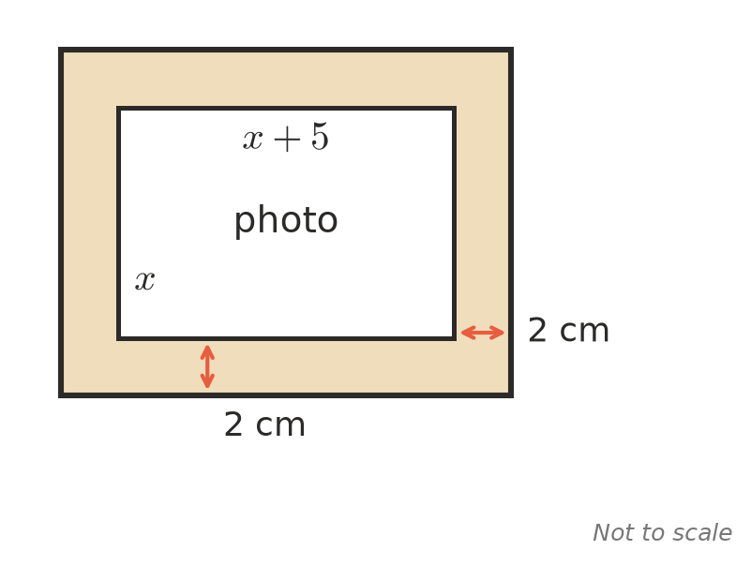
  - Write expressions for the outside length and width of the frame.
  - Find a simplified expression for the area of the frame only (not the photo).
  - Find the area of the frame when $x=10$.
- Use the distributive law to work these out without a calculator.
  - 15 × 99 =
  - 47 × 6 + 53 × 6 =
- Compare $n(n+2)$ with $(n+1)^{2}$ for a few whole numbers $n$. Then use algebra to prove what you notice.
- Year 8 runs a sausage sizzle. They sell $n$ sausages at $4 each and $(n+20)$ drinks at $2 each. Each sausage and each drink costs them $1, and the gas costs $30.
  - Write a simplified expression for their profit.
  - Find the profit when they sell 85 sausages.
  - What is the smallest number of sausages they must sell to make a profit of at least $200?
- A rectangle has an area of $x^{2}+8x+15$ and one side of $(x+3)$. Find an expression for the other side, and check by expanding.

