5.05 The distributive law
Year 8 Maths · A5 question sheet · Level 2 · Core
This worksheet practises expanding brackets, including negative terms outside the brackets, and then collecting like terms. Tip: the sign in front of the brackets goes with the term outside. In $−3(x−4)$, you multiply both $x$ and −4 by −3, giving $−3x+12$.

 Understanding
- This rectangle is split into two parts.
- 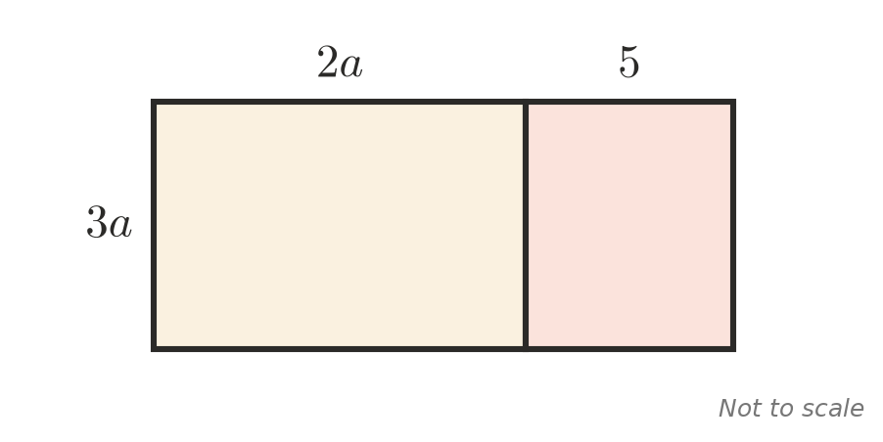
  - Write the area of each part.
  - Use your answer to expand $3a(2a+5)$.
- Explain why $−3(x−4)=−3x+12$, and not $−3x−12$.

 Fluency
- Expand.
  - $6(2x+7)$ =
  - $−5(3a−2)$ =
  - $4m(3m−5)$ =
  - $−2y(y+6)$ =
  - $3a(2b−4c)$ =
  - $−x(5−x)$ =
  - $(4k−1)×5$ =
  - $2p(3p+q−1)$ =
- Expand and simplify.
  - $4(x+3)+2(x−5)$ =
  - $5(2a+1)−3(a+2)$ =
  - $3(m−4)−(m−6)$ =
  - $x(x+2)+3(x−1)$ =
  - $2y(y−3)−y(y+4)$ =
  - $6−2(k−5)$ =

 Reasoning
- Kai expands and simplifies $4(x−2)−3(x−5)$ like this:
- $4x−8−3x−15=x−23$
- Find his mistake and give the correct answer.
- Find the missing term.
  - $□(2x−3)=8x−12$, so □ =
  - $3a(□)=6a^{2}+9a$, so □ =
  - $−2(□−4)=−6m+8$, so □ =
- Show that $4(x+3)−4x$ is equal to 12 for every value of $x$.

 Problem solving
- Use the distributive law to work these out in your head.
  - 8 × 103 =
  - 6 × 59 =
  - 25 × 44 =
- A garden bed is $2x$ metres wide and $(x+4)$ metres long.
  - Write an expanded expression for its area.
  - Find the area when $x=3$.
- At the movies, an adult ticket costs $a$ dollars and a child’s ticket costs $6 less. A family buys 2 adult tickets and 3 child tickets.
  - Write a simplified expression for the total cost.
  - Find the total cost when $a=20$.
- Think of a number. Add 5. Multiply by 4. Subtract 20. Divide by 4. Use algebra to show that you always end with the number you started with.
- Write two different expressions with brackets that expand to $12x+18$.

