5.04 Simplify algebraic expressions
Year 8 Maths · A5 question sheet · Level 3 · Challenge
This worksheet stretches your simplifying skills with long expressions and algebraic fractions, including fractions with more than one term on top. Tip: put brackets around a numerator with two terms before you multiply or subtract it. For example, $\frac{x+1}{2}$ = $\frac{3(x+1)}{6}$ = $\frac{3x+3}{6}$.

 Understanding
- Ken says that $\frac{2x+6}{2}=x+6$.
  - Substitute $x=4$ into both sides to show that he is wrong.
  - Explain his mistake and give the correct simplified expression.
- Find the lowest common denominator of $\frac{a}{6}$, $\frac{a}{8}$ and $\frac{a}{12}$.

 Fluency
- Simplify.
  - $3x×4xy−18x^{3}y^{2}÷3xy$ =
  - $(2a)^{2}+3a×(−a)−a^{2}$ =
  - $\frac{8m^{2}n}{2m}−3n×2m+5mn$ =
  - $−2p×3q+\frac{12p^{2}q^{2}}{4pq}$ =
  - $\frac{4x×6y}{3x}−\frac{10y^{2}}{2y}$ =
- Write as a single fraction in simplest form.
  - $\frac{2x}{3}+\frac{x}{4}−\frac{5x}{6}$ =
  - $\frac{3a}{4}−\frac{a}{6}+\frac{a}{12}$ =
  - $\frac{x+1}{2}+\frac{x−3}{5}$ =
  - $\frac{2y−1}{3}−\frac{y+2}{4}$ =
  - $\frac{a}{2b}+\frac{a}{3b}$ =

 Reasoning
- Mai simplifies $\frac{x−3}{2}−\frac{x−1}{4}$ like this:
- $\frac{2x−6}{4}−\frac{x−1}{4}$ = $\frac{2x−6−x−1}{4}$ = $\frac{x−7}{4}$
- Find her mistake and give the correct answer.
- Is $\frac{a}{2}+\frac{a}{3}=\frac{2a}{5}$ always true, sometimes true or never true? Explain.
- Show that $\frac{5x}{6}−\frac{x}{2}$ is always one third of $x$.
- Find the missing fraction.
  - $\frac{x}{4}+□=\frac{7x}{12}$, so □ =
  - $\frac{3a}{5}−□=\frac{a}{10}$, so □ =

 Problem solving
- Simplify $\frac{x}{2}+\frac{x}{3}+\frac{x}{6}$. What does your answer tell you about $\frac{1}{2}+\frac{1}{3}+\frac{1}{6}$?
- A right-angled triangle is cut from the corner of a rectangle. The lengths are in centimetres.
- 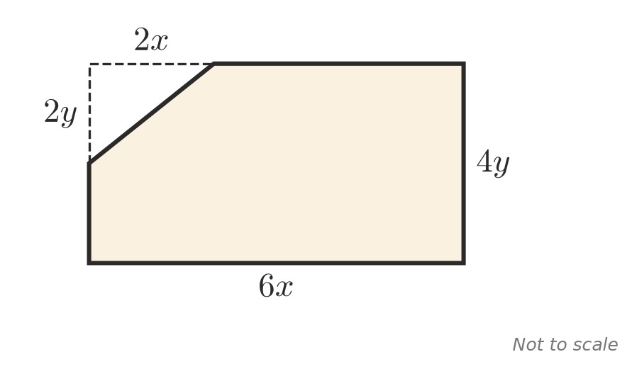
  - Write a simplified expression for the area of the shape that is left.
  - Find the area when $x=5$ and $y=3$.
- A farmer gives away a paddock of $A$ hectares. Her daughter gets $\frac{1}{3}$ of it, her son gets $\frac{1}{4}$ and her nephew gets $\frac{1}{6}$. The rest goes to a church camp.
  - Write a single fraction for the area the three family members get altogether.
  - Write a single fraction for the area the camp gets.
  - The camp gets 30 hectares. Find $A$, and the area the daughter gets.
- Find the mean of $\frac{x}{2}$ and $\frac{x}{3}$ as a single fraction. Explain how you can tell that it lies between them when $x$ is positive.

