5.04 Simplify algebraic expressions
Year 8 Maths · A5 question sheet · Level 2 · Core
This worksheet practises simplifying expressions with several operations, and adding and subtracting algebraic fractions. Tip: to add or subtract fractions, first write them with the lowest common denominator (LCD). For example, $\frac{x}{2}+\frac{x}{3}$ = $\frac{3x}{6}+\frac{2x}{6}$ = $\frac{5x}{6}$.

 Understanding
- Explain each step you would use to simplify $\frac{12a^{2}}{3a}+2a×5$, and give the answer.
- Look at $\frac{x}{4}+\frac{x}{6}$.
  - What is the lowest common denominator?
  - Write the expression as a single fraction.

 Fluency
- Simplify.
  - $3a×4b−5ab$ =
  - $\frac{20x^{2}}{4x}−2x$ =
  - $6m−2m×5+m^{2}$ =
  - $4x×3y+2x×5y−7yx$ =
  - $9p^{2}÷3p+4×2p$ =
  - $−2a×3a+4a^{2}−a$ =
  - $(5x+3x)÷4$ =
  - $2k×3k−18k^{3}÷6k$ =
- Write as a single fraction in simplest form.
  - $\frac{a}{2}+\frac{a}{7}$ =
  - $\frac{3x}{4}−\frac{x}{3}$ =
  - $\frac{2m}{5}+\frac{m}{10}$ =
  - $\frac{5y}{6}−\frac{3y}{8}$ =
  - $\frac{x}{3}+\frac{2}{5}$ =

 Reasoning
- Ben writes $\frac{x}{3}+\frac{x}{4}=\frac{2x}{7}$.
  - Explain his mistake and give the correct answer.
  - Substitute $x=12$ into $\frac{x}{3}+\frac{x}{4}$, into Ben’s answer and into your answer to show who is right.
- Show that $\frac{6a^{2}b}{2a}−ab$ simplifies to $2ab$.
- Which expression is equal to $4x^{2}$?
  - $2x×2x$
  - $8x^{2}÷2x$
  - $x^{2}+3x$
  - $(2x)^{2}−2x^{2}$
- Find the missing term.
  - $2a×□−4a^{2}=6a^{2}$, so □ =
  - $\frac{□}{3x}+2y=6y$, so □ =

 Problem solving
- A square of side $x$ cm is cut from the corner of a rectangle. The lengths are in centimetres.
- 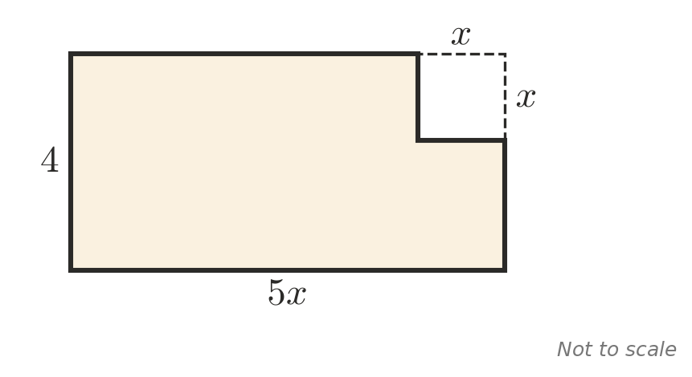
  - Write a simplified expression for the area of the shape that is left.
  - Find the area when $x=3$.
- A pizza is cut into $p$ slices. Ava eats $\frac{1}{3}$ of the slices and Noah eats $\frac{1}{4}$ of them.
  - Write a single fraction for the number of slices they eat altogether.
  - Write a single fraction for the number of slices left.
  - How many slices are left when $p=24$?
- Find a simplified expression for the mean (average) of $2a+1$, $4a−3$ and $3a+5$.
- A triangle has sides of $\frac{x}{2}$, $\frac{x}{3}$ and $\frac{x}{4}$ centimetres.
  - Write its perimeter as a single fraction.
  - Find the perimeter when $x=24$.

