5.04 Simplify algebraic expressions
Year 8 Maths · A5 question sheet · Level 1 · Warm-up
This worksheet practises simplifying expressions that mix operations. Tip: follow the order of operations. Do × and ÷ first, then collect like terms with + and −. For example, $2a+3×4a$ = $2a+12a$ = $14a$.

 Understanding
- Look at the expression $2a+3×4a$.
  - Which operation do you do first?
  - Simplify the expression.
- Copy and fill in the gaps to add these fractions.
  - $\frac{a}{5}+\frac{2a}{5}$ = $\frac{□}{5}$, so □ =
  - $\frac{x}{2}+\frac{x}{4}$ = $\frac{□}{4}+\frac{x}{4}$, so □ =

 Fluency
- Simplify.
  - $5x+2×3x$ =
  - $4m×2−3m$ =
  - $10a−12a÷4$ =
  - $3×2y+4y$ =
  - $6k÷2+k$ =
  - $2a×3b+ab$ =
- Simplify.
  - $4x+3+2x×5$ =
  - $3a×4+2b×5−a$ =
  - $8m÷2+3−m$ =
  - $x×x+3x^{2}$ =
- Write as a single fraction in simplest form.
  - $\frac{x}{4}+\frac{x}{4}$ =
  - $\frac{5a}{7}−\frac{2a}{7}$ =
  - $\frac{m}{3}+\frac{4m}{3}$ =
- Write as a single fraction in simplest form.
  - $\frac{x}{2}+\frac{x}{4}$ =
  - $\frac{a}{3}+\frac{a}{6}$ =

 Reasoning
- Zara says that $3+2×4x=20x$. Explain her mistake and give the correct answer.
- Simplify $2x+4×3x$. Then check your answer by substituting $x=1$ into the original expression and into your answer.

 Problem solving
- A box holds $3n$ pens. Mr Hill buys 4 boxes, then gives away $2n$ pens.
  - Write a simplified expression for the number of pens he has left.
  - How many pens does he have left when $n=8$?
- This shape is made from rectangles A and B. The lengths are in centimetres.
- 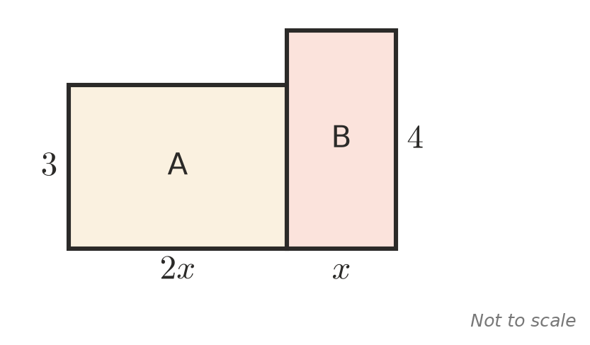
  - Write a simplified expression for the total area.
  - Find the total area when $x=5$.
- Write an expression that uses × and + and simplifies to $8a$.

