5.03 Multiply and divide algebraic terms
Year 8 Maths · Worksheet · Level 3 · Challenge
Name: ____________________ Date: ______________
This worksheet stretches your skills with products and quotients of algebraic terms: powers of terms, several letters and algebraic fractions. Tip: to divide by a fraction, multiply by its reciprocal, then cancel common factors before you multiply out.

 Understanding
- Use expanded form to explain why $(2a^{2})^{3}=8a^{6}$.

- Simplify using the index laws.
  - $x^{3}×x^{4}$ = ______________
  - $\frac{y^{7}}{y^{2}}$ = ______________
  - $(m^{2})^{4}$ = ______________
  - $5a^{0}$ = ______________

 Fluency
- Simplify.
  - $−3a^{2}b×4ab^{3}$ = ______________
  - $(−2x)^{3}$ = ______________
  - $5mn×(−2m^{2})×(−3n)$ = ______________
  - $(3p^{2}q)^{2}$ = ______________
  - $−x^{2}y×(−xy)^{2}$ = ______________
- Simplify.
  - $\frac{−42a^{3}b^{2}}{7ab}$ = ______________
  - $\frac{15x^{2}y}{−25xy^{3}}$ = ______________
  - $\frac{(4m)^{2}}{8m^{3}}$ = ______________
  - $\frac{6a^{2}b×4ab}{8a^{3}b}$ = ______________
  - $36x^{4}y^{2}÷4x^{2}÷3y$ = ______________
- Simplify.
  - $\frac{2a}{3}×\frac{9}{4a}$ = ______________
  - $\frac{5x}{6y}×\frac{3y^{2}}{10x^{2}}$ = ______________
  - $\frac{4m}{5}÷\frac{2m}{15}$ = ______________
  - $\frac{3ab}{8}÷\frac{9b^{2}}{4a}$ = ______________

 Reasoning
- Find the missing term.
  - $□×(−4xy^{2})=24x^{3}y^{2}$, so □ = ______________
  - $\frac{□}{6a^{2}b}=−3ab$, so □ = ______________
  - $(□)^{2}=49m^{6}n^{2}$, so □ = ______________ (give two answers)
- Ravi says that $\frac{8a^{6}}{2a^{2}}=4a^{3}$. Explain his mistake and give the correct answer.

- Show that $\frac{(2x)^{3}}{4x}$ simplifies to $2x^{2}$. Then check by substituting $x=3$ into both expressions.

 Problem solving
- The edges of this rectangular prism are in centimetres.
- 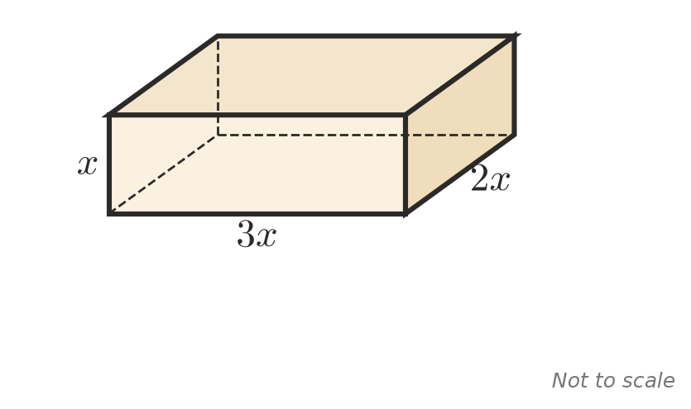
  - Write a simplified expression for the volume. ______________
  - Write a simplified expression for the total surface area. ______________
  - Find the volume and surface area when $x=2$. ______________
  - Every edge of the prism is doubled. How many times larger is the volume? Explain.

- A rectangle has an area of $48a^{2}b$ square units and a length of $8ab$ units.
  - Find its width. ______________
  - Write a simplified expression for its perimeter. ______________
- A square has sides of $4k$ cm. A rectangle has the same area as the square and a length of $8k$ cm.
  - Find the width of the rectangle. ______________
  - Which shape has the larger perimeter, and by how much? ______________
- On a road trip, a car travels $12xt$ kilometres in $3t$ hours. Write a simplified expression for its average speed in km/h. ______________

