5.03 Multiply and divide algebraic terms
Year 8 Maths · Worksheet · Level 2 · Core
Name: ____________________ Date: ______________
This worksheet practises multiplying and dividing algebraic terms, including negatives and powers. Tip: work out the sign first, then the numbers, then each letter. When you multiply powers of the same letter, add the indices: $x^{2}×x^{3}=x^{5}$. When you divide, subtract them.

 Understanding
- Write each product in expanded form, then simplify it to a single term.
  - $m^{2}×m^{3}$ ______________
  - $2x×3x^{2}$ ______________
  - $ab×a$ ______________
- Explain why $\frac{12ab}{4b}=3a$. Write the top and bottom in expanded form and show what cancels.

 Fluency
- Simplify.
  - $5a×6b$ = ______________
  - $−4x×3y$ = ______________
  - $7m×(−2m)$ = ______________
  - $−3p×(−8pq)$ = ______________
  - $2a×3b×4c$ = ______________
  - $5x^{2}×2x^{3}$ = ______________
  - $−ab×6a^{2}$ = ______________
  - $4xy×3x×y$ = ______________
- Simplify.
  - $\frac{24mn}{6n}$ = ______________
  - $\frac{−35x^{2}}{7x}$ = ______________
  - $18ab÷(−9a)$ = ______________
  - $\frac{16p^{2}q}{4pq}$ = ______________
  - $\frac{−30x^{3}y}{−5xy}$ = ______________
  - $\frac{9a}{12}$ = ______________
  - $\frac{10m}{15mn}$ = ______________
- Simplify. Work from left to right.
  - $6a×4b÷8a$ = ______________
  - $\frac{3x×8y}{6xy}$ = ______________
  - $12m^{2}÷3m×2n$ = ______________

 Reasoning
- Find the missing term.
  - $4a×□=20a^{2}b$, so □ = ______________
  - $□÷3y=7x$, so □ = ______________
  - $−6m×□=18m^{3}$, so □ = ______________
  - $\frac{□}{−2k}=5k$, so □ = ______________
- Lily says that $(3x)^{2}=3x^{2}$. Substitute $x=2$ into both sides to test her claim, then write $(3x)^{2}$ correctly as a single term.

- Which expression is equal to $12a^{2}b$? Answer: ______________
  - $3a×4ab$
  - $6ab×2b$
  - $4a×3b$
  - $2a^{2}×6a$

 Problem solving
- The edges of this rectangular prism are in centimetres.
- 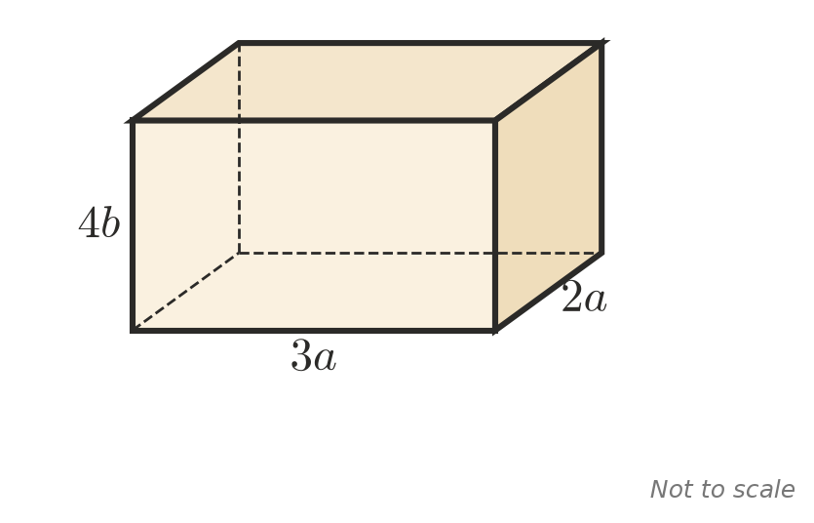
  - Write a simplified expression for the volume. ______________
  - Find the volume when $a=2$ and $b=3$. ______________
- A rectangle has an area of $36xy$ square units and a length of $9x$ units. Find its width. ______________
- A farmer plants $5r$ rows of fruit trees with $8t$ trees in each row.
  - Write a simplified expression for the number of trees. ______________
  - The trees are shared equally between 4 paddocks. How many trees go in each paddock? ______________
- A triangle has a base of $6m$ and a height of $5n$. Write a simplified expression for its area. ______________
- Write two different pairs of terms that multiply to give $24x^{2}y$.

