5.02 Add and subtract algebraic terms
Year 8 Maths · Worksheet · Level 3 · Challenge
Name: ____________________ Date: ______________
This worksheet stretches your skill with like terms: long expressions with several variables and powers, fractional coefficients, and puzzles. Tip: $x^{2}y$ and $yx^{2}$ are like terms, but $x^{2}y$ and $xy^{2}$ are not. Check the power on each letter, not just which letters appear.

 Understanding
- Is each statement always true, sometimes true or never true?
  - $a+a=a^{2}$ ______________
  - $3x+2x=5x$ ______________
  - $4b−4b=b$ ______________
  - $x^{2}+x^{2}=2x^{2}$ ______________
  - $2y+3=5y$ ______________
- Look at the expression $3x^{2}y−2xy^{2}+5yx^{2}+xy−4y^{2}x$.
  - Group the like terms. ______________
  - Simplify the expression. ______________

 Fluency
- Simplify.
  - $3a^{2}−5a+2−7a^{2}+5a−9$ = ______________
  - $−4mn+6m−2nm−9m+n$ = ______________
  - $x^{2}y+3xy^{2}−5yx^{2}+y^{2}x$ = ______________
  - $\frac{1}{2}a+\frac{3}{4}a−a$ = ______________
  - $\frac{2}{3}k−\frac{1}{6}k+2k$ = ______________
  - $7−3w+2w^{2}−w−7+w^{2}$ = ______________

 Reasoning
- Find the missing term.
  - $5x^{2}−□+3x=5x^{2}−4x$, so □ = ______________
  - $−2ab+□−6ba=ab$, so □ = ______________
  - $□−3m^{2}−m=−m$, so □ = ______________
  - $\frac{1}{3}y+□=y$, so □ = ______________
- Jai simplifies $4x−3y−2x+5y$ and gets $2x−8y$. Find his mistake and give the correct answer.

- Simplify $3xy−x^{2}+2yx+4x^{2}$. Then check your answer by substituting $x=−1$ and $y=2$ into the original expression and into your answer.

 Problem solving
- The lengths on this shape are in metres. All the corners are right angles.
- 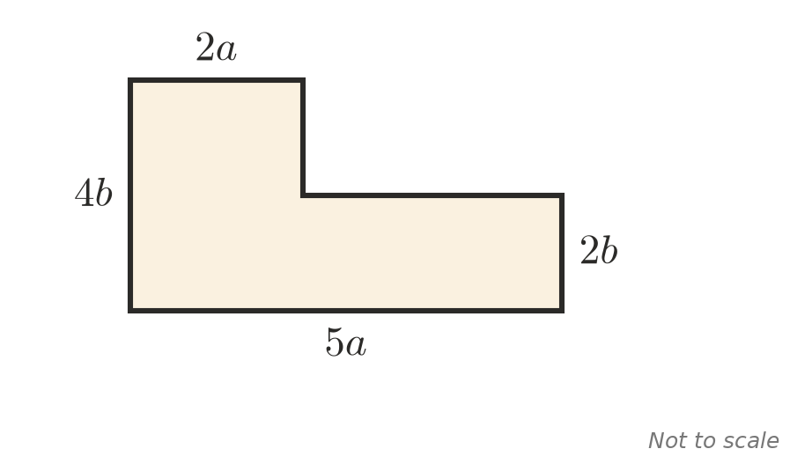
  - Write expressions for the two sides that are not labelled. ______________
  - Write a simplified expression for the perimeter. ______________
  - Find the perimeter when $a=3$ and $b=2$. ______________
- In this magic square, every row, column and diagonal adds to the same total.
- 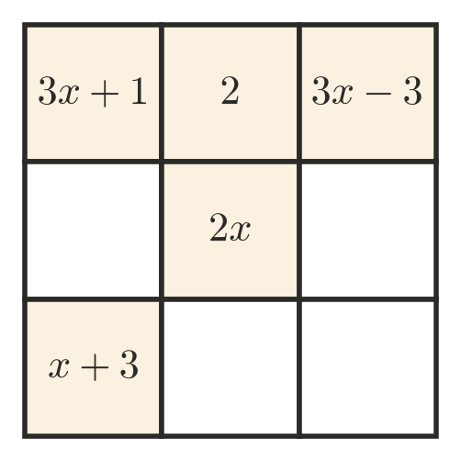
  - Find the total of each row, as a simplified expression. ______________
  - Fill in the four empty squares.
- Let $n$ be a whole number. The next two whole numbers are $n+1$ and $n+2$.
  - Write a simplified expression for the sum of these three consecutive numbers. ______________
  - Explain why the sum of any three consecutive whole numbers is a multiple of 3.

  - Five consecutive even numbers start at $2k$. Write a simplified expression for their sum, and find the five numbers if their sum is 90. ______________
- A rectangle has a length of $4x−y$ and a perimeter of $14x+2y$. Find its width. ______________
- In this list, each expression after the first two is the sum of the two before it.
- $a$, $b$, $a+b$, $a+2b$, …
  - Write the next three expressions in the list. ______________
  - Find the sum of the first six expressions. ______________
  - Compare your answer to part b with the fifth expression. What do you notice?

