5.02 Add and subtract algebraic terms
Year 8 Maths · Worksheet · Level 2 · Core
Name: ____________________ Date: ______________
This worksheet practises collecting like terms, including terms with negative coefficients and powers. Tip: the sign in front of a term belongs to that term. In $4x−9−6x$, the terms are $4x$, −9 and $−6x$, so the $x$ terms give $4x−6x=−2x$.

 Understanding
- Sort these terms into groups of like terms.
- $3ab$, $−2a$, $5a^{2}$, $ba$, $7a$, $−a^{2}$, $4b$, $−6ab$

- Look at the expression $5x^{2}−3x+7−x$.
  - How many terms does it have? ______________
  - What is the coefficient of $x^{2}$? ______________
  - What are the coefficients of the two $x$ terms? ______________
  - What is the constant term? ______________

 Fluency
- Simplify.
  - $8y−11y$ = ______________
  - $−6p+2p$ = ______________
  - $−5m−7m$ = ______________
  - $4ab−9ba$ = ______________
  - $3x^{2}+8x^{2}−x^{2}$ = ______________
  - $−2k+5k−9k$ = ______________
- Simplify by collecting like terms.
  - $7a+3b−2a−8b$ = ______________
  - $4x−9−6x+2$ = ______________
  - $5m^{2}+3m−2m^{2}−7m$ = ______________
  - $6xy−4x+2yx+x$ = ______________
  - $−3p+8q−p−8q$ = ______________
  - $9−2t+4t^{2}−5+t$ = ______________
  - $2ab+3a−5ba−3a+b$ = ______________
- Add the expressions and simplify.
  - $3x+2y$ and $5x−7y$ ______________
  - $4m−1$, $2m+6$ and $−3m$ ______________

 Reasoning
- Priya writes $5x^{2}−2x=3x$. Explain why she is wrong.

- Find the missing term.
  - $7a+□=3a$, so □ = ______________
  - $□−5y=−2y$, so □ = ______________
  - $4m^{2}−□+2m=4m^{2}−3m$, so □ = ______________
  - $−x+□=6x$, so □ = ______________
- Simplify $5a+2b−3a$. Then substitute $a=2$ and $b=3$ into the original expression and into your answer to check that they give the same value.

- Which expression is not equal to $4x−3y$? Answer: ______________
  - $6x−3y−2x$
  - $x−3y+3x$
  - $4x−5y+2y$
  - $4x+3y−6x$

 Problem solving
- The lengths on this shape are in centimetres.
- 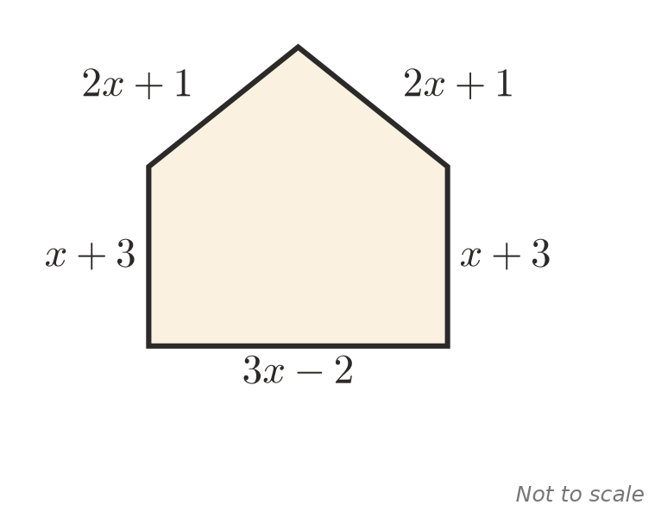
  - Write a simplified expression for the perimeter. ______________
  - Find the perimeter when $x=4$. ______________
- Three friends save for a beach trip. Ana saves $3d$ dollars. Ben saves $12 less than Ana. Cara saves $5 more than twice $d$.
  - Write expressions for Ben’s and Cara’s savings. ______________
  - Write a simplified expression for the total they save. ______________
  - Find the total when $d=20$. ______________
- A triangle has a perimeter of $12a+4b$. Two of its sides are $5a+2b$ and $3a−b$. Find the length of the third side. ______________
- Write an expression with five terms, including two negative terms, that simplifies to $3m−2n$.

