Transformations: Practice test 3
Year 7 Maths · Test · Test 3
Name: ____________________ Date: ______________
Time: 45 minutes
Total: 40 marks
Show your working in the boxes. Then write each final answer on the answer sheet on the last page.

 Section A: No calculator
- In each pair, the yellow shape has been moved to the red position by one transformation. Name the transformation: translation, reflection or rotation.
- 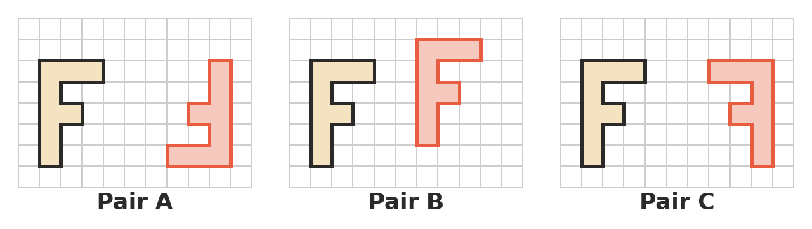
  - Pair A (1 mark)

  - Pair B (1 mark)

  - Pair C (1 mark)

- Which transformation turns a shape around a fixed point called the centre? Answer: ______________ (1 mark)
  - Rotation
  - Translation
  - Reflection
  - Enlargement
- Triangle KLM is translated 4 units to the left and 6 units up to make triangle K′L′M′.
- 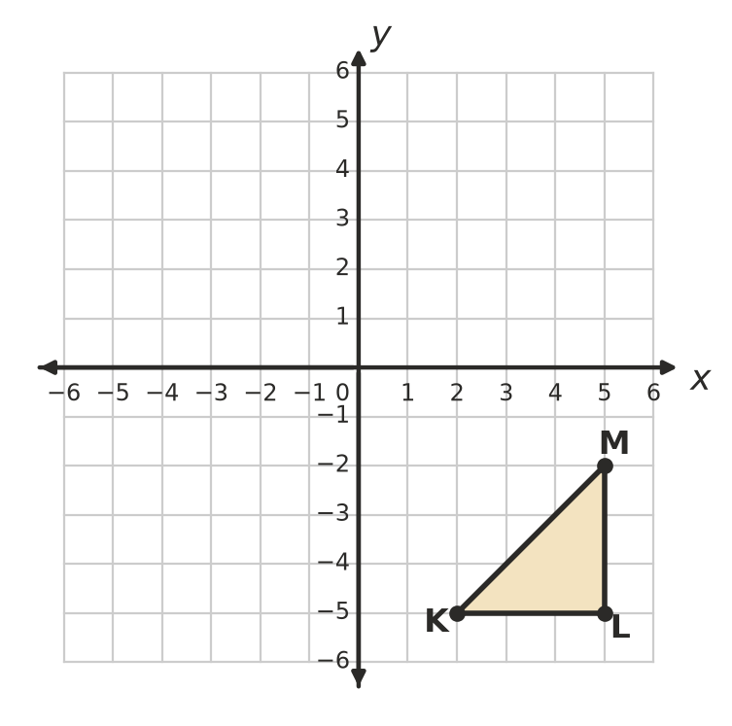
  - Write the coordinates of K′, L′ and M′. (2 marks)

  - Draw triangle K′L′M′ on the grid. (1 mark)

- A translation moves the point Q(5, 5) to Q′(−1, −2).
  - Describe the translation in words. (1 mark)

  - The same translation is used on the point P(0, 4). Write the coordinates of P′. (1 mark)

- Write the coordinates of the image of each point.
  - (−2, −9) is reflected in the x-axis. (1 mark)

  - (10, 4) is reflected in the y-axis. (1 mark)

- Triangle TUV is reflected in the dashed line y = 1.
- 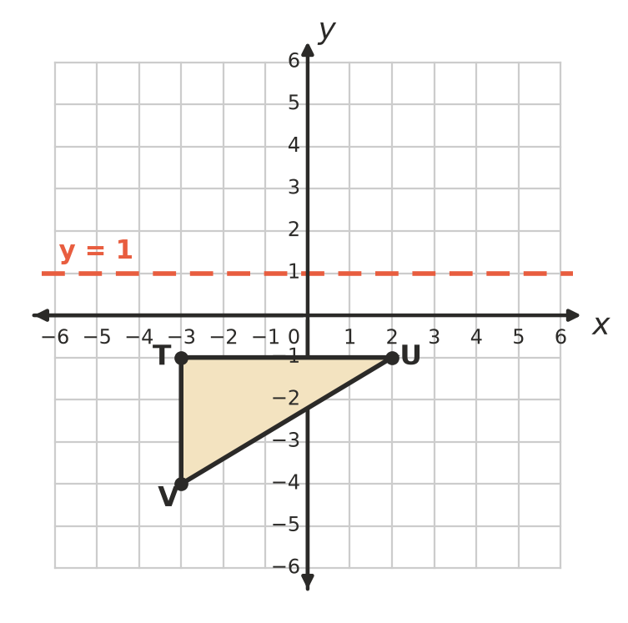
  - Write the coordinates of U′. (1 mark)

  - Write the coordinates of V′. (1 mark)

- Triangle ABC is rotated 180° about the origin.
- 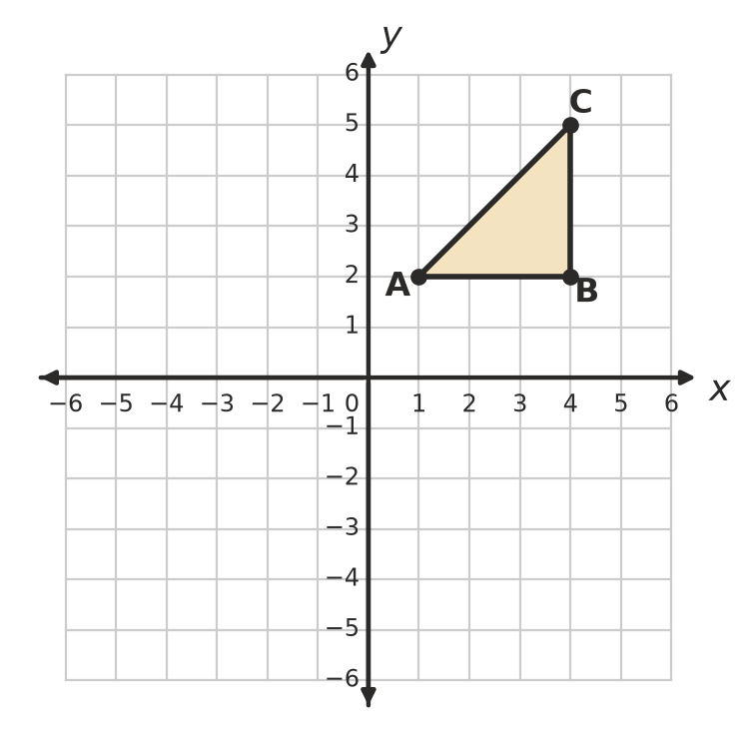
  - Write the coordinates of B′. (1 mark)

  - Write the coordinates of C′. (1 mark)

  - The point (−3, −5) is rotated 90° anticlockwise about the origin. Write the coordinates of its image. (1 mark)

- The point H(−1, −2) is rotated 90° anticlockwise about the point C(1, 0). Write the coordinates of H′. (2 marks)
- 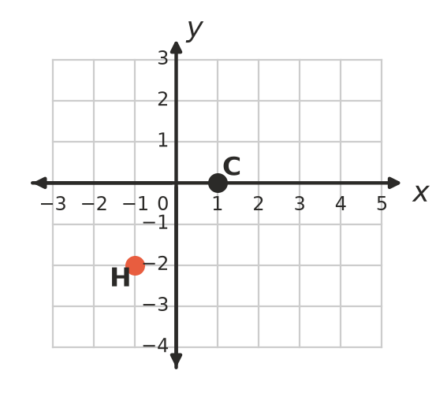

- Complete the sentence: a rotation of 240° anticlockwise moves a shape to the same place as a rotation of ______________° clockwise about the same point. (1 mark)

- The point (2, 3) is moved by two transformations.
  - The point is reflected in the x-axis, then translated 4 units to the left. Write the coordinates of the final point. (1 mark)

  - This time, the point is translated 4 units to the left first, then reflected in the x-axis. Write the coordinates of the final point. (1 mark)

- Shape A is a rectangle, B is a regular octagon, C is an isosceles triangle and D is a pinwheel. For each shape, write the number of lines of symmetry and the order of rotational symmetry on the answer sheet. (4 marks)
- 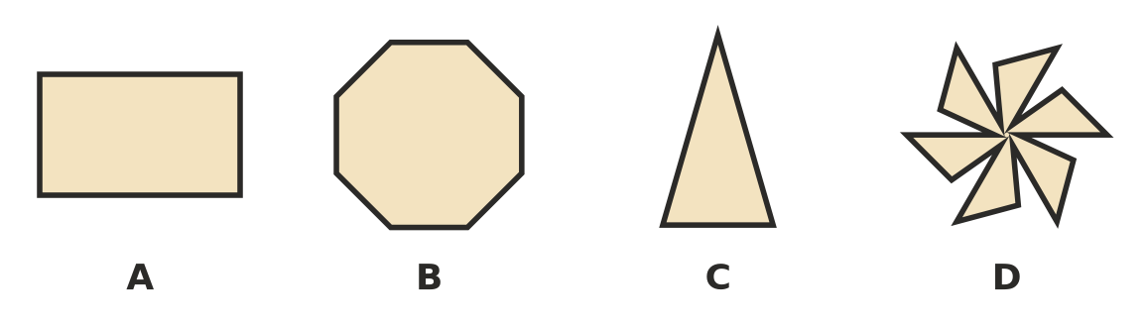

- Tiles that cover a floor with no gaps and no overlaps make a tessellation.
  - A tessellation uses regular hexagons (angles of 120°) and equilateral triangles (angles of 60°). At every corner point, two hexagons and two triangles meet. Find the total of the angles at each corner point. (1 mark)

  - Mia cuts out many copies of a quadrilateral with four different angles. Explain why her quadrilaterals can always tessellate. (2 marks)

 Section B: Calculator allowed
- A drone’s position is shown on a large grid. It flies in a straight line from (84, −36) to (−59, 127).
  - Describe this translation in words. (1 mark)

  - A second drone makes the same translation, starting at (−15, −88). Write the coordinates of where it finishes. (1 mark)

  - After the translation in part a), the first drone flies 70 units right and 48 units down. Describe the single translation from its start to its final position. (1 mark)

- Rectangle EFGH has corners E(−14, −6), F(−14, 9), G(11, 9) and H(11, −6). It is reflected in the y-axis.
  - Write the coordinates of H′. (1 mark)

  - Find the area of the image E′F′G′H′. (1 mark)

- A Christmas star decoration has 9 identical points spaced equally around its centre.
  - What is the order of rotational symmetry of the star? (1 mark)

  - What is the smallest angle the star can turn so that it looks exactly the same? (1 mark)

  - Give an angle between 100° and 150° that the star can turn through and look exactly the same. (1 mark)

- A point P is rotated 90° clockwise about the origin. Its image is then translated 2 units to the left and 3 units down. The final point is (4, −9). Find the coordinates of P. Show your working. (2 marks)

- The point (7, −2) is rotated 90° clockwise about the origin three times in a row.
  - Write the coordinates of the final point. (1 mark)

  - Name the single rotation that moves (7, −2) straight to the same final point. (1 mark)

 Answer sheet
Name: ____________________
Write your final answer for each question in the table.
Question | Answer | Marks | Question | Answer | Marks
1a |  | /1 | 10b |  | /1
1b |  | /1 | 11A | Lines: …… Order: …… | /1
1c |  | /1 | 11B | Lines: …… Order: …… | /1
2 |  | /1 | 11C | Lines: …… Order: …… | /1
3a | K′ ( , ) L′ ( , ) M′ ( , ) | /2 | 11D | Lines: …… Order: …… | /1
3b | (on the grid in Question 3) | /1 | 12a |  | /1
4a |  | /1 | 12b |  | /2
4b |  | /1 | 13a |  | /1
5a |  | /1 | 13b |  | /1
5b |  | /1 | 13c |  | /1
6a |  | /1 | 14a |  | /1
6b |  | /1 | 14b |  | /1
7a |  | /1 | 15a |  | /1
7b |  | /1 | 15b |  | /1
7c |  | /1 | 15c |  | /1
8 |  | /2 | 16 |  | /2
9 |  | /1 | 17a |  | /1
10a |  | /1 | 17b |  | /1
 |  |  |  | Total | /40

