Transformations: Practice test 2
Year 7 Maths · Test · Test 2
Name: ____________________ Date: ______________
Time: 45 minutes
Total: 40 marks
Show your working in the boxes. Then write each final answer on the answer sheet on the last page.

 Section A: No calculator
- In each pair, the yellow shape has been moved to the red position by one transformation. Name the transformation: translation, reflection or rotation.
- 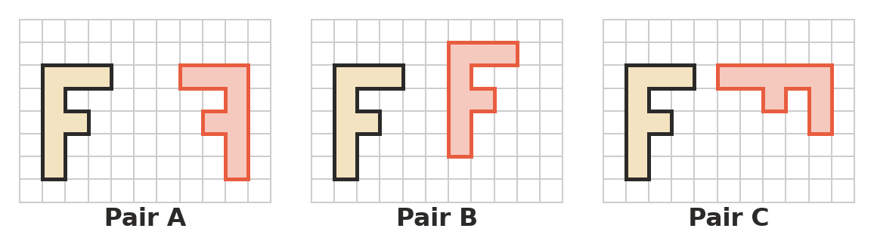
  - Pair A (1 mark)

  - Pair B (1 mark)

  - Pair C (1 mark)

- In which transformation does every point of a shape move the same distance in the same direction? Answer: ______________ (1 mark)
  - Reflection
  - Rotation
  - Translation
  - Tessellation
- Triangle XYZ is translated 6 units to the left and 7 units down to make triangle X′Y′Z′.
- 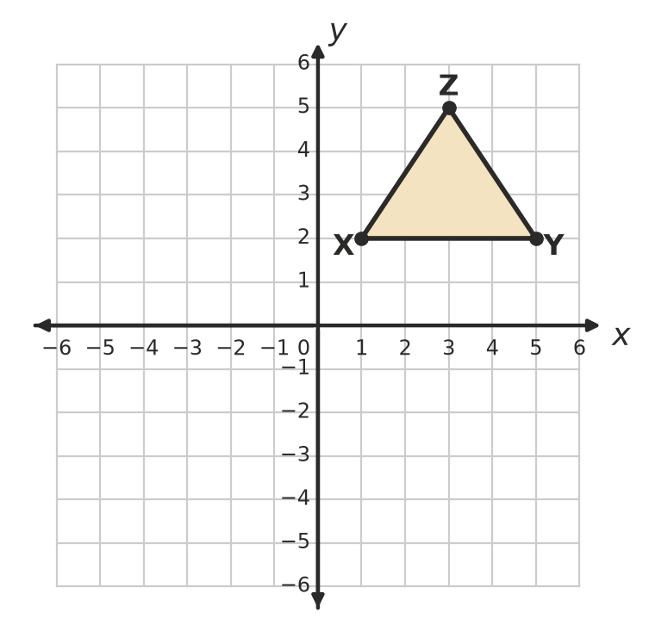
  - Write the coordinates of X′, Y′ and Z′. (2 marks)

  - Draw triangle X′Y′Z′ on the grid. (1 mark)

- A translation moves the point R(−4, −1) to R′(2, 3).
  - Describe the translation in words. (1 mark)

  - The same translation is used on the point S(−6, 2). Write the coordinates of S′. (1 mark)

- Write the coordinates of the image of each point.
  - (3, 9) is reflected in the y-axis. (1 mark)

  - (−8, −4) is reflected in the x-axis. (1 mark)

- Quadrilateral ABCD is reflected in the dashed line x = −1.
- 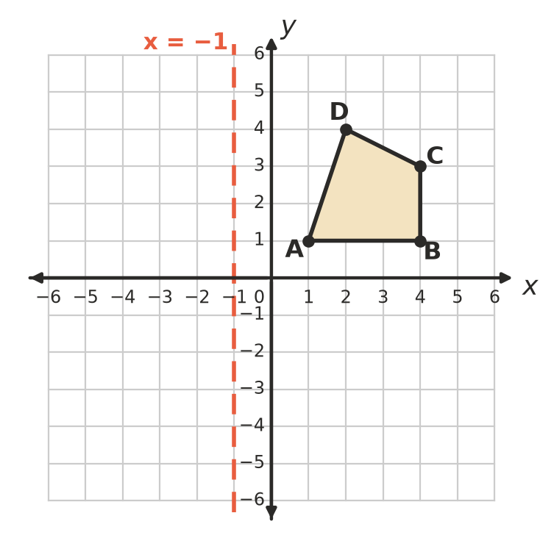
  - Write the coordinates of B′. (1 mark)

  - Write the coordinates of D′. (1 mark)

- Triangle EFG is rotated 90° clockwise about the origin.
- 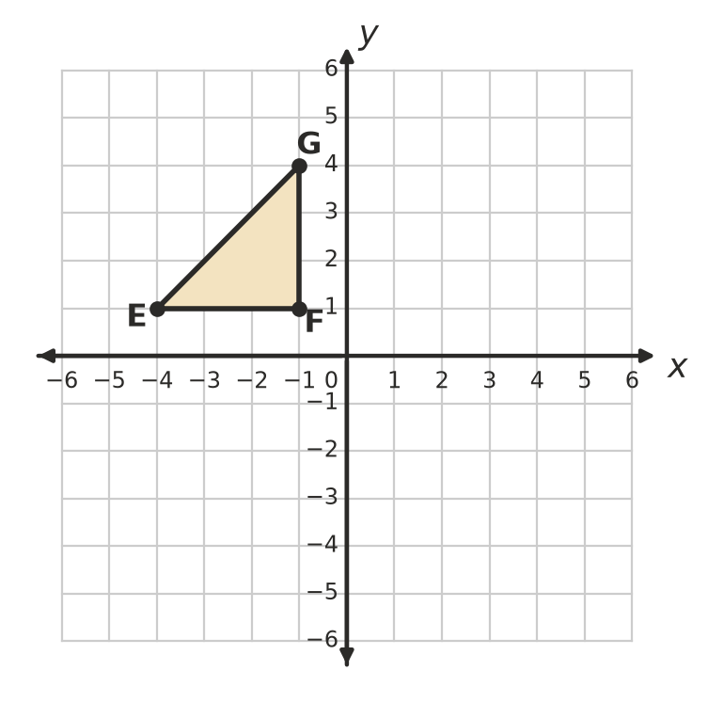
  - Write the coordinates of E′. (1 mark)

  - Write the coordinates of G′. (1 mark)

  - The point (6, −2) is rotated 90° anticlockwise about the origin. Write the coordinates of its image. (1 mark)

- The point N(−2, 3) is rotated 180° about the point C(1, 1). Write the coordinates of N′. (2 marks)
- 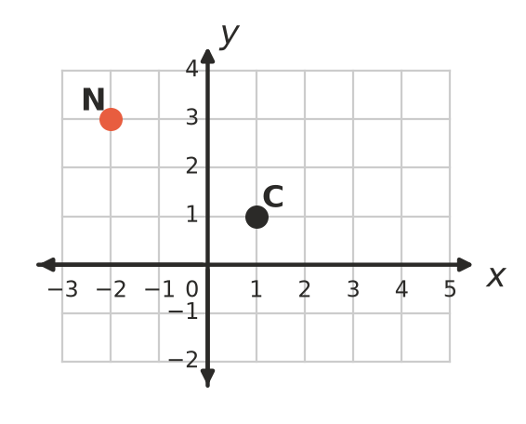

- Complete the sentence: a rotation of 300° clockwise moves a shape to the same place as a rotation of ______________° anticlockwise about the same point. (1 mark)

- The point (4, 1) is moved by two transformations.
  - The point is translated 5 units to the left, then rotated 90° clockwise about the origin. Write the coordinates of the final point. (1 mark)

  - This time, the point is rotated 90° clockwise about the origin first, then translated 5 units to the left. Write the coordinates of the final point. (1 mark)

- Shape A is a regular pentagon, B is a rhombus, C is a cross and D is a pinwheel. For each shape, write the number of lines of symmetry and the order of rotational symmetry on the answer sheet. (4 marks)
- 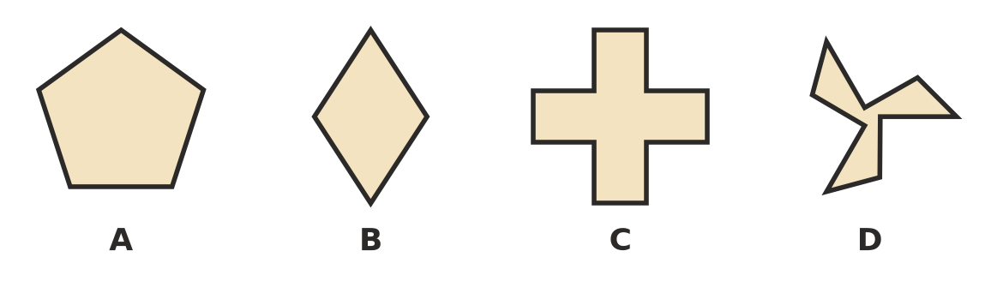

- A bathroom floor is tiled with regular octagons and squares. Each angle of a regular octagon is 135°. At every corner point, two octagons and one square meet.
  - Find the total of the angles that meet at each corner point. (1 mark)

  - Explain why regular octagons cannot tessellate on their own, without the squares. (2 marks)

 Section B: Calculator allowed
- A bushwalking map is drawn on a large grid. A hiker walks from her camp at (−125, 40) straight to a lookout at (68, −95).
  - Describe the translation from the camp to the lookout in words. (1 mark)

  - Describe the translation from the lookout back to the camp. (1 mark)

  - From the lookout, she makes the same translation as in part a) again to reach a waterfall. Write the coordinates of the waterfall. (1 mark)

- A triangle has sides of 13 cm, 14 cm and 15 cm. Its area is 84 cm². The triangle is rotated 270° clockwise about one of its corners.
  - What is the perimeter of the image? (1 mark)

  - What is the area of the image? (1 mark)

- A car hubcap has 7 identical spokes spaced equally around its centre.
  - What is the order of rotational symmetry of the hubcap? (1 mark)

  - What is the smallest angle the hubcap can turn so that it looks exactly the same? Round your answer to one decimal place. (1 mark)

  - A different hubcap looks exactly the same each time it turns 24°. What is its order of rotational symmetry? (1 mark)

- A point P is reflected in the x-axis. Its image is then rotated 180° about the origin. The final point is (5, −7). Find the coordinates of P. Show your working. (2 marks)

- Answer each part.
  - The point (−13, −20) is reflected in the y-axis, and then its image is reflected in the x-axis. Write the coordinates of the final point. (1 mark)

  - A shape is translated 4 units right and 9 units up, then translated 10 units left and 2 units down. Describe the single translation that has the same effect. (1 mark)

 Answer sheet
Name: ____________________
Write your final answer for each question in the table.
Question | Answer | Marks | Question | Answer | Marks
1a |  | /1 | 10b |  | /1
1b |  | /1 | 11A | Lines: …… Order: …… | /1
1c |  | /1 | 11B | Lines: …… Order: …… | /1
2 |  | /1 | 11C | Lines: …… Order: …… | /1
3a | X′ ( , ) Y′ ( , ) Z′ ( , ) | /2 | 11D | Lines: …… Order: …… | /1
3b | (on the grid in Question 3) | /1 | 12a |  | /1
4a |  | /1 | 12b |  | /2
4b |  | /1 | 13a |  | /1
5a |  | /1 | 13b |  | /1
5b |  | /1 | 13c |  | /1
6a |  | /1 | 14a |  | /1
6b |  | /1 | 14b |  | /1
7a |  | /1 | 15a |  | /1
7b |  | /1 | 15b |  | /1
7c |  | /1 | 15c |  | /1
8 |  | /2 | 16 |  | /2
9 |  | /1 | 17a |  | /1
10a |  | /1 | 17b |  | /1
 |  |  |  | Total | /40

