Transformations: Practice test 1
Year 7 Maths · Test · Test 1
Name: ____________________ Date: ______________
Time: 45 minutes
Total: 40 marks
Show your working in the boxes. Then write each final answer on the answer sheet on the last page.

 Section A: No calculator
- In each pair, the yellow shape has been moved to the red position by one transformation. Name the transformation: translation, reflection or rotation.
- 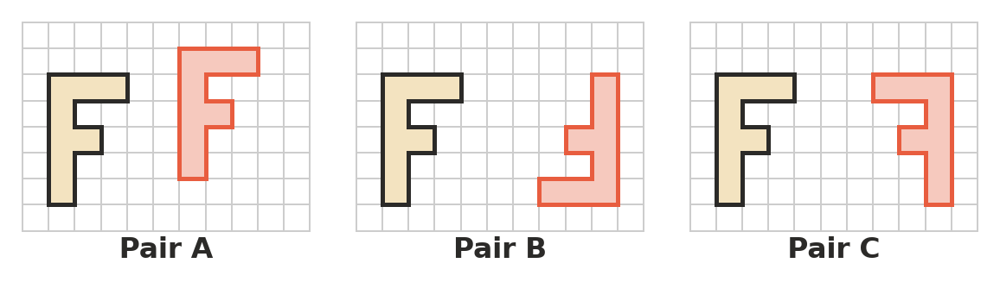
  - Pair A (1 mark)

  - Pair B (1 mark)

  - Pair C (1 mark)

- Which word describes a shape and its image after any translation, reflection or rotation? Answer: ______________ (1 mark)
  - Larger
  - Congruent
  - Parallel
  - Symmetrical
- Quadrilateral JKLM is translated 7 units to the right and 5 units up to make J′K′L′M′.
- 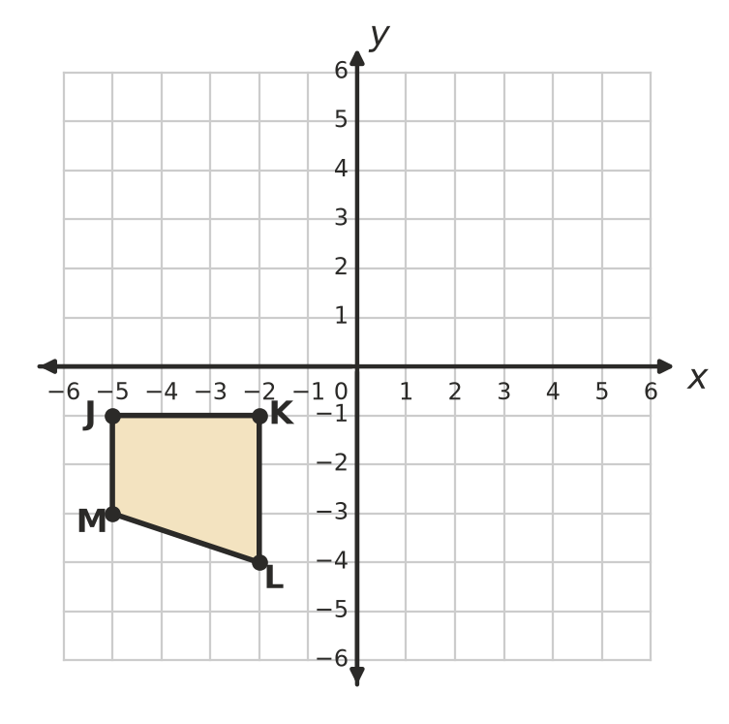
  - Write the coordinates of J′, K′, L′ and M′. (2 marks)

  - Draw quadrilateral J′K′L′M′ on the grid. (1 mark)

- A translation moves the point A(2, −4) to A′(−5, 1).
  - Describe the translation in words. (1 mark)

  - The same translation is used on the point B(6, 0). Write the coordinates of B′. (1 mark)

- Write the coordinates of the image of each point.
  - (−5, 3) is reflected in the x-axis. (1 mark)

  - (7, −2) is reflected in the y-axis. (1 mark)

- Triangle PQR is reflected in the dashed line y = −1.
- 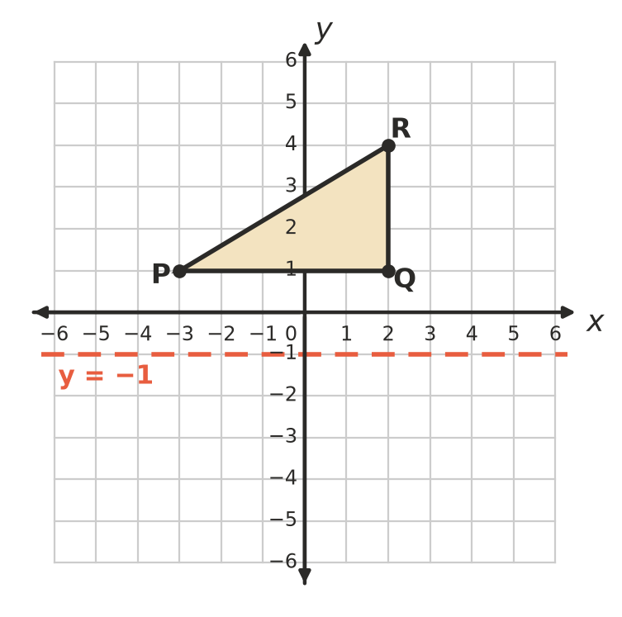
  - Write the coordinates of P′. (1 mark)

  - Write the coordinates of R′. (1 mark)

- Triangle UVW is rotated 90° anticlockwise about the origin.
- 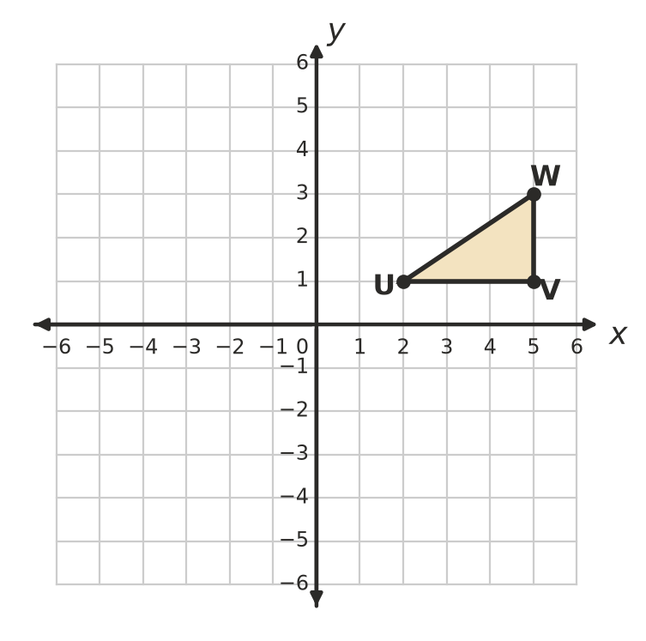
  - Write the coordinates of V′. (1 mark)

  - Write the coordinates of W′. (1 mark)

  - The point (−4, 3) is rotated 180° about the origin. Write the coordinates of its image. (1 mark)

- The point G(1, 4) is rotated 90° clockwise about the point C(−1, 2). Write the coordinates of G′. (2 marks)
- 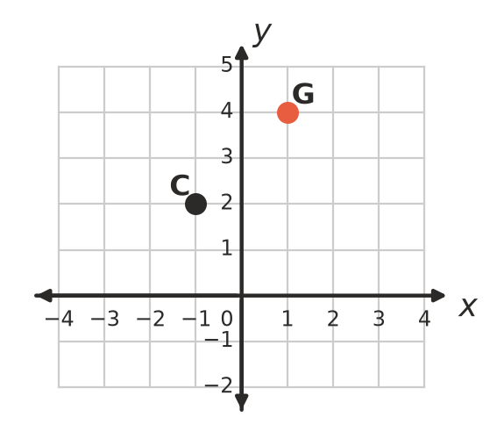

- Complete the sentence: a rotation of 270° anticlockwise moves a shape to the same place as a rotation of ______________° clockwise about the same point. (1 mark)

- The point H(3, −2) is moved by two transformations.
  - H is rotated 180° about the origin, then translated 2 units up. Write the coordinates of the final point. (1 mark)

  - This time, H is translated 2 units up first, then rotated 180° about the origin. Write the coordinates of the final point. (1 mark)

- Shape A is a square, B is an equilateral triangle, C is a Z-shape and D is an arrow. For each shape, write the number of lines of symmetry and the order of rotational symmetry on the answer sheet. (4 marks)
- 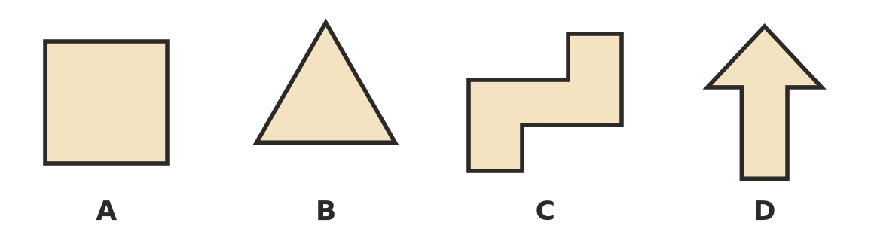

- Tiles that cover a floor with no gaps and no overlaps make a tessellation.
  - Each angle of an equilateral triangle is 60°. How many equilateral triangles meet at each corner point of a triangle tessellation? (1 mark)

  - Each angle of a regular decagon (10 sides) is 144°. Explain why regular decagons cannot tessellate on their own. (2 marks)

 Section B: Calculator allowed
- On a large map grid, a translation moves the point C(−48, 25) to C′(29, −63).
  - Describe the translation in words. (1 mark)

  - The same translation moves a point E to E′(−6, 14). Write the coordinates of E. (1 mark)

  - A second translation then moves C′ 40 units to the left and 30 units up. Write the coordinates of the final point. (1 mark)

- A right-angled triangle has sides of 10 cm, 24 cm and 26 cm. Its area is 120 cm². The triangle is reflected in a mirror line.
  - What is the perimeter of the image? (1 mark)

  - What is the area of the image? (1 mark)

- A ceiling fan has 5 identical blades spaced equally around its centre.
  - What is the order of rotational symmetry of the fan? (1 mark)

  - What is the smallest angle the fan can turn so that it looks exactly the same? (1 mark)

  - Does the fan look exactly the same after it turns 216°? Give a reason. (1 mark)

- A point P is translated 4 units to the right and 6 units down. Its image is then reflected in the x-axis. The final point is (1, 3). Find the coordinates of P. Show your working. (2 marks)

- The point (−9, 14) is rotated 90° clockwise about the origin, and then its image is rotated 90° clockwise about the origin again.
  - Write the coordinates of the final point. (1 mark)

  - Name the single transformation that moves (−9, 14) straight to the same final point. (1 mark)

 Answer sheet
Name: ____________________
Write your final answer for each question in the table.
Question | Answer | Marks | Question | Answer | Marks
1a |  | /1 | 10b |  | /1
1b |  | /1 | 11A | Lines: …… Order: …… | /1
1c |  | /1 | 11B | Lines: …… Order: …… | /1
2 |  | /1 | 11C | Lines: …… Order: …… | /1
3a | J′ ( , ) K′ ( , ) L′ ( , ) M′ ( , ) | /2 | 11D | Lines: …… Order: …… | /1
3b | (on the grid in Question 3) | /1 | 12a |  | /1
4a |  | /1 | 12b |  | /2
4b |  | /1 | 13a |  | /1
5a |  | /1 | 13b |  | /1
5b |  | /1 | 13c |  | /1
6a |  | /1 | 14a |  | /1
6b |  | /1 | 14b |  | /1
7a |  | /1 | 15a |  | /1
7b |  | /1 | 15b |  | /1
7c |  | /1 | 15c |  | /1
8 |  | /2 | 16 |  | /2
9 |  | /1 | 17a |  | /1
10a |  | /1 | 17b |  | /1
 |  |  |  | Total | /40

