14.06 Line and rotational symmetry
Year 7 Maths · Worksheet · Level 3 · Challenge
Name: ____________________ Date: ______________
This worksheet practises line and rotational symmetry in harder shapes and designs, on the number plane, and in number puzzles. Tip: the smallest angle of rotation is 360° ÷ the order. Reflecting a shape in one line of symmetry and then another is the same as rotating it, so lines of symmetry and rotational symmetry are closely linked.

 Understanding
- Write true or false for each statement.
Statement | True or false
Every regular polygon with n sides has rotational symmetry of order n.
A shape with rotational symmetry of order 3 must have 3 lines of symmetry.
A shape with exactly 2 lines of symmetry has rotational symmetry of order 2.
A shape with rotational symmetry of order 1 cannot have a line of symmetry.
A shape can have 4 lines of symmetry and rotational symmetry of order 2.

- For each design, write the number of lines of symmetry, the order of rotational symmetry and the smallest angle of rotation (write “none” if there is no rotational symmetry).
- 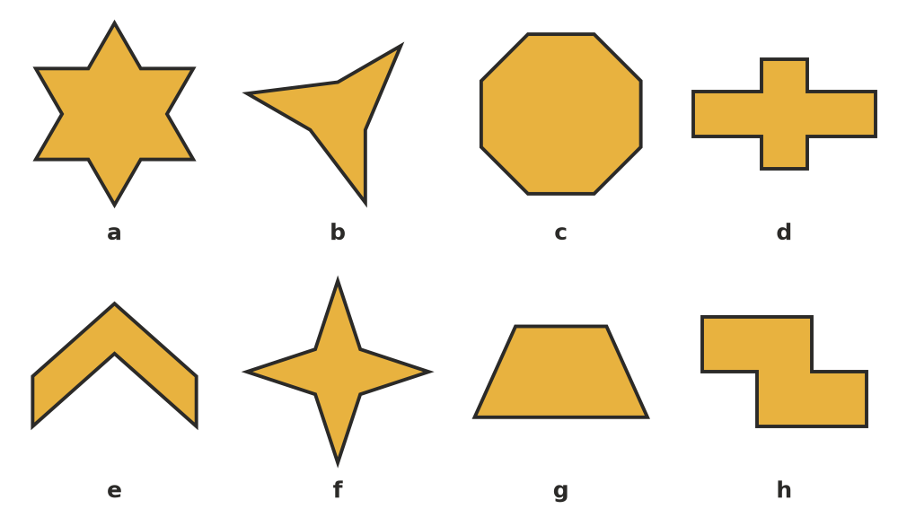
Design | a | b | c | d | e | f | g | h
Lines of symmetry
Order of rotational symmetry
Smallest angle of rotation

- Answer each question about shapes on the number plane.
  - A shape has the y-axis as its only line of symmetry. Four of its corners are (1, 1), (3, 1), (4, 3) and (0, 5). Find its other corners. ______________
  - A shape has rotational symmetry of order 2 about the origin. Three of its corners are (2, 1), (5, 3) and (1, 4). Find its other three corners. ______________

 Fluency
- Complete the design so that both dashed lines are lines of symmetry.
- 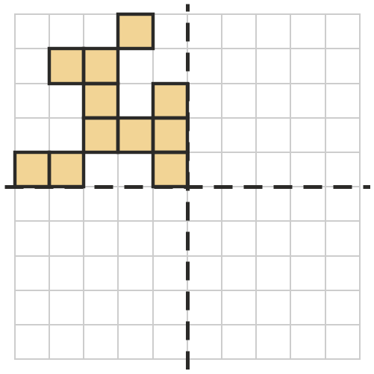
- Complete the design so that it has rotational symmetry of order 4 about the dot.
- 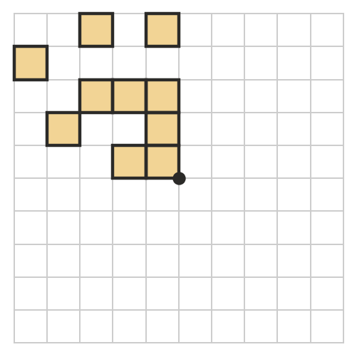
- Answer each question.
  - A regular polygon has a smallest angle of rotation of 24°. How many sides does it have? ______________
  - A regular seven-pointed star has how many lines of symmetry? What is its smallest angle of rotation, as a mixed number of degrees? ______________
- A car wheel has 5 identical spokes, evenly spaced.
  - What is the order of rotational symmetry of the wheel? ______________
  - The wheel turns through 216°. Does it look the same as before? Explain. ______________
  - Find the smallest turn bigger than 360° that leaves the wheel looking the same. ______________

 Reasoning
- Use what you know about combining two reflections (from 14.05) to explain why a shape with two lines of symmetry at right angles must have rotational symmetry of order 2.

- Can a shape have rotational symmetry of order 3 and exactly 1 line of symmetry? Explain. (Tip: what happens to the line of symmetry when you turn the shape a third of a turn?)

- Design b in Question 2 has rotational symmetry but no lines of symmetry. Describe how you could change it so it has 3 lines of symmetry as well.

 Problem solving
- Shade the fewest extra squares so that the pattern has rotational symmetry of order 4 about the dot. How many extra squares did you shade? ______________
- 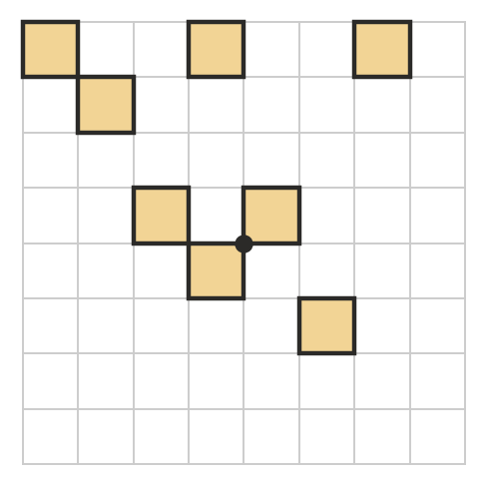
- On a digital clock, the digits 0, 1 and 8 look the same upside down, and 6 and 9 turn into each other. A number has rotational symmetry if it looks the same after a half turn, like 1691.
  - How many 4-digit numbers have this kind of rotational symmetry? Explain how you counted. ______________
  - Which years from 1000 to 2999 have it? ______________
- On the grid, draw two separate shapes: one with rotational symmetry of order 2 but no lines of symmetry, and one with exactly 1 line of symmetry.
- 