14.06 Line and rotational symmetry
Year 7 Maths · Worksheet · Level 1 · Warm-up
Name: ____________________ Date: ______________
This worksheet practises finding lines of symmetry and rotational symmetry. Tip: a line of symmetry is a fold line where the two halves match exactly. For rotational symmetry, trace the shape and turn the tracing about the centre. Count how many times it fits exactly on top of the shape in one full turn: that number is the order of rotational symmetry.

 Understanding
- Fill in the gaps.
  - A line that splits a shape into two matching mirror halves is called a line of ______________
  - A shape has rotational symmetry if it fits exactly onto itself when it is ______________ less than a full turn.
  - The number of times a shape fits onto itself in one full turn is called its ______________ of rotational symmetry.
  - A shape that only fits onto itself after a full turn has rotational symmetry of order ______________
- Draw all the lines of symmetry on each shape with a ruler. Then write how many lines of symmetry each shape has.
- 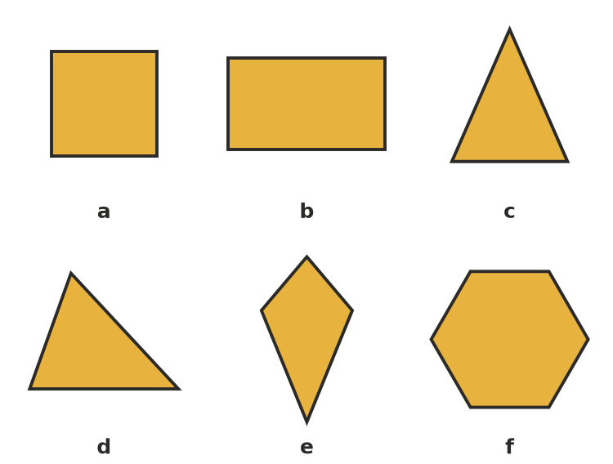
  - ______________ b) ______________ c) ______________ d) ______________ e) ______________ f) ______________
- How many lines of symmetry does each capital letter have?
Letter | H | E | A | N | X | Z
Lines of symmetry

 Fluency
- Complete each pattern so that the dashed line is a line of symmetry. Shade the squares.
  - The mirror line goes up and down.
- 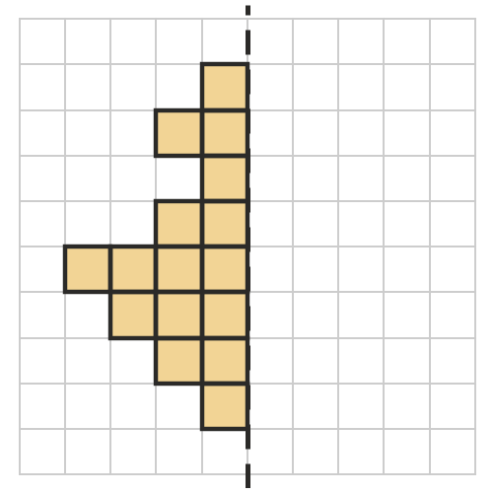
  - The mirror line goes across.
- 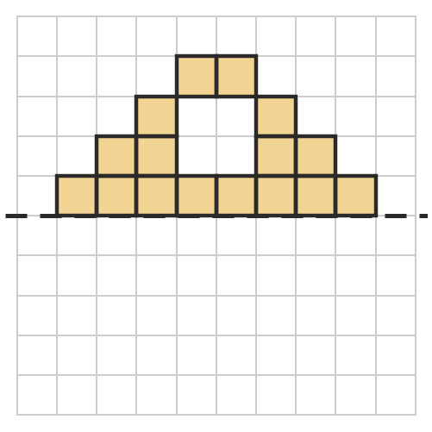
- Write the order of rotational symmetry of each shape.
- 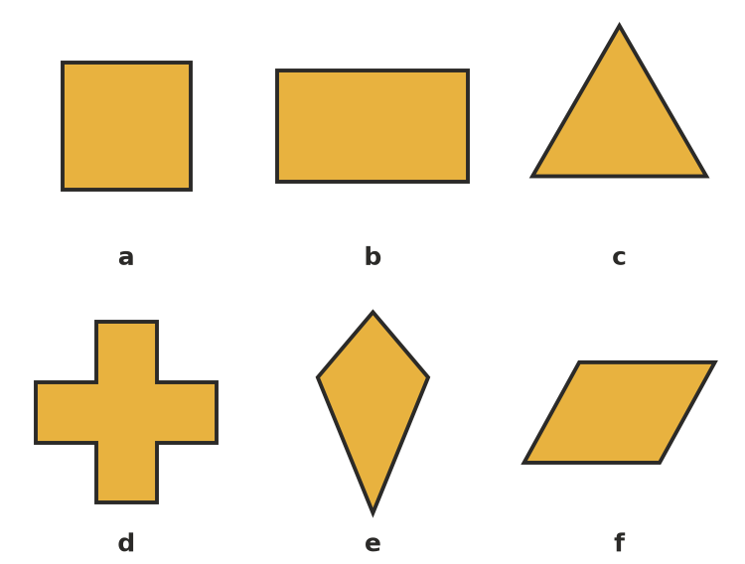
  - ______________ b) ______________ c) ______________ d) ______________ e) ______________ f) ______________
- Complete the table for these regular polygons.
Shape | Number of sides | Lines of symmetry | Order of rotational symmetry
equilateral triangle | 3
square | 4
regular pentagon | 5
regular hexagon | 6

 Reasoning
- A shape has rotational symmetry of order 1. What does that tell you about the shape?

- Look at the kite in Question 5 e). Does it have line symmetry? Does it have rotational symmetry? Explain what this shows.

 Problem solving
- Which of these letters look exactly the same after a half turn? Circle them.
- H N S E T Z
- On the grid, draw a shape that has exactly 2 lines of symmetry. Draw the lines of symmetry as dashed lines.
- 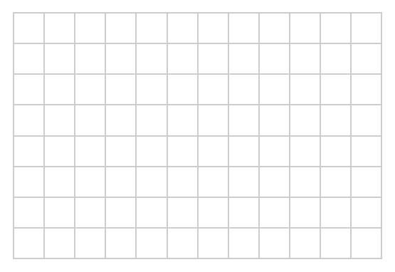
- How many lines of symmetry does a circle have? Explain.

