14.06 Line and rotational symmetry
Year 7 Maths · A5 question sheet · Level 2 · Core
This worksheet practises finding lines of symmetry and the order of rotational symmetry, and completing symmetrical designs. Tip: if a shape has rotational symmetry of order n, the smallest turn that fits it onto itself is 360° ÷ n.

 Understanding
- Copy and fill in the gaps.
  - A rectangle (not a square) has ______________ lines of symmetry and rotational symmetry of order
  - A shape with rotational symmetry of order 4 fits onto itself every ______________ degrees.
  - A regular polygon with 8 sides has ______________ lines of symmetry.
- For each shape, write the number of lines of symmetry and the order of rotational symmetry.
- 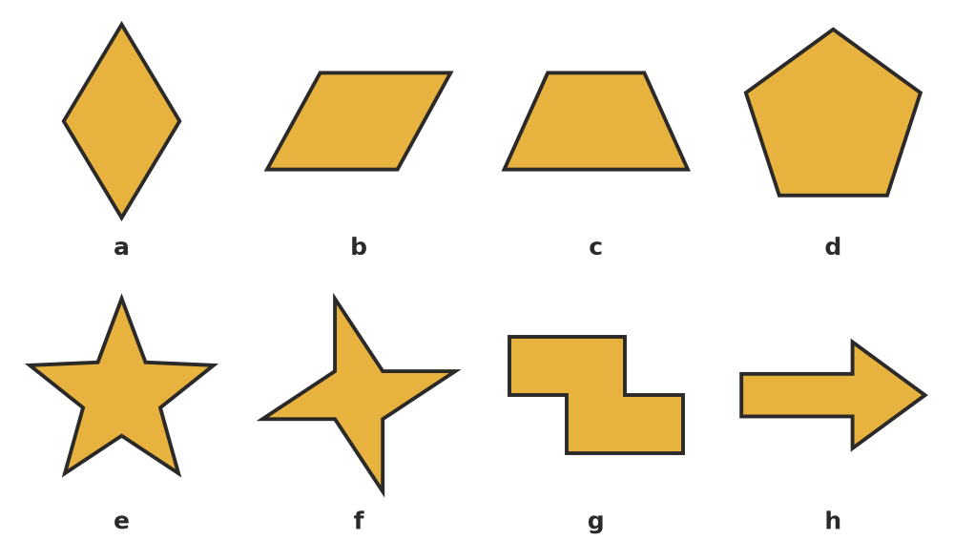
Shape | a | b | c | d | e | f | g | h
Lines of symmetry
Order of rotational symmetry

- Copy and complete the table for these capital letters (written in plain block capitals).
Letter | H | N | S | T | X | M | Z | I
Lines of symmetry
Order of rotational symmetry

 Fluency
- Copy and complete the design so that both dashed lines are lines of symmetry. Shade the squares.
- 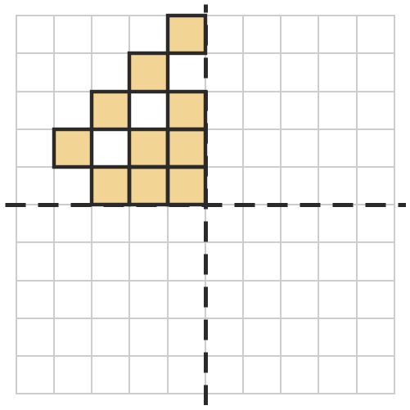
- Copy and complete the design so that it has rotational symmetry of order 2 about the dot. (Tip: each shaded square needs a partner the same distance from the dot, in exactly the opposite direction.)
- 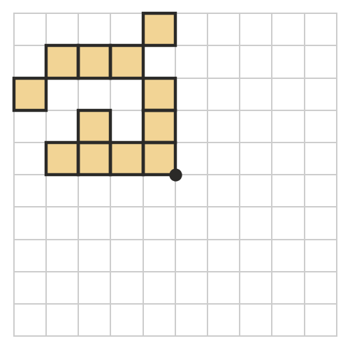
- Copy and complete the table for these regular polygons.
Number of sides | Lines of symmetry | Order of rotational symmetry
3
4
5
6
8
10

- Answer each question.
  - A shape has rotational symmetry of order 9. What is its smallest angle of rotation?
  - The smallest angle of rotation of a shape is 30°. What is its order of rotational symmetry?

 Reasoning
- Look at shape f in Question 2. Explain how a shape can have rotational symmetry but no lines of symmetry.
- Ben says, “A parallelogram has 2 lines of symmetry, because its opposite sides are the same length.” Is he right? Explain. (Tip: imagine folding it.)
- Explain why a regular pentagon has 5 lines of symmetry.

 Problem solving
- Shade the fewest extra squares so that the pattern has rotational symmetry of order 4 about the dot. How many extra squares did you shade?
- 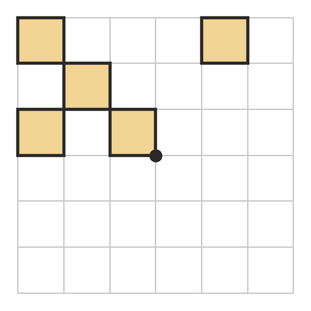
- On a digital clock, the digits 0, 1 and 8 look the same upside down, and 6 and 9 turn into each other. Using only these digits, find as many 3-digit numbers as you can that look exactly the same after a half turn (for example, 619). How many are there?

