14.05 Multiple transformations
Year 7 Maths · Worksheet · Level 3 · Challenge
Name: ____________________ Date: ______________
This worksheet practises combining two or three transformations, working backwards, and finding a single transformation that does the same job as several. Tip: write the coordinates after every step. The images are A′, then A″, then A‴.

 Understanding
- Start with the point (x, y). Write the final image after each pair of steps, and name a single transformation that does the same.
  - Reflect in the x-axis, then reflect in the y-axis. ______________
  - Rotate 180° about the origin, then reflect in the x-axis. ______________
  - Rotate 90° clockwise about the origin, then rotate 90° clockwise about the origin again. ______________
- Complete the table.
Point | Step 1 | Step 2 | Step 3 | Final image
(4, 1) | reflect in the y-axis | translate 2 right and 3 down | rotate 90° anticlockwise about the origin
(−3, 5) | rotate 180° about the origin | reflect in the x-axis | translate 6 left
(2, −6) | translate 1 left and 4 up | rotate 90° clockwise about the origin | reflect in the y-axis

- Look at shapes A and B.
- 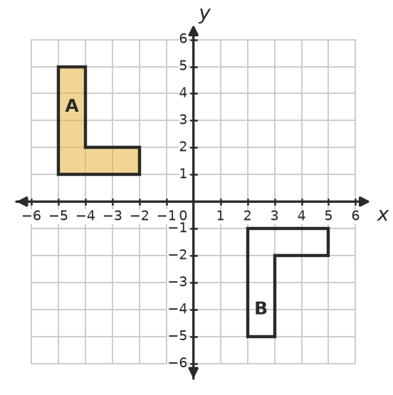
  - Explain why no single translation, rotation or reflection in an axis maps A onto B. ______________
  - Describe two transformations that do map A onto B. ______________

 Fluency
- Reflect triangle PQR in the dashed line x = 1. Then rotate the image 180° about the origin. Draw both images and write the coordinates of P″Q″R″.
- 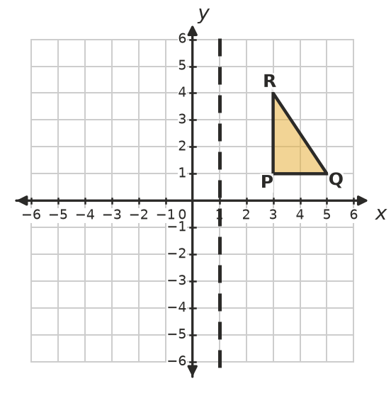
- P″ = ______________ Q″ = ______________ R″ = ______________
- Transform triangle JKL in three steps. Draw each image.
- Step 1: translate 2 units left and 3 units up. Step 2: reflect in the x-axis. Step 3: rotate 90° anticlockwise about the origin.
- 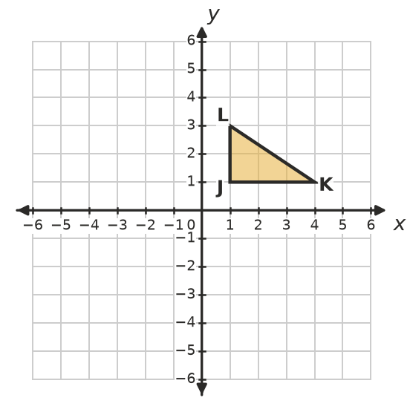
- J‴ = ______________ K‴ = ______________ L‴ = ______________
- Reflect each point in the line x = 1, then reflect the image in the line x = 4.
  - (0, 0) ______________
  - (3, 2) ______________
  - (−2, 5) ______________
  - What single transformation does the same as these two reflections? ______________
- Name a single transformation that does the same as each combination.
  - Translate 4 right, then translate 6 left and 3 up. ______________
  - Rotate 90° clockwise about the origin three times in a row. ______________

 Reasoning
- Explain why reflecting in the x-axis and then in the y-axis always gives the same result as a 180° rotation about the origin.

- Can a reflection followed by a translation ever give the same image as a single rotation? Explain. (Tip: think about whether the image is back to front.)

- A shape is rotated 90° clockwise about the origin and then translated 3 units right. Describe the steps that would move the image back to the object, in order.

 Problem solving
- Point P is reflected in the y-axis, then translated 2 units right and 5 units down, then rotated 180° about the origin. It finishes at (−3, 1). Find P. Show your steps.

- The point A(4, −2) is moved to A′(2, 4). Find three different ways to do this:
  - using one translation ______________
  - using one rotation about the origin ______________
  - using a reflection in an axis followed by a translation ______________

