14.05 Multiple transformations
Year 7 Maths · Worksheet · Level 2 · Core
Name: ____________________ Date: ______________
This worksheet practises combining translations, reflections and rotations on the number plane. Tip: work one step at a time and write the coordinates after each step. The first image of A is A′, and the image of A′ is A″.

 Understanding
- Fill in the gaps.
  - The image of A′ is written ______________
  - Reflecting in the y-axis changes the sign of the ______________ coordinate.
  - Rotating 180° about the origin changes the sign of ______________ coordinates.
- Complete the table.
Point | First step | After step 1 | Second step | After step 2
(3, 2) | reflect in the x-axis |  | translate 4 left
(−5, 1) | reflect in the y-axis |  | rotate 180° about the origin
(2, −4) | rotate 90° clockwise about the origin |  | translate 3 up
(−1, −3) | translate 5 right and 2 up |  | reflect in the y-axis

- Flag A was transformed to flag B, and then flag B was transformed to flag C.
- 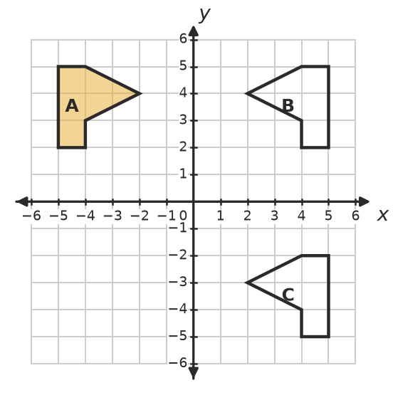
  - Describe the transformation from A to B. ______________
  - Describe the transformation from B to C. ______________

 Fluency
- Reflect triangle ABC in the x-axis to get A′B′C′. Then translate A′B′C′ 6 units right to get A″B″C″. Draw both images and write the coordinates of A″B″C″.
- 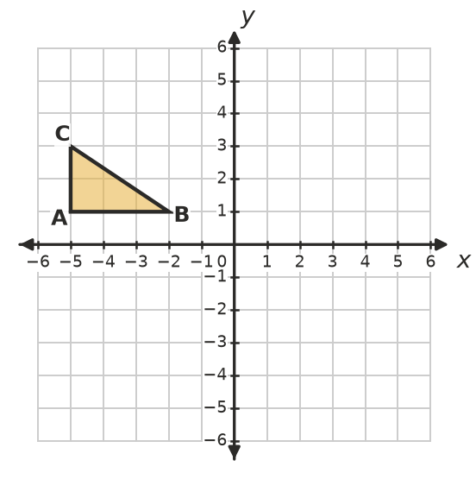
- A″ = ______________ B″ = ______________ C″ = ______________
- Rotate the flag 180° about the origin. Then reflect the image in the y-axis. Draw both images. Where does the tip of the flag, (4, 4), finish? ______________
- 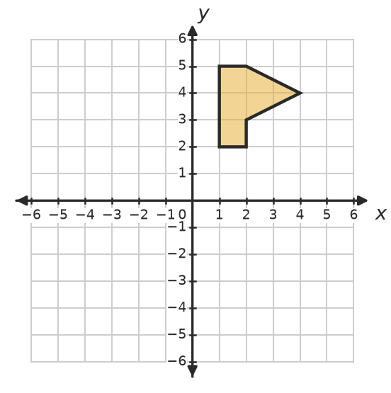
- Reflect triangle DEF in the y-axis to get D′E′F′. Then reflect D′E′F′ in the x-axis to get D″E″F″. Draw both images and write the coordinates of D″E″F″.
- 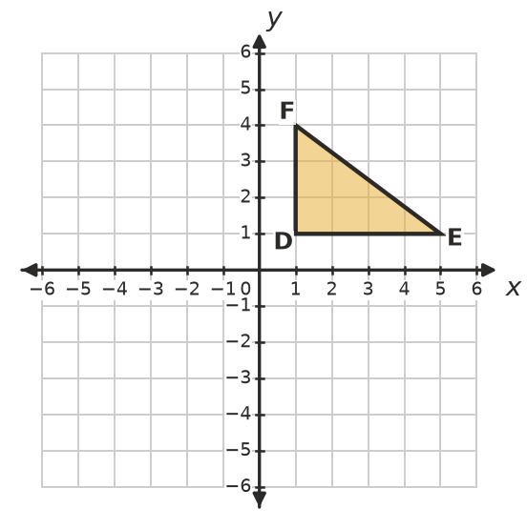
- D″ = ______________ E″ = ______________ F″ = ______________
- Start with the point (2, 1) each time.
  - Rotate it 90° clockwise about the origin, then reflect it in the x-axis. ______________
  - Reflect it in the x-axis, then rotate it 90° clockwise about the origin. ______________
  - Does the order matter? ______________

 Reasoning
- In Question 6, one single transformation takes DEF straight to D″E″F″. Name it and explain how the coordinates show this.

- Does the order matter when you do two translations? Explain.

- Kim reflects (3, 4) in the y-axis and then in the x-axis. She writes (−3, 4). What has she done wrong? What is the correct answer?

 Problem solving
- A point is reflected in the x-axis and then translated 3 units right and 1 unit up. It finishes at (1, 4). Where did it start? Work backwards and show your steps.

- Describe two transformations that move flag P onto flag Q.
- 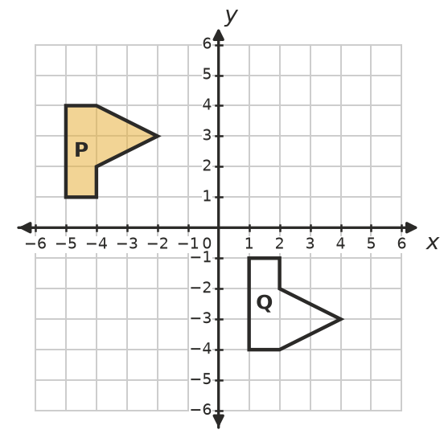

- Look at Question 5. Which single transformation takes the original flag straight to its final position? ______________

