14.05 Multiple transformations
Year 7 Maths · A5 question sheet · Level 1 · Warm-up
This worksheet practises doing two transformations one after the other. Tip: do one step at a time. Draw the first image lightly, then transform that image to get the final one. The first image of A is A′ (“A dash”), and the image of A′ is A″ (“A double dash”).

 Understanding
- Copy and fill in the gaps.
  - Point A is translated to A′. Then A′ is reflected. The final image is called
  - When you do two transformations, you do the second one to the ______________ image, not to the object.
  - After any number of translations, reflections and rotations, the final image is still ______________ to the object.
- Copy and complete the table. Do the first translation, then the second.
Point | First translation | After step 1 | Second translation | After step 2
(1, 2) | 3 right |  | 4 up
(6, 5) | 2 left |  | 3 down
(3, 7) | 5 right |  | 6 down

- Flag A was transformed to A′, and then A′ was transformed to A″.
- 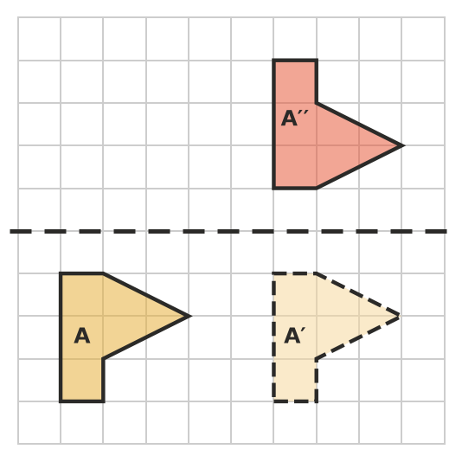
  - Which transformation takes A to A′? Describe it fully.
  - Which transformation takes A′ to A″?

 Fluency
- Translate the flag 4 squares right. Then reflect the image in the dashed line. Draw both images.
- 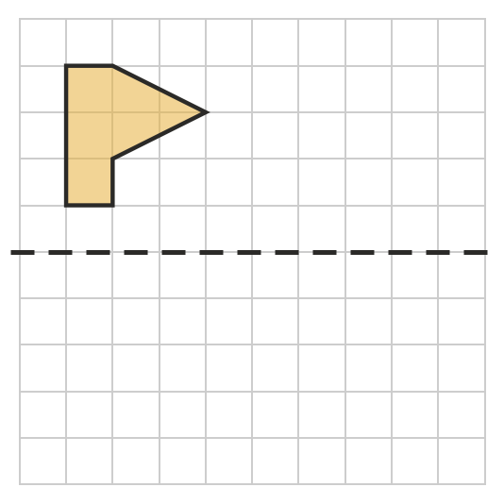
- Reflect the shape in the dashed line. Then translate the image 3 squares down. Draw both images.
- 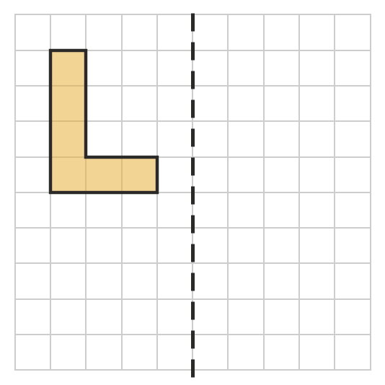
- Reflect the flag in the horizontal dashed line. Then reflect the image in the vertical dashed line. Draw both images.
- 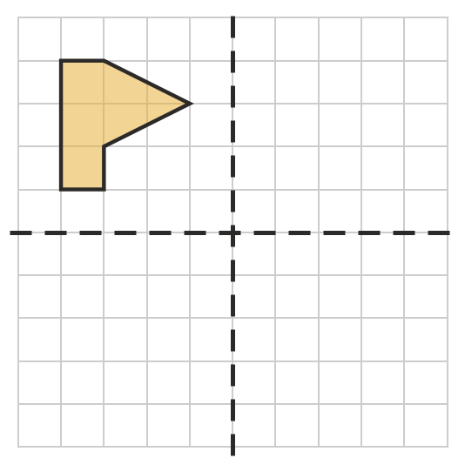

 Reasoning
- Look at your answer to Question 6. Which single transformation would take the flag straight to its final position? Explain.
- On a number plane, the mirror line is the vertical line through 5 on the x-axis. Start with the point (1, 2).
  - Translate it 2 right, then reflect it in the mirror line. Where does it finish?
  - Now start again. Reflect (1, 2) in the mirror line first, then translate it 2 right. Where does it finish?
  - Does the order of the transformations matter?

 Problem solving
- A counter is translated 3 right and 2 up, and then 4 right and 1 down. Describe one translation that does the same thing.
- A shape is reflected in a mirror line, and then the image is reflected in the same mirror line again. Where does the shape end up? Explain.
- Look at Question 3 again. Describe a different pair of transformations that takes flag A to A″. (Tip: try doing the two steps in the other order.)

