Investigation: Tessellations
Year 7 Maths · A5 question sheet
A tessellation is a pattern of shapes that covers a flat surface with no gaps and no overlaps, and could keep going forever in every direction. You see tessellations in brick walls, floor tiles, pavers and the cells of a honeycomb. In this investigation you will test which regular polygons tessellate, find out why, and then design a tessellating tile of your own. You will need scissors, a ruler, a pencil and some coloured pencils.

Part A: What is a tessellation?
- Look at the three tessellations below.
- 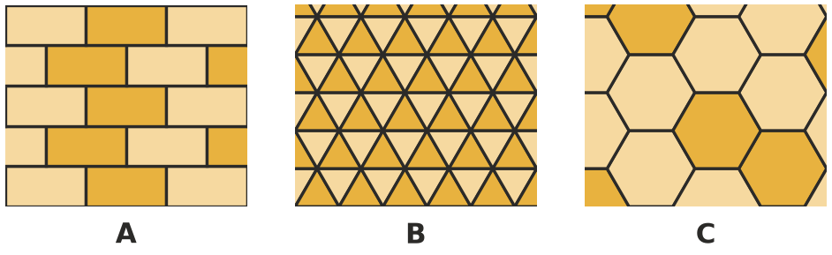
  - Which shape is used in tessellation A?
  - Which shape is used in tessellation B?
  - Which shape is used in tessellation C? Where in nature do you see this pattern?
- List three tessellations you can find at school or at home. For each one, name the shape that is repeated.

Part B: Which regular polygons tessellate?
A regular polygon has all its sides the same length and all its angles the same size. The shapes below are printed at real size, with every side 2 cm long. Cut them out (or trace each one several times) and use them to test whether copies of each shape fit together around a point with no gaps and no overlaps.
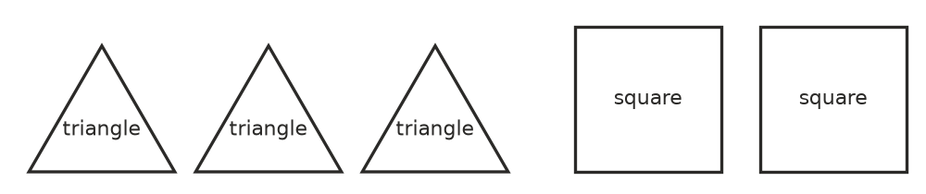
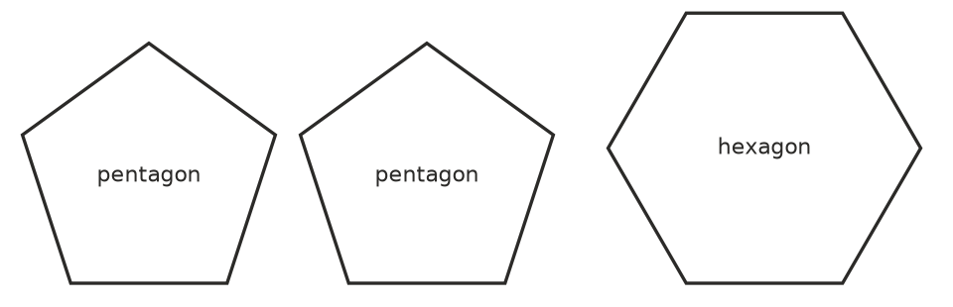
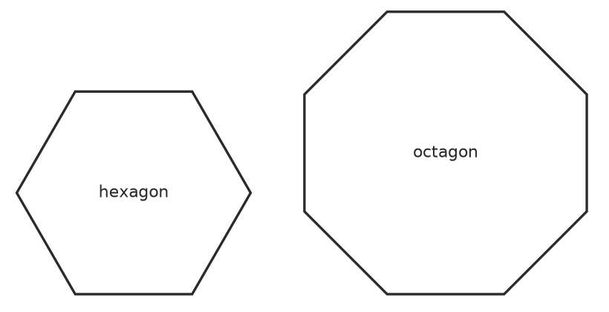
- Where the corners of the tiles meet at a point, the angles must add to exactly 360°, a full turn. Copy and complete the table. In the fourth column, work out 360 ÷ the angle.
Regular polygon | Number of sides | Size of each angle | 360 ÷ angle | Whole number?
triangle | 3 | 60°
square | 4 | 90°
pentagon | 5 | 108°
hexagon | 6 | 120°
octagon | 8 | 135°
decagon | 10 | 144°
dodecagon | 12 | 150°

- When you fitted three pentagons around a point, what did you notice? Use the picture and the angle sizes to explain.
- 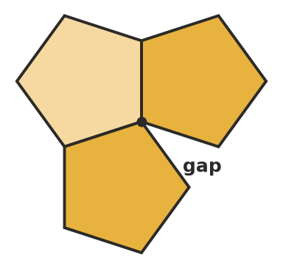
- Which regular polygons tessellate on their own? Write a rule, using angles, for deciding whether a regular polygon will tessellate.
- The angles of a regular polygon get bigger as the number of sides grows, but they are always less than 180°. Explain why no regular polygon with more than 6 sides can tessellate on its own.

Part C: Mixing shapes
Some tessellations use two or more kinds of regular polygon. The angles meeting at each point must still add to 360°.
- This tessellation uses regular octagons and squares.
- 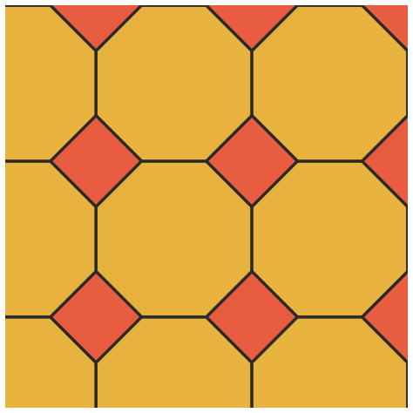
  - How many octagons and how many squares meet at each point where corners meet?
  - Show that the angles at that point add to 360°.
- Find other mixes of regular polygons whose angles add to 360° at a point. Use the angles from Question 3. One row is done for you. Test your mixes with the cut-out shapes.
Shapes meeting at a point | Angle sum
1 square + 2 octagons | 90° + 135° + 135° = 360°

Part D: Transformations in tessellations
- Look again at the tessellations in Question 1.
  - In tessellation A (the brick wall), which transformation moves one brick onto the next brick in the same row?
  - In tessellation B, an upward-pointing triangle sits next to a downward-pointing triangle. Which transformation moves one onto the other?
  - In tessellation C, describe a transformation that moves one hexagon onto a neighbouring hexagon.

Part E: Design your own tile
The Dutch artist M. C. Escher made famous tessellations of birds, fish and lizards. He started with a shape that tessellates, such as a square, and changed it. Here is one way to do it, called the nibble method.
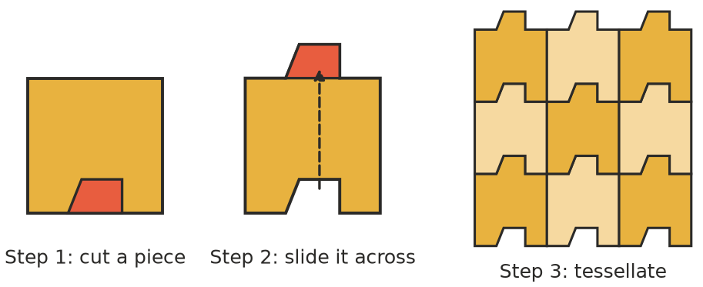
- Step 1: Start with a square. Cut (nibble) a piece out of one side.
- Step 2: Translate the piece straight across to the opposite side and stick it on. The area of the tile has not changed.
- Step 3: Trace around your tile again and again, sliding it so that the bumps fit into the gaps.
- Design your own tile using the nibble method. You can nibble from two sides (one pair of opposite sides each) to make it more interesting. Draw your tile, then tessellate it on a copy of the grid in your book below at least six times. Colour your design and add details to turn your tile into an animal, a person or an object.
- 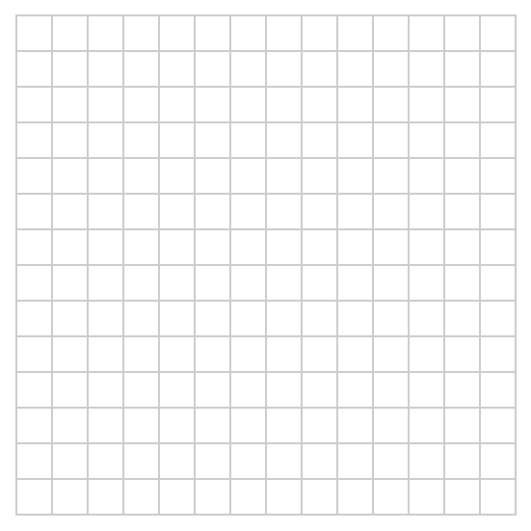
- Which transformation did you use to move the nibbled piece? Which transformation did you use to repeat the tile across the grid?
- Explain why a tile made by the nibble method from a square must still tessellate.

