14.04 Rotations
Year 7 Maths · Worksheet · Level 3 · Challenge
Name: ____________________ Date: ______________
This worksheet practises rotations about the origin and about other points, rules for rotating coordinates, and finding the centre and angle of a rotation. Tip: to find a centre of rotation, use tracing paper. Trace the object, put your pencil on a grid point you think might be the centre, and turn. If the tracing lands exactly on the image, you have found it.

 Understanding
- Use a sketch to rotate the point (3, 1) about the origin. Then use the pattern to complete each rule.
  - 90° clockwise: (3, 1) → ______________ so (x, y) → ______________
  - 90° anticlockwise: (3, 1) → ______________ so (x, y) → ______________
  - 180°: (3, 1) → ______________ so (x, y) → ______________
- Complete the table. All rotations are about the origin.
Point | 90° clockwise | 90° anticlockwise | 180°
(4, 2)
(−5, 3)
(−1, −6)
(0, −3)

- Each yellow shape has been rotated to make the red shape. Find the centre of rotation and describe the rotation fully (centre, angle and direction).
  - ______________
- 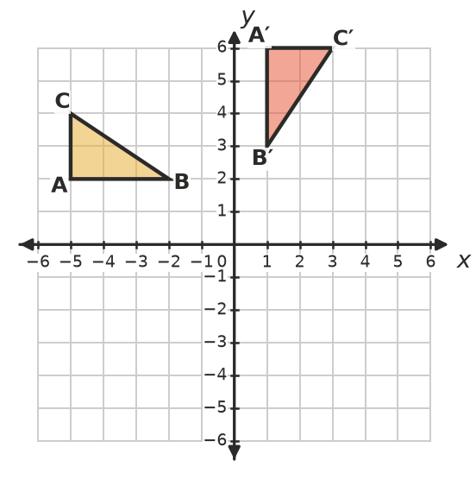
  - ______________
- 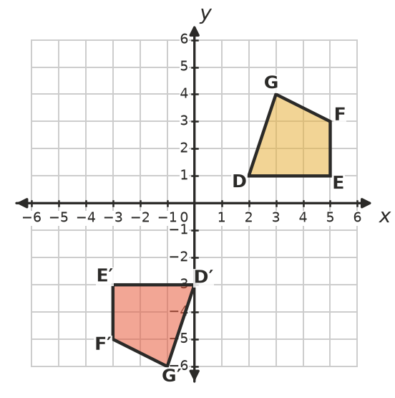

 Fluency
- Rotate quadrilateral PQRS 90° anticlockwise about the origin. Draw the image and write its coordinates.
- 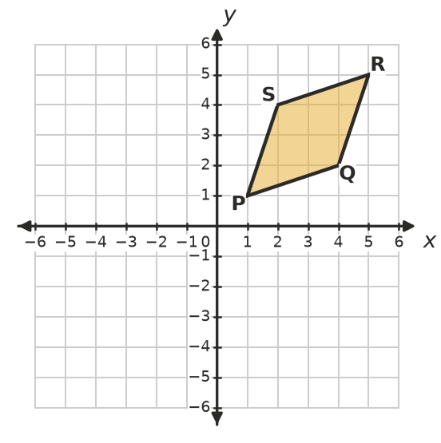
- P′ = ______________ Q′ = ______________ R′ = ______________ S′ = ______________
- Rotate triangle KLM 180° about point C(−1, 1). Draw the image and write its coordinates.
- 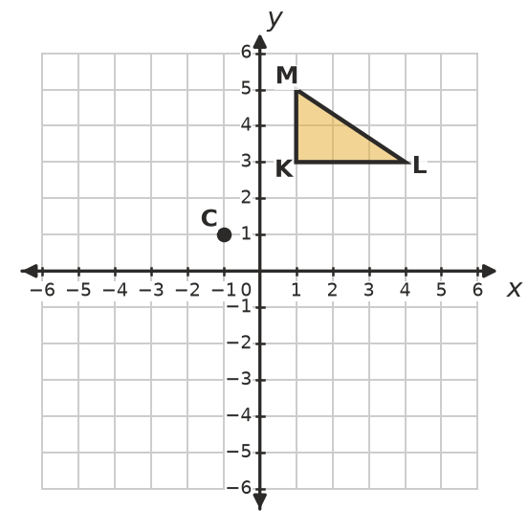
- K′ = ______________ L′ = ______________ M′ = ______________
- Rotate the flag 270° clockwise about point P(2, −1). Draw the image. Where does the tip of the flag, (5, 1), end up? ______________
- 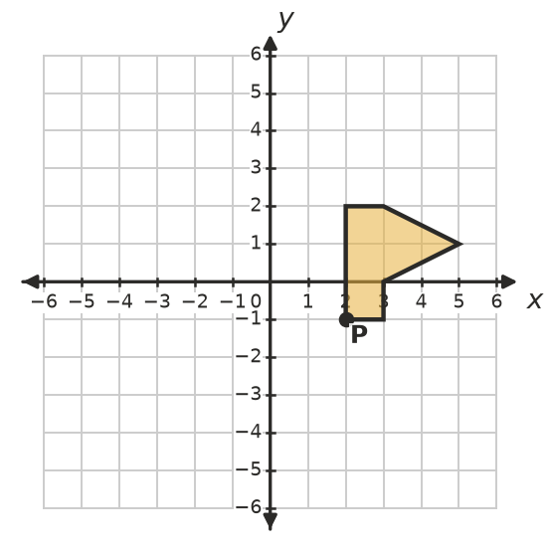
- Rotate each point 180° about the point (2, 1).
  - (5, 4) ______________
  - (0, −3) ______________
  - (2, 1) ______________
  - (−3, 2) ______________

 Reasoning
- Use a sketch of the point (3, 1) to explain why a rotation of 90° clockwise about the origin swaps the coordinates and changes the sign of one of them.

- Noah says a rotation of 450° clockwise is the same as a rotation of 90° clockwise. Is he right? Explain.

- A point is rotated 90° clockwise about the origin, four times in a row. Where does it end up? Explain.

 Problem solving
- A Ferris wheel has 12 gondolas, equally spaced and numbered 1 to 12 going clockwise. The wheel turns clockwise.
  - What angle does the wheel turn through to move gondola 1 into the place where gondola 4 was? ______________
  - What angle (clockwise) moves gondola 1 into the place where gondola 9 was? ______________
  - What smaller angle, turning the other way, would do the same as part b)? ______________
- A point P is rotated 90° clockwise about the origin. Its image is (−3, 5). Find P. Show how you checked your answer.

- The triangle with corners (0, 0), (4, 0) and (0, 2) is rotated 90°, 180° and 270° anticlockwise about the origin. Draw the three images on the grid.
- 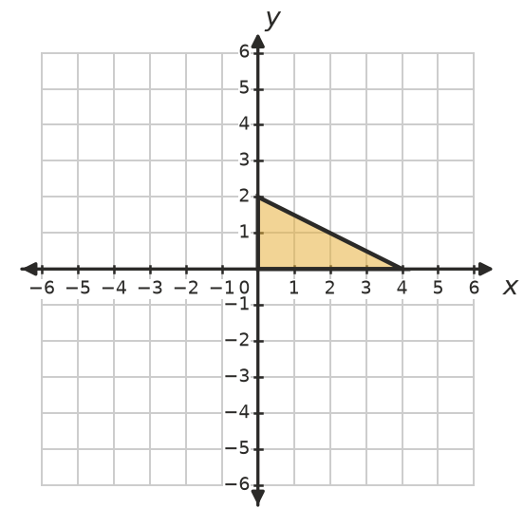
  - What is the total area of the shape made by all four triangles? ______________
  - If you rotate the whole shape 90° about the origin, does it look different? Explain. ______________

