14.04 Rotations
Year 7 Maths · A5 question sheet · Level 2 · Core
This worksheet practises rotating points and shapes by 90° and 180° about the origin and about other points. Tip: use tracing paper. To check a 90° turn, a line from the centre to a corner of the object should be at right angles to the line from the centre to the matching corner of the image, and the same length.

 Understanding
- Copy and fill in the gaps.
  - A rotation of 180° is called a ______________ turn.
  - A rotation of 90° clockwise ends in the same place as a rotation of ______________ ° anticlockwise.
  - The only point that does not move in a rotation is the ______________ of rotation.
  - When (x, y) is rotated 180° about the origin, its image is (______________, ______________).
- Write an equal rotation in the other direction.
  - 90° clockwise = ______________ anticlockwise
  - 180° clockwise = ______________ anticlockwise
  - 270° anticlockwise = ______________ clockwise
- The yellow flag has been rotated about the origin to make flags 1, 2 and 3. Describe each rotation.
- 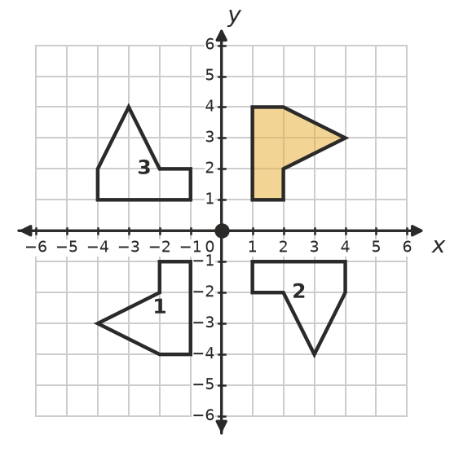
  - Flag 1:
  - Flag 2:
  - Flag 3:

 Fluency
- Rotate triangle ABC 180° about the origin. Draw the image, label it A′B′C′ and write its coordinates.
- 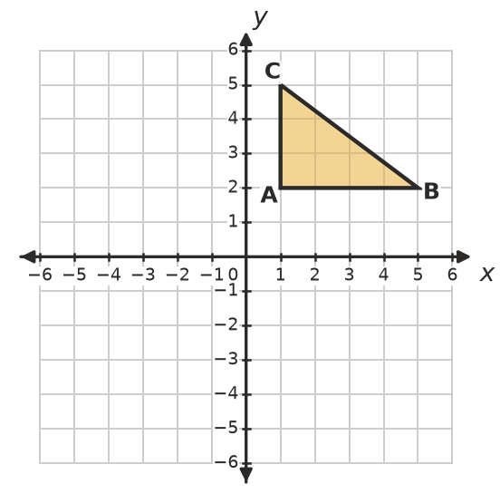
- Rotate triangle DEF 90° clockwise about the origin. Draw the image, label it D′E′F′ and write its coordinates.
- 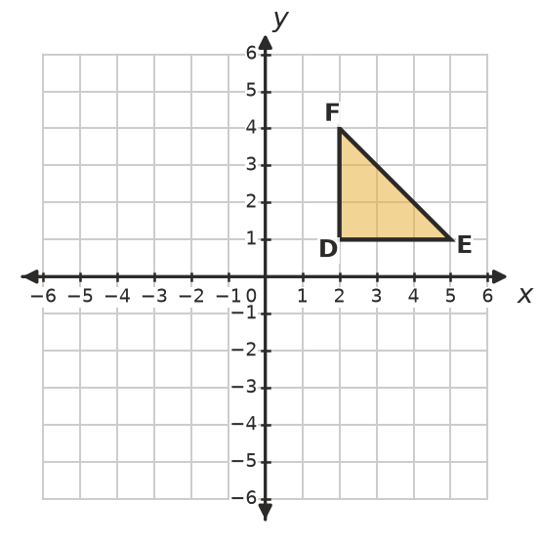
- Rotate the shape 90° anticlockwise about point P. Draw the image.
- 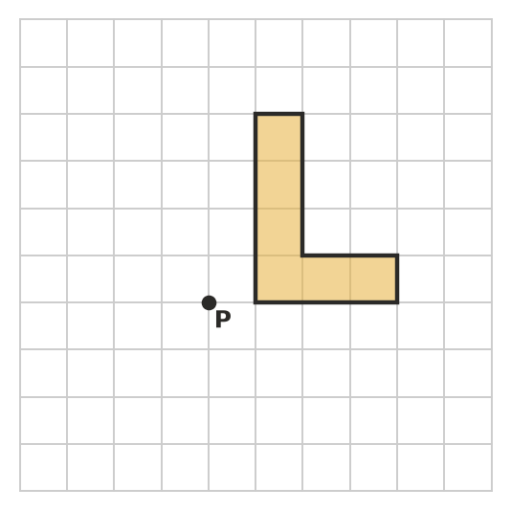
- Rotate each point 180° about the origin.
  - (3, −5)
  - (−2, −6)
  - (0, 4)
  - (−7, 1)

 Reasoning
- Explain why a rotation of 180° clockwise gives the same image as a rotation of 180° anticlockwise about the same centre.
- Jo rotates the point (3, 1) 90° clockwise about the origin and gets (−1, 3). Explain her mistake and find the correct image. (Tip: sketch it.)
- A point is rotated about the origin and its image is the same point. What can you say about the point? Explain.

 Problem solving
- Answer each question.
  - A(2, 5) is rotated 180° about the origin. Where is A′?
  - A point is rotated 180° about the origin and lands on (4, −1). Where did it start?
- A square has corners (1, 1), (3, 1), (3, 3) and (1, 3). It is rotated 90° clockwise about the corner (1, 1).
  - Find the corners of the image.
  - What is the area of the image? Explain.
- A clock’s hour hand turns 360° in 12 hours.
  - How many degrees does the hour hand turn in 1 hour?
  - How many degrees does the hour hand turn from 3 o’clock to 7 o’clock?
  - How many degrees does the minute hand turn in 20 minutes?

