14.04 Rotations
Year 7 Maths · A5 question sheet · Level 1 · Warm-up
This worksheet practises rotations: turning a shape about a fixed point called the centre of rotation. Tip: tracing paper makes rotations easy. Trace the shape and the dot, press your pencil point on the dot, turn the paper the right amount, then mark where the corners land.

 Understanding
- Copy and fill in the gaps.
  - A rotation turns a shape about a fixed point called the ______________ of rotation.
  - Turning the same way as the hands of a clock is called
  - Turning the opposite way to the hands of a clock is called
  - To describe a rotation, give the centre, the direction and the ______________ of turn.
- Copy and complete the table.
Amount of turn
a quarter turn
a half turn
a three-quarter turn
a full turn

- You are facing north. Which direction are you facing after each turn?
  - 90° clockwise
  - 180°
  - 90° anticlockwise
  - 270° clockwise
- Each yellow flag has been rotated about the dot to make the red flag. Describe each rotation (for example, “a quarter turn clockwise”).
  - 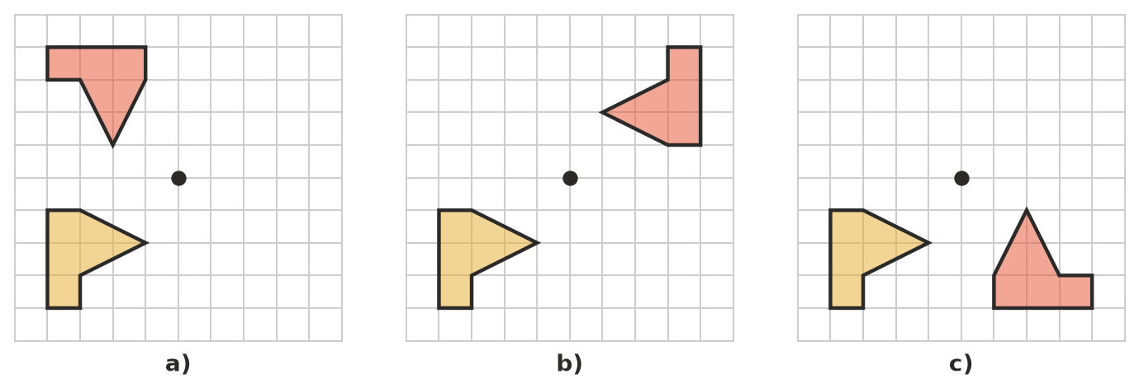

 Fluency
- Rotate the flag a half turn (180°) about the dot. Draw the image.
- 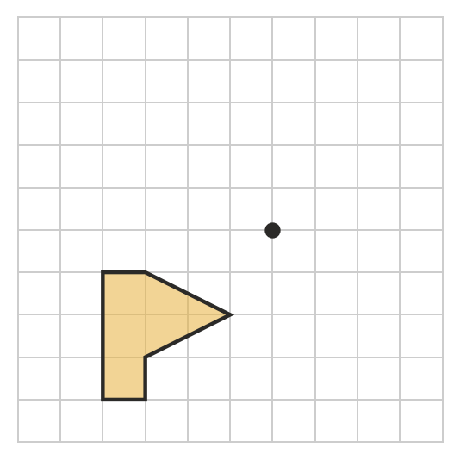
- Rotate the shape a quarter turn (90°) clockwise about the dot. Draw the image.
- 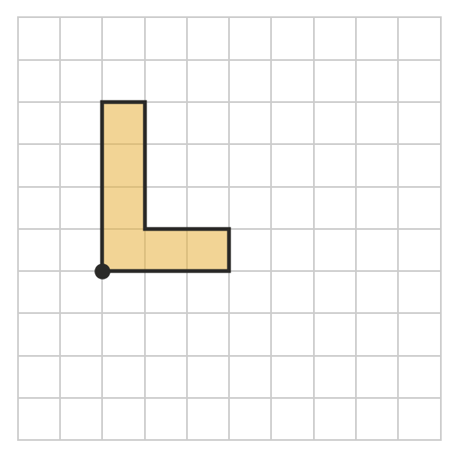
- Rotate the flag a quarter turn (90°) anticlockwise about the dot. Draw the image.
- 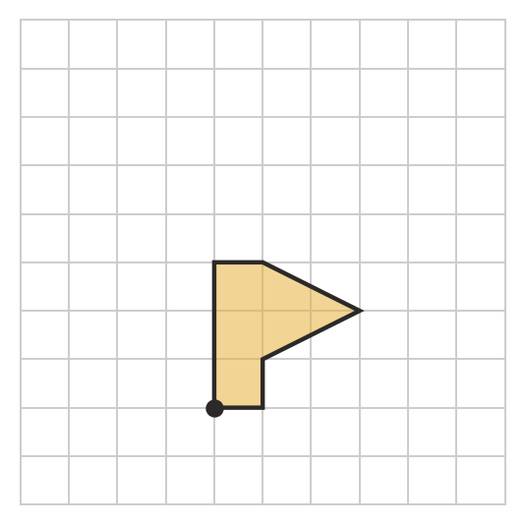

 Reasoning
- Explain why a turn of 270° clockwise ends in the same place as a turn of 90° anticlockwise.
- Mai rotates a shape a half turn clockwise. Leo rotates the same shape a half turn anticlockwise about the same point. Do their images match? Explain.

 Problem solving
- The minute hand of a clock turns 360° in one hour.
  - How many degrees does it turn in 15 minutes?
  - How many degrees does it turn in 30 minutes?
  - How many minutes does it take to turn 270°?
- What do you get when you rotate each of these 180° (a half turn)? Draw or write your answer.
  - the capital letter M
  - the small letter b
  - the number 6

