14.03 Reflections
Year 7 Maths · Worksheet · Level 3 · Challenge
Name: ____________________ Date: ______________
This worksheet practises reflections in the axes and in other horizontal, vertical and diagonal lines, and finding a mirror line from an object and its image. Tip: every point on the vertical line x = 2 has an x-coordinate of 2, and every point on the horizontal line y = −1 has a y-coordinate of −1. The mirror line is always exactly halfway between a point and its image.

 Understanding
- Write the rule for each reflection, in the form (x, y) → ( ______________ , ______________ ).
  - Reflection in the x-axis. ______________
  - Reflection in the y-axis. ______________
- Complete the table.
Point | In the x-axis | In the y-axis | In the line x = 2 | In the line y = −1
(5, 3)
(−1, −4)
(2, 6)
(0, −1)

- Each yellow shape has been reflected to make the red shape. Draw the mirror line on each grid and write its equation.
  - ______________
- 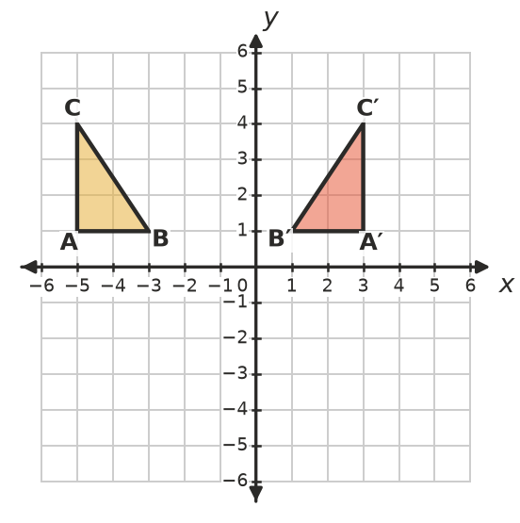
  - ______________
- 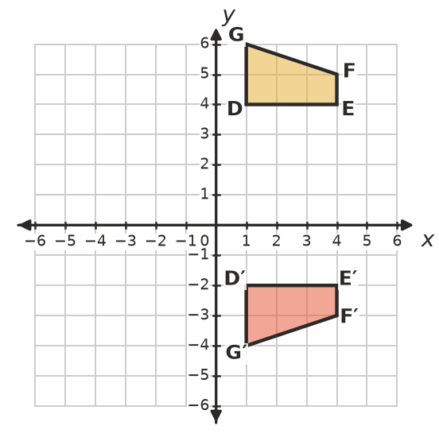

 Fluency
- Reflect quadrilateral PQRS in the dashed line x = −1. Draw the image, label it P′Q′R′S′ and write its coordinates.
- 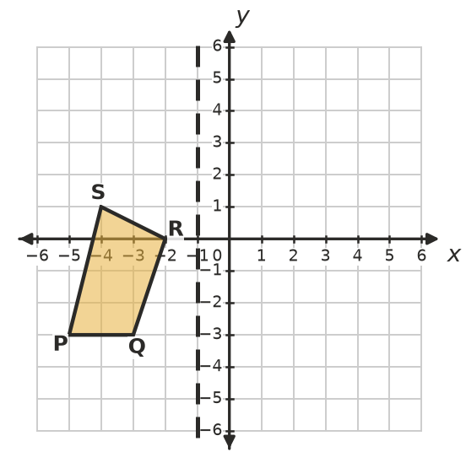
- P′ = ______________ Q′ = ______________ R′ = ______________ S′ = ______________
- Reflect the flag in the dashed line y = 1. Draw the image. Then write the coordinates of the image of the tip of the flag, (5, −2). ______________
- 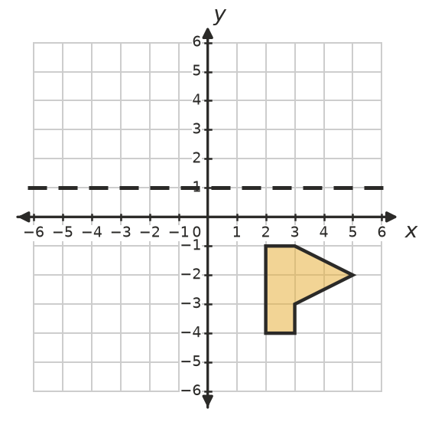
- Reflect the triangle in the dashed diagonal mirror line. Draw the image. (Tip: for a diagonal line, count the squares diagonally. Each point moves along a diagonal that crosses the mirror line at right angles.)
- 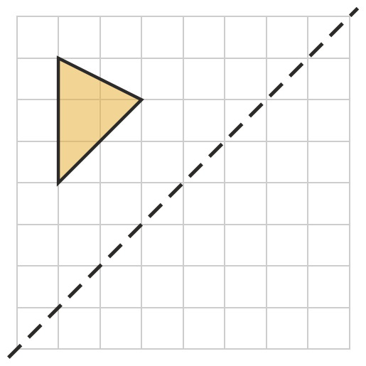
- Triangle XYZ crosses the y-axis. Reflect it in the y-axis. Draw the image, label it X′Y′Z′ and write its coordinates.
- 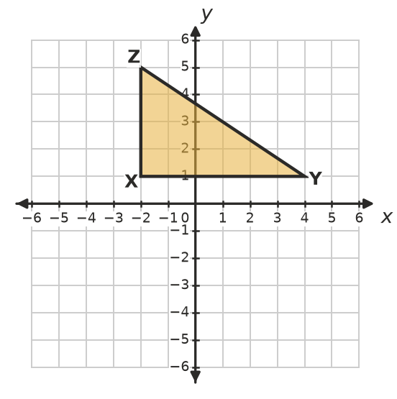
- X′ = ______________ Y′ = ______________ Z′ = ______________

 Reasoning
- Point A is reflected to A′. Explain how the mirror line is related to the line segment AA′. Use the words “halfway” and “right angles”.

- Ava reflects (7, 2) in the line x = 3 and gets (−7, 2). Explain her mistake and find the correct image.

- Can a whole shape be its own image after a reflection? If so, describe a shape and a mirror line that would do this.

 Problem solving
- Find the equation of the mirror line for each reflection.
  - A(−5, 3) is reflected to A′(3, 3). ______________
  - B(2, −6) is reflected to B′(2, 4). ______________
  - C(−3, 0) is reflected to C′(7, 0). ______________
- When point P is reflected in the y-axis, its image is (−2, 9). Where is the image of P when P is reflected in the x-axis instead? Show your thinking.

- A rectangle has corners (1, 1), (3, 1), (3, 4) and (1, 4). It is reflected in the vertical line x = k. The rectangle and its image fit together, with no gap and no overlap, to make one larger rectangle.
  - Find both possible values of k. ______________
  - Find the area of the larger rectangle. ______________

