14.03 Reflections
Year 7 Maths · Worksheet · Level 2 · Core
Name: ____________________ Date: ______________
This worksheet practises reflecting points and shapes in the x-axis, the y-axis and other mirror lines on the number plane. Tip: when you reflect in the x-axis, the x-coordinate stays the same and the y-coordinate changes sign. When you reflect in the y-axis, the y-coordinate stays the same and the x-coordinate changes sign.

 Understanding
- Fill in the gaps.
  - When (4, 3) is reflected in the x-axis, its image is (4, ______________).
  - When (4, 3) is reflected in the y-axis, its image is (______________, 3).
  - A point on the mirror line is its own ______________
  - The line joining a point to its image crosses the mirror line at a ______________ angle.
- Complete the table.
Point | Reflected in the x-axis | Reflected in the y-axis
(3, 5)
(−4, 2)
(6, −1)
(−2, −7)
(0, 4)
(5, 0)

- Triangle T has been moved to make triangles 1, 2 and 3.
- 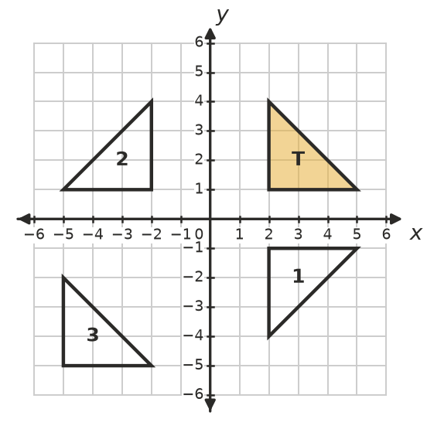
  - Which triangle is the reflection of T in the x-axis? ______________
  - Which triangle is the reflection of T in the y-axis? ______________
  - Which transformation moves T onto the other triangle? ______________

 Fluency
- Reflect triangle ABC in the x-axis. Draw the image, label it A′B′C′ and write its coordinates.
- 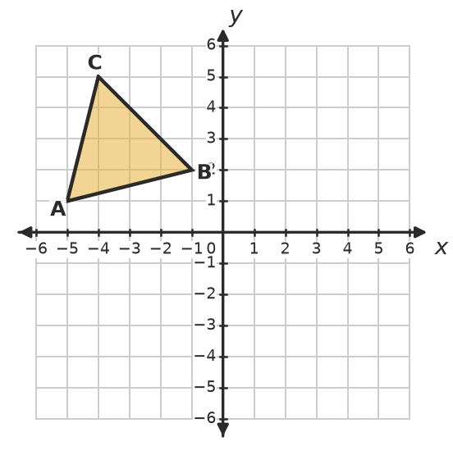
- A′ = ______________ B′ = ______________ C′ = ______________
- Reflect quadrilateral DEFG in the y-axis. Draw the image, label it D′E′F′G′ and write its coordinates.
- 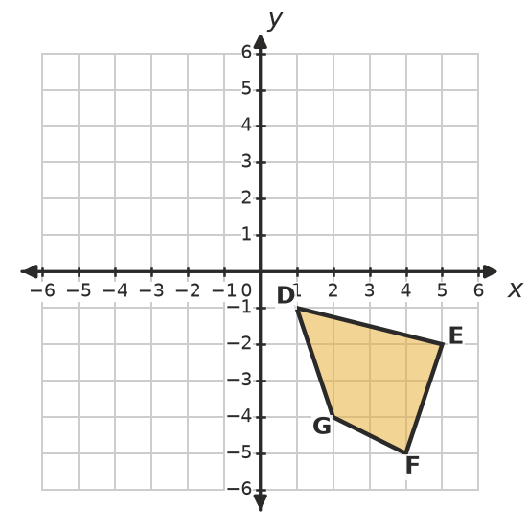
- D′ = ______________ E′ = ______________ F′ = ______________ G′ = ______________
- Reflect the flag in the dashed line x = 1. Draw the image.
- 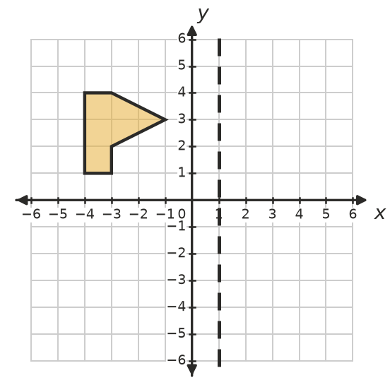
  - The tip of the flag is at (−1, 3). Where is its image? ______________
  - The bottom-left corner of the pole is at (−4, 1). Where is its image? ______________
- Reflect each point in the horizontal line y = 1. (Sketch the line on a number plane if it helps.)
  - (3, 4) ______________
  - (−2, 0) ______________
  - (5, 1) ______________
  - (−4, −3) ______________

 Reasoning
- Explain why the x-coordinate does not change when a point is reflected in the x-axis.

- Sam reflects (4, −3) in the y-axis and writes (4, 3). Explain his mistake and give the correct answer.

- Answer each question.
  - The point (a, 5) is reflected in the y-axis. Its image is (−3, 5). What is a? ______________
  - Which points are their own image when they are reflected in the x-axis? ______________

 Problem solving
- Find the mirror line for each reflection. (Tip: it is halfway between the point and its image.)
  - A(−4, 2) is reflected to A′(6, 2). ______________
  - B(3, 5) is reflected to B′(3, −1). ______________
- A rectangle has corners (0, 2), (4, 2), (4, 5) and (0, 5). It is reflected in the y-axis. Together, the rectangle and its image make one larger rectangle.
  - Write the corners of the image. ______________
  - What are the length and width of the larger rectangle? ______________
  - Find the area and perimeter of the larger rectangle. ______________
- Who am I?
  - I am a point in the 2nd quadrant. When I am reflected in the x-axis, I land on (−3, −7). ______________
  - I am a point in the 2nd quadrant. When I am reflected in the y-axis, I land on (5, 2). ______________

