14.03 Reflections
Year 7 Maths · Worksheet · Level 1 · Warm-up
Name: ____________________ Date: ______________
This worksheet practises reflecting points and shapes in a mirror line. Tip: reflect one corner at a time. Count how many squares the corner is from the mirror line, then count the same number of squares on the other side, straight across the line.

 Understanding
- Fill in the gaps.
  - A reflection flips a shape over a ______________ line.
  - Each point of the image is the ______________ distance from the mirror line as the matching point of the object, but on the other side.
  - A point that is on the mirror line ______________ move.
  - After a reflection, the image looks back to ______________
- Reflect each point in the dashed mirror line. Mark the image and label it A′, B′, C′ and D′.
- 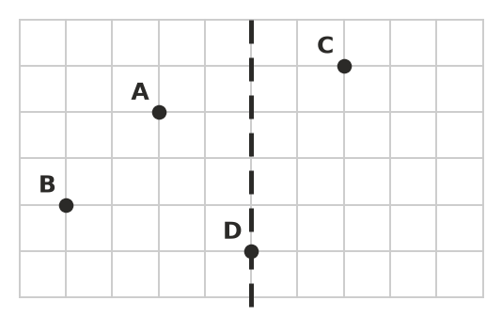
  - Point A is 2 squares to the left of the mirror line. So A′ is ______________ squares to the ______________ of the line.
  - How many squares is B from the mirror line? ______________
  - Where is D′? Explain. ______________
- In which pictures has the yellow shape been correctly reflected in the dashed line? For each wrong one, say what went wrong.
- 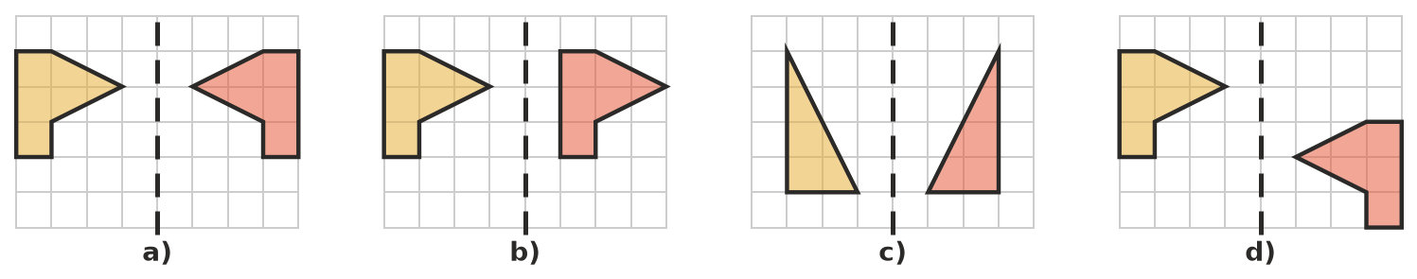
  - ______________
  - ______________
  - ______________
  - ______________

 Fluency
- Reflect the shape in the dashed mirror line. Draw the image.
- 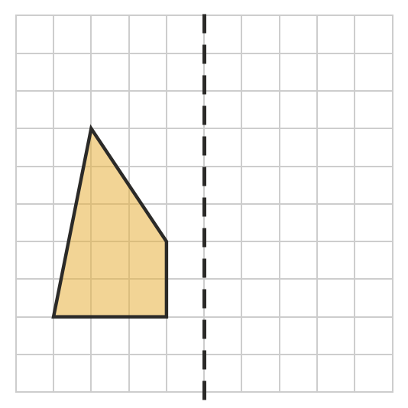
- Reflect the flag in the dashed mirror line. Draw the image.
- 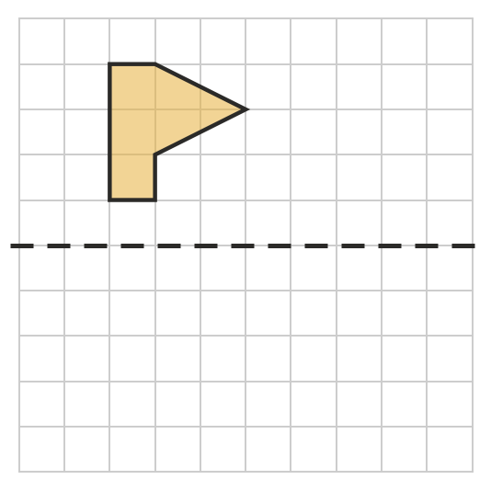
- Reflect the half-house in the dashed mirror line to finish the house.
- 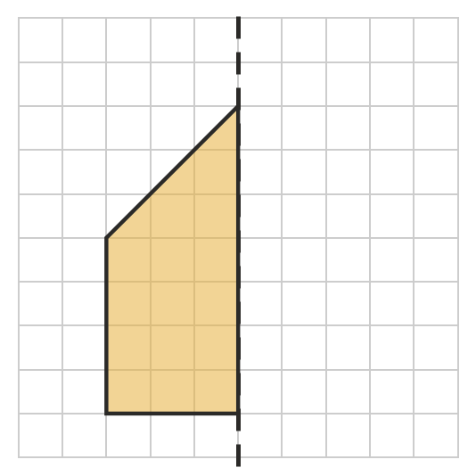
- Reflect each point in the dashed line x = 5. Mark the images on the grid and write their coordinates.
- 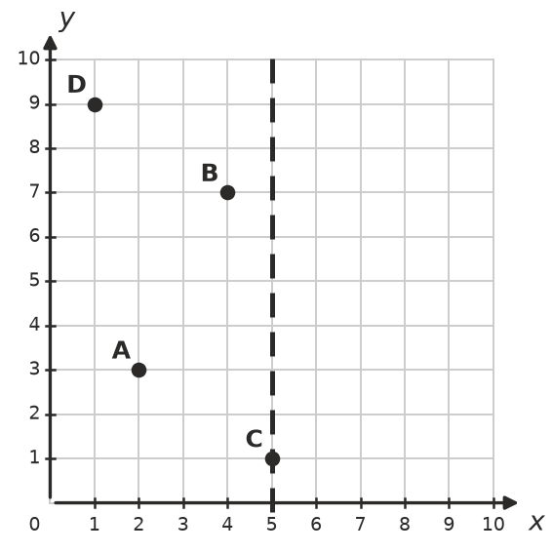
Point | Image
A(2, 3) | A′
B(4, 7) | B′
C(5, 1) | C′
D(1, 9) | D′

 Reasoning
- In Question 7, point C did not move. Explain why.

- Look at the y-coordinates in Question 7. What do you notice about the y-coordinate of each point and its image? Why does this happen?

 Problem solving
- Which of these capital letters look exactly the same after they are reflected in a vertical mirror line? Circle them.
- A B F H R T
- Point P is 3 squares above a horizontal mirror line.
  - Where is its image P′? ______________
  - How far apart are P and P′? ______________

