14.02 Translations
Year 7 Maths · Worksheet · Level 2 · Core
Name: ____________________ Date: ______________
This worksheet practises describing and drawing translations on the number plane, in all four quadrants. Tip: moving right adds to the x-coordinate and moving left subtracts from it. Moving up adds to the y-coordinate and moving down subtracts from it.

 Understanding
- Fill in the gaps.
  - In a translation, every point moves the same ______________ in the same direction.
  - A translation of 3 units left changes the ______________ coordinate of every point by −3.
  - A translation of 5 units down changes the ______________ coordinate of every point by −5.
  - To undo a translation of 2 right and 7 up, you translate ______________ and ______________
- Triangle PQR has been translated to triangle P′Q′R′.
- 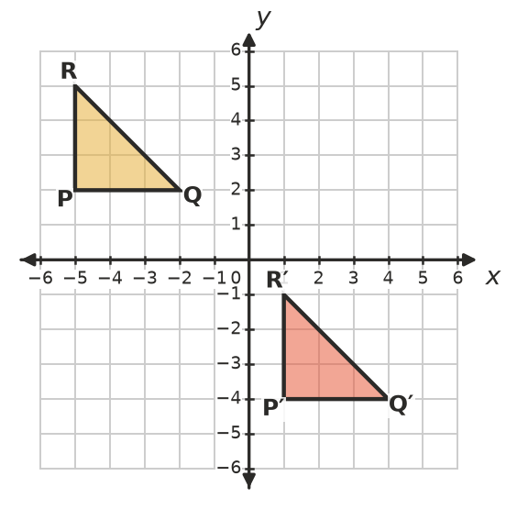
  - Describe the translation. ______________
  - Write the coordinates of P′, Q′ and R′. ______________
- Complete the table.
Starting point | Translation | Image
(−4, 3) | 5 right and 2 down
(2, −1) | 6 left and 3 up
(0, 0) | 3 left and 5 down
(−6, −2) | 4 right and 7 up
(5, 4) | 8 left and 4 down

 Fluency
- Translate quadrilateral ABCD 6 units right and 3 units down. Draw the image and label it A′B′C′D′. Then write the coordinates of the image.
- 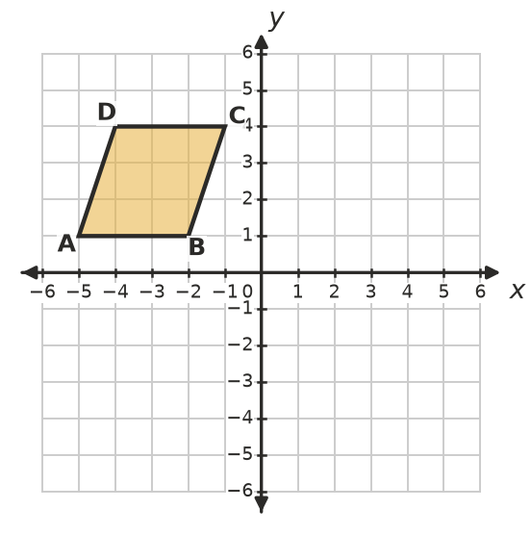
- A′ = ______________ B′ = ______________ C′ = ______________ D′ = ______________
- Translate triangle EFG 6 units left and 4 units up. Draw the image and label it E′F′G′. Then write the coordinates of the image.
- 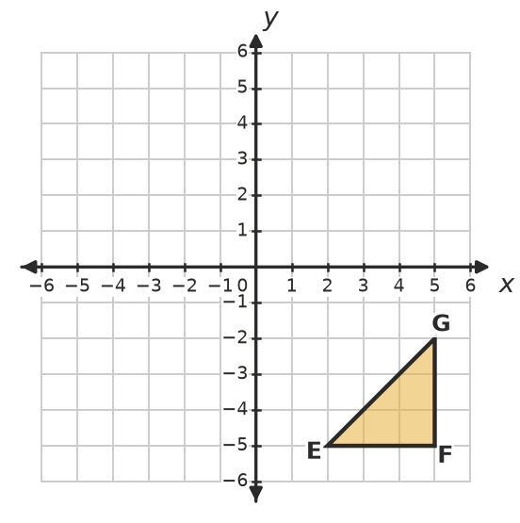
- E′ = ______________ F′ = ______________ G′ = ______________
- The four flags P, Q, R and S are translations of each other. Describe each translation.
- 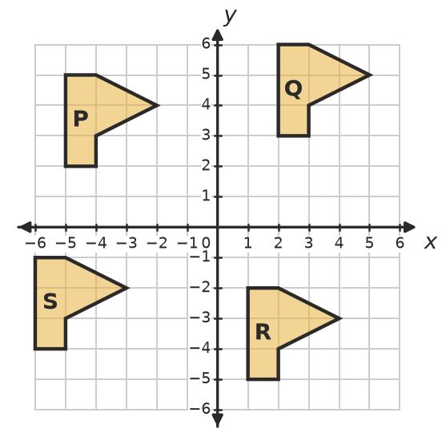
  - P to Q: ______________
  - Q to R: ______________
  - R to S: ______________
  - S to P: ______________
- Every point of a shape is translated 4 units right and 2 units down.
  - Where does (−3, 5) move to? ______________
  - Where does (0, −4) move to? ______________
  - Where does (−6, −1) move to? ______________
  - Which point moves to (2, 0)? ______________

 Reasoning
- Explain how to find the starting point if you know the image of a point and the translation.

- Mia translates (−3, 2) 5 units right and 4 units down. She says the image is (2, 6). Explain her mistake and give the correct image.

- In a translation, A(1, 1) moves to A′(4, 6). Explain why you know that B(−2, 0) moves 3 right and 5 up too, and find B′.

 Problem solving
- A triangle was translated 3 units left and 2 units down. Its image has corners A′(1, −2), B′(4, −2) and C′(1, 3). Find the corners A, B and C of the original triangle.
- A = ______________ B = ______________ C = ______________
- A square has corners (−5, 1), (−2, 1), (−2, 4) and (−5, 4). It is translated so that the corner (−5, 1) lands on (1, −5).
  - Describe the translation. ______________
  - Find the corners of the image. ______________
  - Which quadrant is the image in? ______________
- A drone starts at (−4, −1). It flies 6 units right and 3 units up, then 2 units left and 5 units down.
  - Where is the drone after the first flight? ______________
  - Where is it after the second flight? ______________
  - Describe one translation that takes it straight from its start to its finish. ______________

