14.02 Translations
Year 7 Maths · Worksheet · Level 1 · Warm-up
Name: ____________________ Date: ______________
This worksheet practises translations: sliding points and shapes left or right and up or down. Tip: describe a translation with the left or right move first, then the up or down move, just like coordinates go across first, then up.

 Understanding
- Fill in the gaps.
  - A translation ______________ every point of a shape the same distance in the same direction.
  - After a translation, the image faces the ______________ way as the object.
  - If point A is translated, its image is called ______________
- Each point has been translated to its image. Describe each translation, for example “4 right and 1 up”.
- 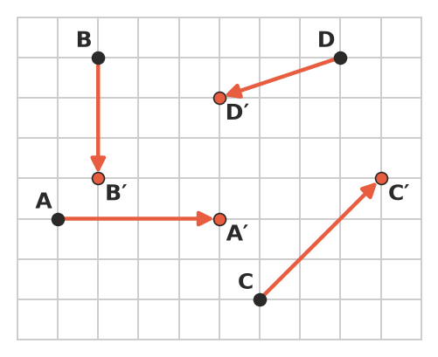
  - A to A′: ______________
  - B to B′: ______________
  - C to C′: ______________
  - D to D′: ______________
- Complete the table. Use the number plane in your head, or sketch it.
Starting point | Translation | Image
(2, 3) | 4 right
(5, 1) | 2 up
(7, 6) | 3 left and 2 down
(1, 8) | 5 right and 6 down
(9, 4) | 9 left and 1 up

 Fluency
- Translate triangle ABC 5 units right and 1 unit up. Draw the image and label it A′B′C′.
- 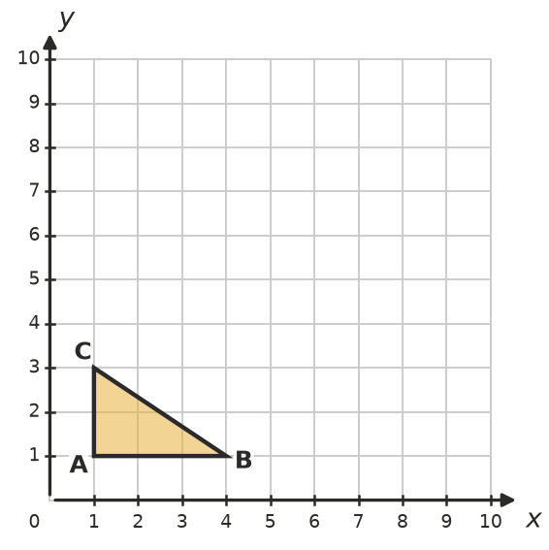
  - A′ = ______________
  - B′ = ______________
  - C′ = ______________
- Describe the translation that moves the object onto the image. (Tip: pick one corner of the object and count to the matching corner of the image.)
- 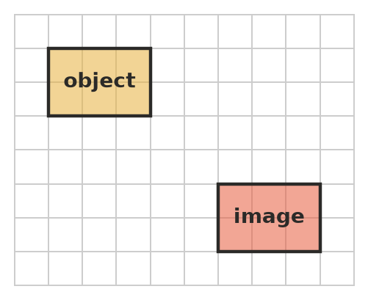

- Translate the shape 3 squares left and 4 squares down. Draw the image.
- 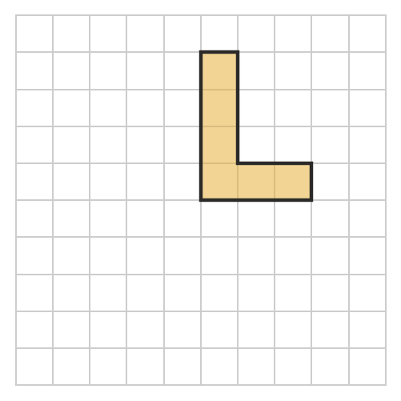
- Describe the translation that moves each point to its image.
  - (2, 2) to (6, 5): ______________
  - (8, 7) to (3, 7): ______________
  - (4, 9) to (1, 2): ______________
  - (0, 5) to (6, 0): ______________

 Reasoning
- A shape is translated 6 units right. Does the image have the same size? Does it face the same way? Explain.

- Ben translates the point (3, 5) 2 units right and 4 units up. He says the image is (7, 7). What did Ben do wrong? What is the right answer?

 Problem solving
- In a board game, a counter starts at (2, 1). It moves 3 right and 4 up. Then it moves 1 left and 2 up.
  - Where is the counter after the first move? ______________
  - Where is it after the second move? ______________
  - Describe one translation that would take it from (2, 1) straight to its final position. ______________
- A shape was translated 3 units right and 2 units up. One corner of the image is A′(8, 6). Where was corner A before the translation? Explain how you worked it out.

