14.02 Translations
Year 7 Maths · A5 question sheet · Level 3 · Challenge
This worksheet practises translations on the number plane, written in words and as coordinate rules, and combining translations. Tip: a rule like (x, y) → (x + 3, y − 2) means “add 3 to every x-coordinate and subtract 2 from every y-coordinate”, which is a translation of 3 right and 2 down.

 Understanding
- Answer each question.
  - Write the rule for a translation of 5 units left and 1 unit up.
  - Describe in words the translation (x, y) → (x, y − 6).
  - Describe in words the translation (x, y) → (x − 2, y + 7).
- Pentagon ABCDE has been translated to pentagon A′B′C′D′E′.
- 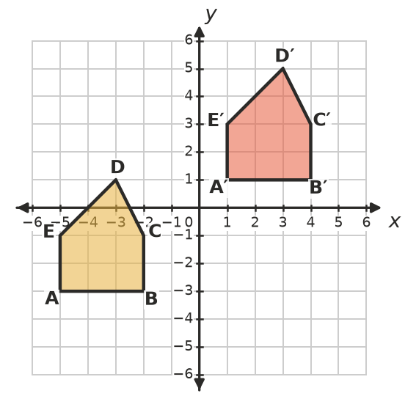
  - Describe the translation in words.
  - Write the translation as a rule.
- Copy and complete the table.
Starting point | Rule | Image
(−7, 4) | (x, y) → (x + 9, y − 6)
(3, −8) | (x, y) → (x − 5, y + 10)
(−1, −1) | (x, y) → (x − 4, y − 4)
 | (x, y) → (x + 6, y − 2) | (0, −3)
 | (x, y) → (x − 20, y + 15) | (12, −15)

 Fluency
- Translate triangle KLM using the rule (x, y) → (x − 7, y + 2). Draw the image and label it K′L′M′. Write the coordinates of the image.
- 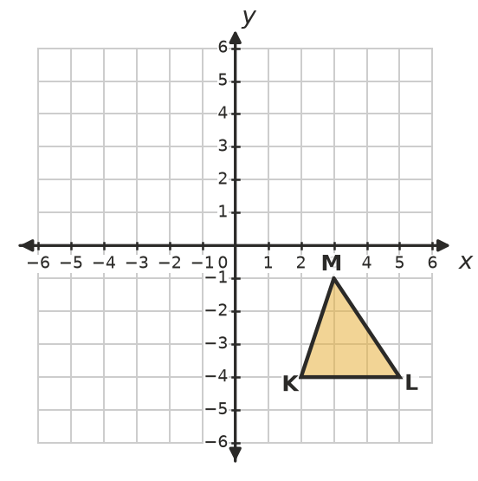
- A translation moves A(−3, 4) to A′(2, −1).
  - Describe the translation in words.
  - Find the image of B(0, 0).
  - Find the image of C(5, −2).
  - Which point D moves to D′(−6, 6)?
- Answer each question about two translations done one after the other.
  - (x, y) → (x + 3, y − 5), then (x, y) → (x − 7, y + 2). Write one rule that does both.
  - 8 left and 1 up, then 2 right and 6 up. Describe one translation that does both.
  - The first translation is 4 right and 3 down. Together, the two translations move a shape 1 left and 2 up. What is the second translation?
- Which of the shapes A, B, C and D are translations of shape S? For each one that is, write the rule. For each one that is not, say which transformation it is.
- 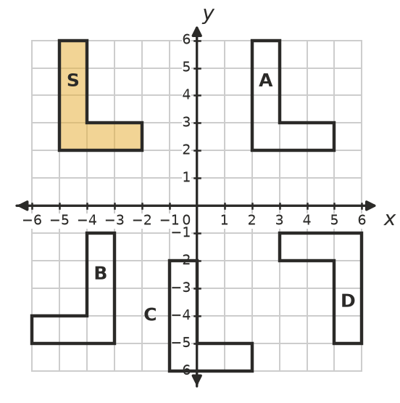
  - Shape A:
  - Shape B:
  - Shape C:
  - Shape D:

 Reasoning
- Leo translates a shape 3 right and then 5 up. Zoe translates the same shape 5 up and then 3 right. Do they end in the same place? Explain using coordinates.
- Write the rule that undoes the translation (x, y) → (x + 6, y − 4). Explain how you know it works.
- A translation moves a shape to a new position. Can the image ever sit exactly on top of the object, without the translation being “0 right and 0 up”? Explain.

 Problem solving
- The point P(k, 3) is translated 5 units left and 2 units up. Its image lies on the y-axis. Find k and the coordinates of the image.
- A triangle has corners (−5, 2), (−2, 2) and (−2, 6). It is translated some whole number of units right and some whole number of units down, so that the whole triangle is inside the 4th quadrant (not touching either axis). Find the smallest translation that does this, and the corners of the image.
- A translation moves (−2, 5) to (3, 1). The same translation is used again and again, starting from (−2, 5).
  - Where is the point after the translation has been used 3 times?
  - What is the smallest number of times it must be used so that the y-coordinate is less than −20?

