14.01 Transformation of shapes
Year 7 Maths · Worksheet · Level 2 · Core
Name: ____________________ Date: ______________
This worksheet practises naming and drawing translations, reflections and rotations, and matching the points of an object with the points of its image. Tip: if you are not sure, trace the object on tracing paper. If you can slide the tracing onto the image, it is a translation. If you have to turn it, it is a rotation. If you have to flip the paper over, it is a reflection.

 Understanding
- Fill in the gaps.
  - A translation ______________ a shape to a new position without turning it.
  - A reflection flips a shape over a mirror ______________
  - A rotation turns a shape about a fixed point called the centre of ______________
  - The object and its image are the same shape and size, so they are ______________
  - The image of point B is written as ______________
- In each picture, the yellow shape is the object and the red shape is the image. Name the transformation.
- 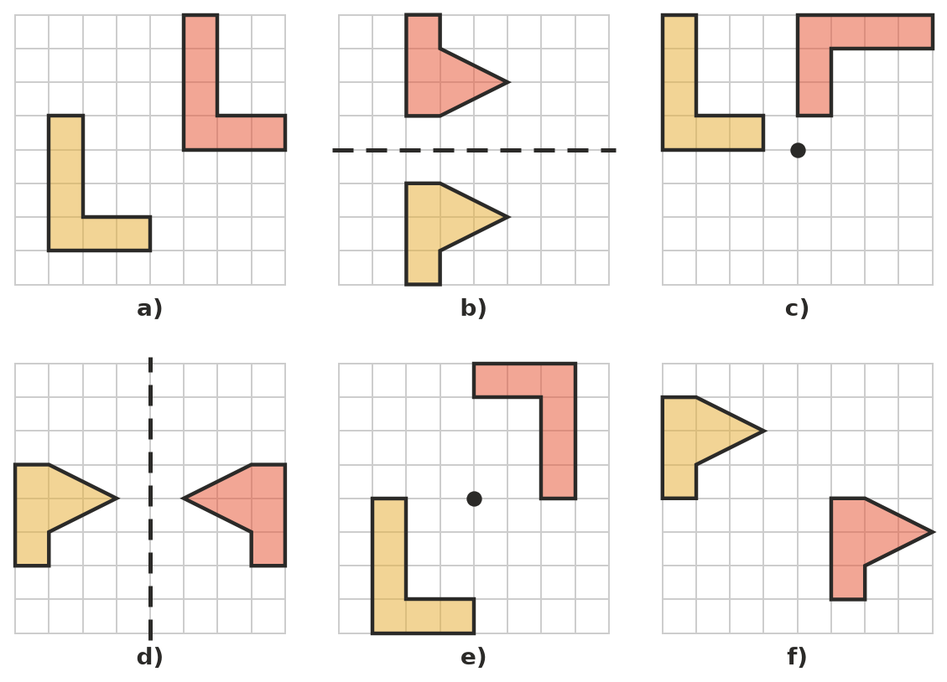
  - ______________
  - ______________
  - ______________
  - ______________
  - ______________
  - ______________
- Write true or false for each statement.
Statement | True or false
The image after a reflection is congruent to the object.
A rotation always turns a shape through a quarter turn.
A translation changes which way a shape is facing.
A reflection makes the image look back to front.
After a rotation, the image can face a different direction.

 Fluency
- Which transformation does each movement show? Write translation, reflection or rotation.
Movement | Transformation
A shopping trolley pushed straight down an aisle
The blades of a wind turbine
A mountain seen upside down in a still lake
A drawer being pulled open
A key turning in a lock
Your left hand compared with your right hand

- Triangle ABC has been reflected in the dashed line to make triangle PQR.
- 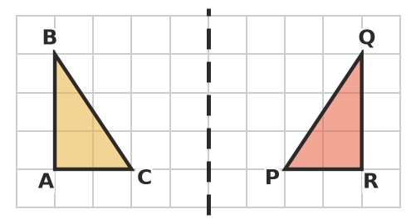
  - Which point is the image of A? ______________
  - Which point is the image of B? ______________
  - Which point is the image of C? ______________
  - Which side of triangle PQR matches side AB? ______________
  - Side AB is 3 units long. How long is the matching side of triangle PQR? ______________
- Draw the image of each shape on its grid.
  - Slide the shape 4 squares right and 2 squares up.
- 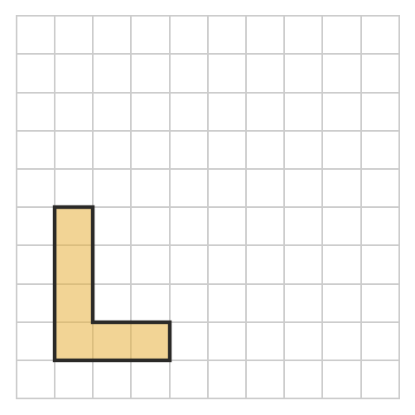
  - Flip the flag over the dashed mirror line.
- 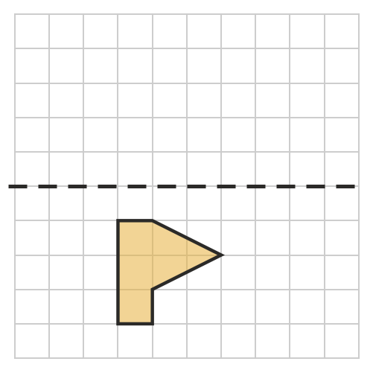
  - Give the shape a half turn about the dot. (Tip: trace the shape, hold the tracing down with your pencil point on the dot, and turn the paper halfway round.)
- 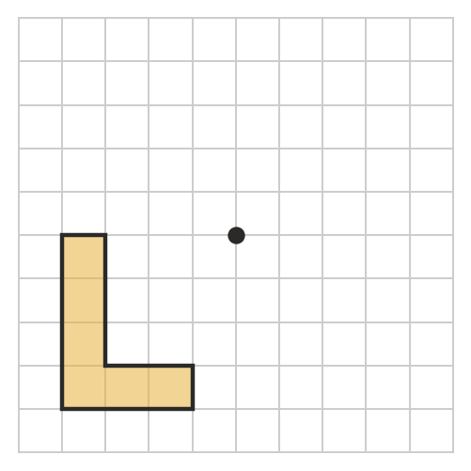
- Shape S has been moved to make shapes 1 to 5. Write translation, reflection or rotation for each one. If a shape is not an image of S, write “none” and give a reason.
- 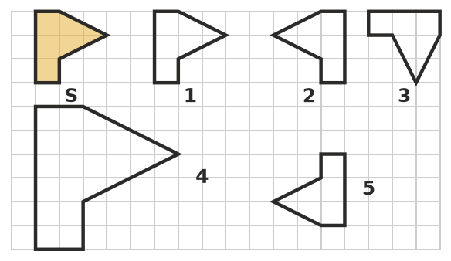
  - Shape 1: ______________
  - Shape 2: ______________
  - Shape 3: ______________
  - Shape 4: ______________
  - Shape 5: ______________

 Reasoning
- Explain the difference between a reflection and a rotation.

- An arrow pointing right is moved so that it points left, in the same row. Tom says it was reflected. Ana says it was given a half turn. Can they both be right? Explain.

- A rectangle has a perimeter of 18 cm and an area of 20 cm². It is rotated a quarter turn. What are the perimeter and area of the image? Explain.

 Problem solving
- On the front of many ambulances, the word AMBULANCE is printed back to front. Explain why, and name the transformation involved.

- You are facing north. Which direction are you facing after each turn?
  - A quarter turn clockwise. ______________
  - A half turn. ______________
  - Three-quarters of a turn clockwise. ______________
  - A quarter turn anticlockwise, then a half turn. ______________
- Each border pattern below is made by repeating the yellow shape. Which transformation is used to make each pattern?
- 
   
   
   

