14.01 Transformation of shapes
Year 7 Maths · Worksheet · Level 1 · Warm-up
Name: ____________________ Date: ______________
This worksheet introduces the three ways to move a shape without changing its size or shape: translations, reflections and rotations. Tip: think slide, flip and turn. The shape you start with is the object, and the shape after the move is the image.

 Understanding
- Match each everyday word with the name of its transformation: translation, reflection or rotation.
Everyday word | Transformation
slide
flip
turn

- Fill in the gaps. Use these words: image, object, congruent, A′.
  - The shape before it is moved is called the ______________
  - The shape after it is moved is called the ______________
  - The object and the image are exactly the same shape and size. We say they are ______________
  - When point A is moved, its new position is written as ______________ (we say “A dash” or “A prime”).
- In each picture, the yellow shape is the object and the red shape is the image. Name the transformation.
- 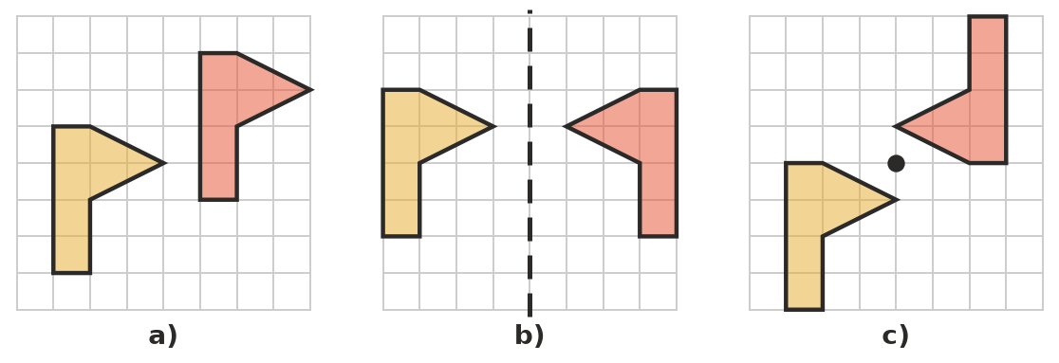
  - ______________
  - ______________
  - ______________

 Fluency
- Which transformation does each movement show? Write translation, reflection or rotation.
Movement | Transformation
A sliding door opening
A ceiling fan spinning
Your face in the bathroom mirror
A lift going up to level 3
A steering wheel turning
A butterfly’s left wing compared with its right wing

- Slide the shape 7 squares to the right. Draw the image on the grid.
- 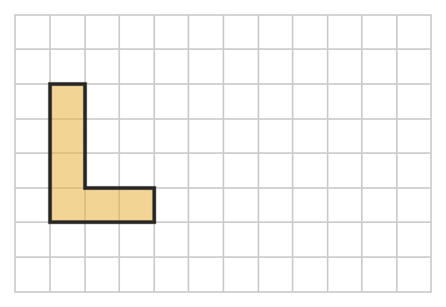
- Flip the flag over the dashed mirror line. Draw the image on the grid.
- 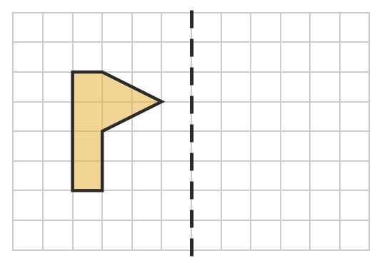
- Shape S has been moved to make shapes A, B, C and D. Write translation, reflection or rotation for each one.
- 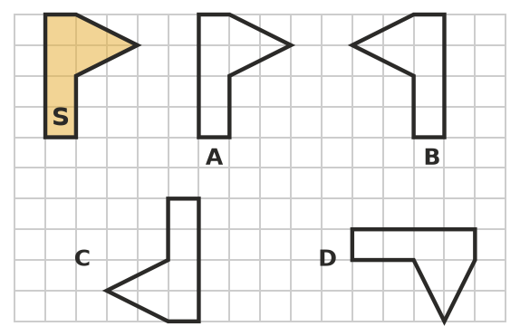
  - Shape A: ______________
  - Shape B: ______________
  - Shape C: ______________
  - Shape D: ______________

 Reasoning
- Kai moves a triangle with a slide, a flip or a turn. Does the image have the same size as the object? Explain.

- Shape 1 has been moved to make shape 2.
- 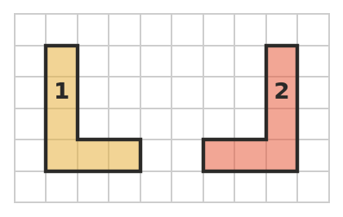
- Sam says, “It has been turned.” Jess says, “It has been flipped.” Who is right? Explain how you know.

 Problem solving
- On the front of many ambulances, the word AMBULANCE is printed back to front. Why do you think it is printed this way? Which transformation is involved?

- The minute hand of a clock turns clockwise. What fraction of a full turn does it make when it moves:
  - from 12 to 3? ______________
  - from 12 to 6? ______________
  - from 12 to 9? ______________
  - all the way round from 12 back to 12? ______________

