14.01 Transformation of shapes
Year 7 Maths · A5 question sheet · Level 3 · Challenge
This worksheet practises identifying translations, reflections and rotations when no mirror line or centre is shown, matching points and sides, and reasoning about what each transformation keeps the same. Tip: read the corners of a shape in order, A to B to C. A translation or rotation keeps that order going the same way round. A reflection reverses it.

 Understanding
- Copy and fill in the gaps.
  - Translations, reflections and rotations do not change the size or shape of an object, so the image is always ______________ to the object.
  - The direction a shape faces is called its orientation. A ______________ does not change orientation at all.
  - A ______________ produces a mirror image, so the shape is back to front.
  - A rotation is described by its centre, its direction (clockwise or anticlockwise) and its
- In each picture, the yellow shape is the object and the red shape is the image. No mirror lines or centres are shown. Name the transformation. If more than one transformation is possible, name them all. If it is not a translation, reflection or rotation, say why.
  - 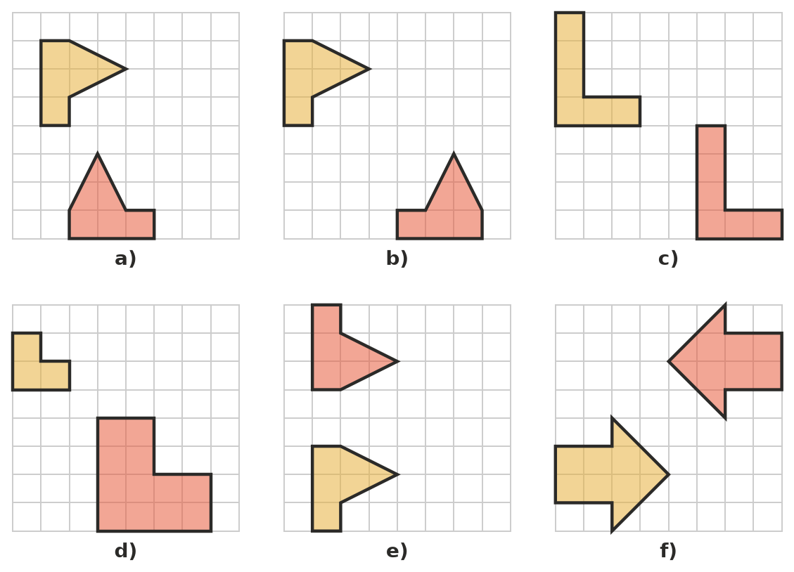

- The corners of a triangle ABC go clockwise when read A to B to C. For each transformation, do the corners of the image A′B′C′ go clockwise or anticlockwise?
Transformation
translation
reflection
rotation

 Fluency
- Quadrilateral ABCD has been transformed to make quadrilateral PQRS.
- 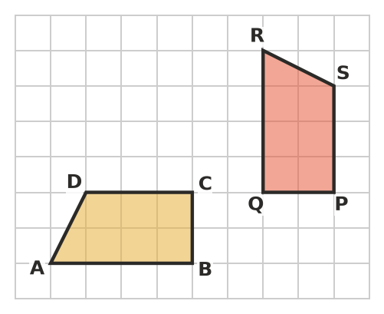
  - Name the transformation.
  - Which point is the image of A? Of C?
  - Which side of PQRS matches side AB? How long is it?
  - Which angle of PQRS matches angle ABC? What size is it?
- Which transformation does each movement show? Write translation, reflection or rotation.
Movement
A rubber stamp compared with the print it makes
A box sliding down a straight ramp
A seat on a Ferris wheel, which stays upright as the wheel turns, moving from the bottom to the top
The second hand of a watch
A paper doll chain, from one doll to the next

- Draw the image of each shape on its grid.
  - Reflect the flag in the dashed mirror line.
- 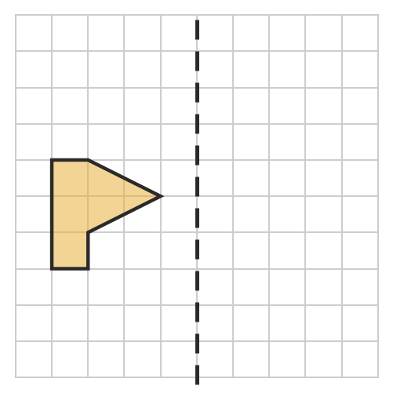
  - Rotate the shape a quarter turn clockwise about the dot.
- 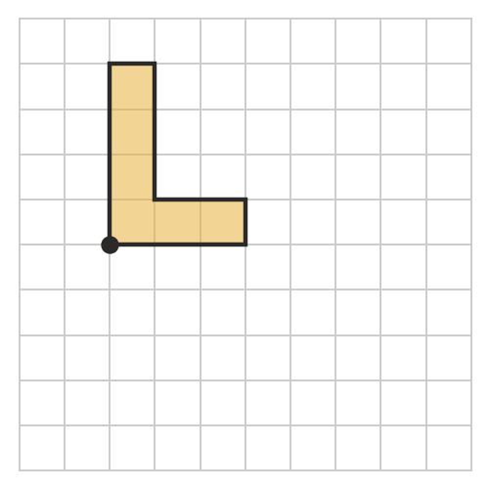
  - Rotate the flag a half turn about the dot.
- 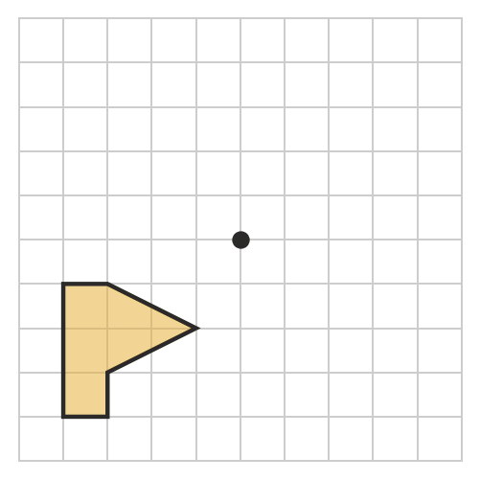
- Each border pattern is made by repeating the yellow shape. Which transformation is used to make each pattern?
  - 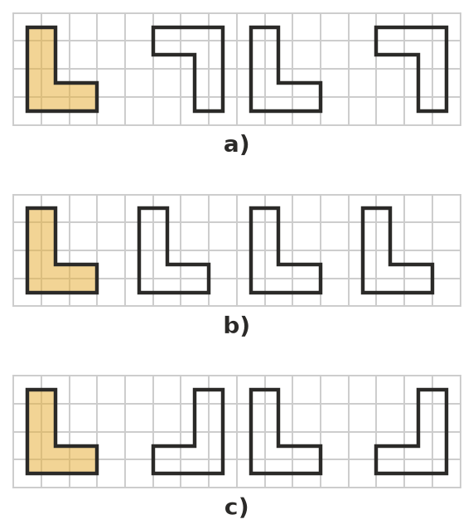

 Reasoning
- Use Question 3 to explain how you can tell a reflection from a rotation when no mirror line or centre is shown.
- A rectangle 2 units wide and 4 units tall is reflected in a vertical mirror line 1 unit to the right of the rectangle. Describe a translation that gives exactly the same image. Explain.
- A photo is enlarged on a photocopier. Is the enlarged photo the image of the original under a translation, reflection or rotation? Explain.

 Problem solving
- The hour hand of a clock turns clockwise from 2 to 11.
  - What fraction of a full turn is this?
  - How many degrees is this?
  - Describe a smaller turn, in the other direction, that ends in the same place.
- A shape is reflected in a mirror line, and then the image is reflected again in the same mirror line. Where does the final image end up? Explain.

