14.01 Transformation of shapes
Year 7 Maths · A5 question sheet · Level 1 · Warm-up
This worksheet introduces the three ways to move a shape without changing its size or shape: translations, reflections and rotations. Tip: think slide, flip and turn. The shape you start with is the object, and the shape after the move is the image.

 Understanding
- Match each everyday word with the name of its transformation: translation, reflection or rotation.
Everyday word
slide
flip
turn

- Copy and fill in the gaps. Use these words: image, object, congruent, A′.
  - The shape before it is moved is called the
  - The shape after it is moved is called the
  - The object and the image are exactly the same shape and size. We say they are
  - When point A is moved, its new position is written as ______________ (we say “A dash” or “A prime”).
- In each picture, the yellow shape is the object and the red shape is the image. Name the transformation.
  - 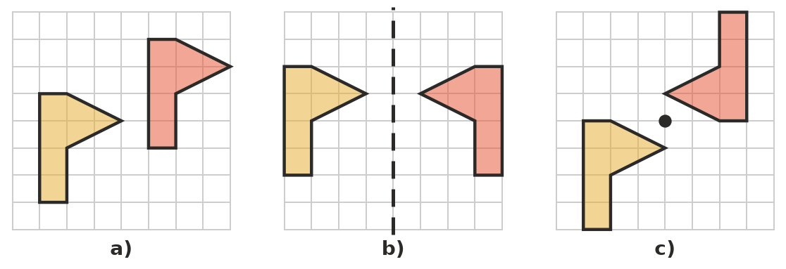

 Fluency
- Which transformation does each movement show? Write translation, reflection or rotation.
Movement
A sliding door opening
A ceiling fan spinning
Your face in the bathroom mirror
A lift going up to level 3
A steering wheel turning
A butterfly’s left wing compared with its right wing

- Slide the shape 7 squares to the right. Draw the image on a copy of the grid in your book.
- 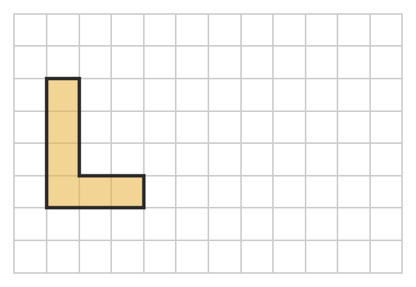
- Flip the flag over the dashed mirror line. Draw the image on a copy of the grid in your book.
- 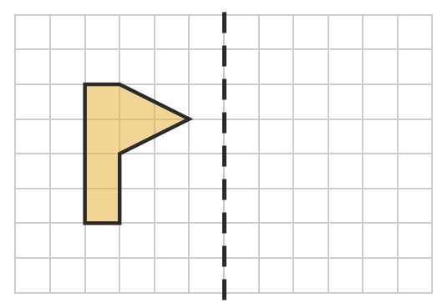
- Shape S has been moved to make shapes A, B, C and D. Write translation, reflection or rotation for each one.
- 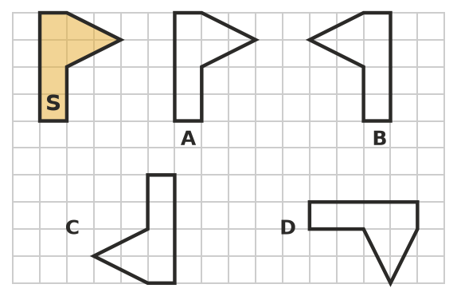
  - Shape A:
  - Shape B:
  - Shape C:
  - Shape D:

 Reasoning
- Kai moves a triangle with a slide, a flip or a turn. Does the image have the same size as the object? Explain.
- Shape 1 has been moved to make shape 2.
- 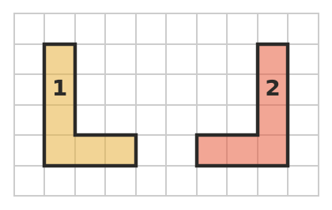
- Sam says, “It has been turned.” Jess says, “It has been flipped.” Who is right? Explain how you know.

 Problem solving
- On the front of many ambulances, the word AMBULANCE is printed back to front. Why do you think it is printed this way? Which transformation is involved?
- The minute hand of a clock turns clockwise. What fraction of a full turn does it make when it moves:
  - from 12 to 3?
  - from 12 to 6?
  - from 12 to 9?
  - all the way round from 12 back to 12?

