Statistics: Practice test 3
Year 7 Maths · Test · Test 3
Name: ____________________ Date: ______________
Time: 45 minutes
Total: 40 marks
Show your working in the boxes. Then write each final answer on the answer sheet on the last page.

 Section A: No calculator
- Answer each part about types of data.
  - Which one of these is continuous numerical data: the number of cows in a paddock, the favourite colour of each student, the length of each snake at a reptile park, or the number of pages in each book? (1 mark)

  - Write one example of a categorical variable you could collect about the students in your class. (1 mark)

  - Is the number of text messages a person sends in a day discrete or continuous? Explain your answer. (1 mark)

- Twenty-four students wrote down how they travel to school (B = bus, C = car, W = walk, K = bike).
- B, C, W, B, B, C, W, K, B, C, B, W, C, B, W, B, C, K, B, W, C, B, W, C
How they travel | Tally | Frequency
Bus
Car
Walk
Bike

  - Complete the frequency table. (2 marks)

  - What percentage of the students walk to school? (1 mark)

- Sam recorded how many pages of his novel he read each night for 9 nights.
- 24, 31, 18, 27, 31, 22, 35, 31, 24
  - Find the mode. (1 mark)

  - Find the median. (1 mark)

  - Find the mean. (2 marks)

- These are the ages of the 10 people at a youth group meeting, including the leader.
- 12, 13, 13, 14, 14, 14, 15, 15, 16, 45
  - Which age is an outlier? (1 mark)

  - Find the mean age when the outlier is left out. (1 mark)

  - The mean age of all 10 people is 17.1. Explain why the median is a better measure of the typical age of the group. (1 mark)

- The column graph shows the number of tickets sold for a school concert each day.
- 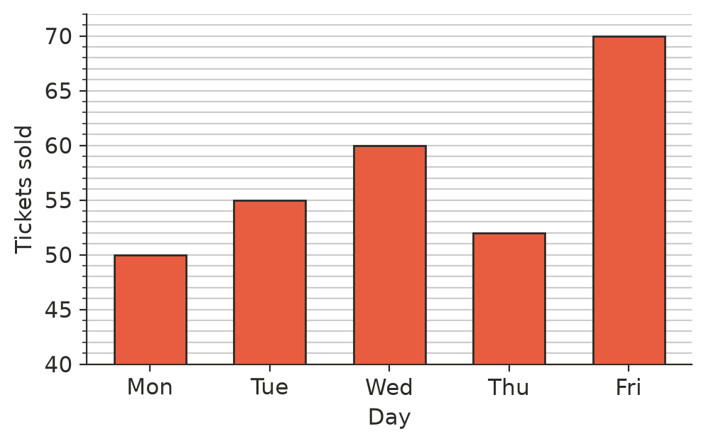
  - How many tickets were sold on Wednesday? (1 mark)

  - Jake says, “Three times as many tickets were sold on Friday as on Monday.” Explain why Jake is wrong, and why the graph might have fooled him. (2 marks)

- A family collected the eggs from their chooks every day for 3 weeks. The dot plot shows how many eggs they collected each day.
- 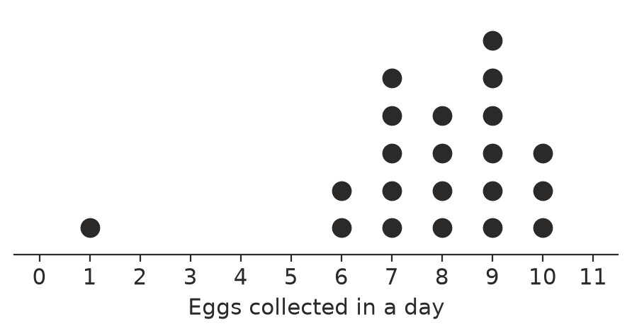
  - What is the mode? (1 mark)

  - What is the median? (1 mark)

  - Describe the distribution. Mention any cluster, gap or outlier. (1 mark)

- A vet weighed 12 dogs. Here are their masses in kilograms.
- 23, 8, 31, 15, 27, 19, 34, 12, 26, 9, 21, 28
Stem | Leaf
0
1
2
3

- Key: 1 | 5 means 15 kg
  - Complete the ordered stem-and-leaf plot. (2 marks)

  - Find the median mass. (1 mark)

  - Find the range. (1 mark)

- 48 students chose their favourite sport. The pie chart shows the results.
- 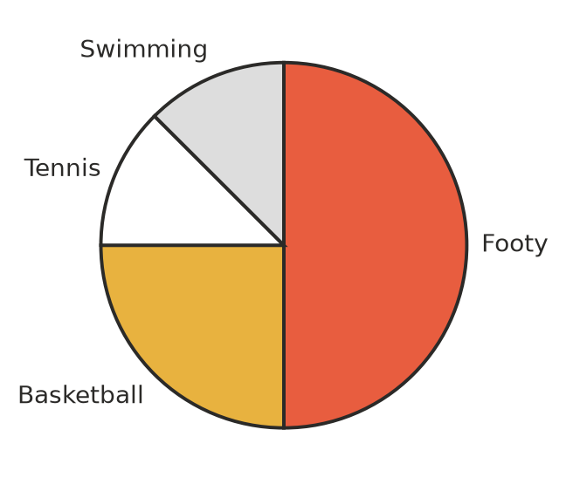
  - How many students chose footy? (1 mark)

  - What is the angle at the centre of the tennis sector? (1 mark)

- A family drove from home to their holiday house. The line graph shows their distance from home.
- 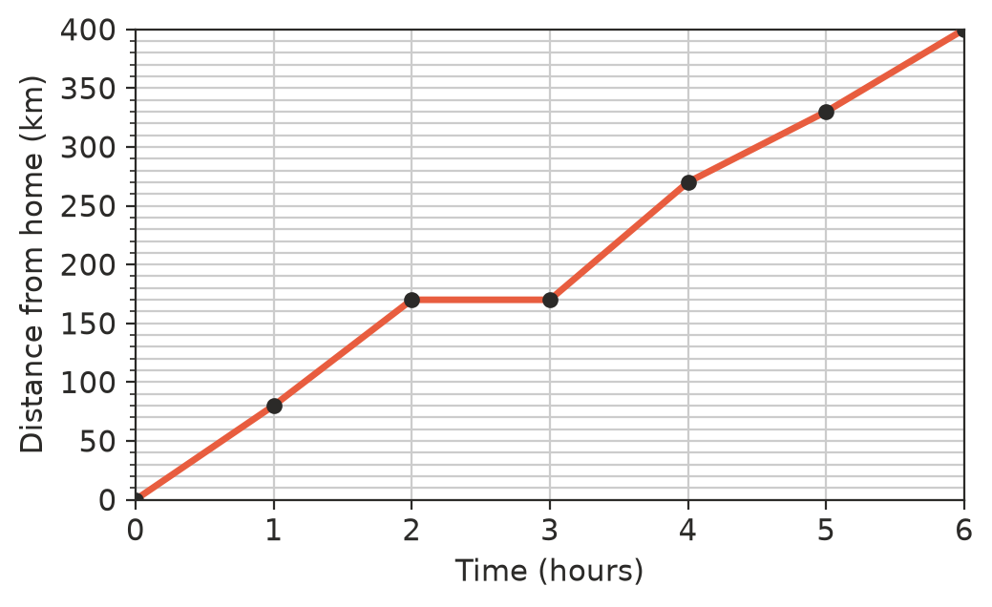
  - How far from home were they after 2 hours? (1 mark)

  - What do you think happened between 2 hours and 3 hours? Give a reason from the graph. (1 mark)

  - In which one-hour period did they travel the furthest? (1 mark)

 Section B: Calculator allowed
- A farmer recorded the rainfall, in millimetres, on 10 days in a row.
- 0, 2.4, 0, 0, 15.6, 8.2, 0, 0.6, 3.4, 0
  - Find the mean daily rainfall. (1 mark)

  - Find the median daily rainfall. (1 mark)

  - Grace says, “It usually rains about 3 mm a day here.” Explain why the mean gives the wrong idea about a typical day, and say which measure describes a typical day better. (2 marks)

- A 450 hectare farm is used in the ways shown in the table. The farmer wants to draw a pie chart.
Use | Area (hectares) | Angle
Wheat | 200
Canola | 125
Sheep pasture | 100
Other | 25

  - Complete the angle column. (2 marks)

  - What percentage of the farm is used for canola? Give your answer correct to one decimal place. (1 mark)

- Five whole numbers have a mean of 10, a median of 9, a mode of 6 and a range of 12. Find the five numbers. Show how you worked them out. (3 marks)

- Four numbers have a mean of 12.5. A fifth number is added and the mean goes up to 14. What is the fifth number? (2 marks)

 Answer sheet
Name: ____________________
Write your final answer for each question in the table.
Question | Answer | Marks | Question | Answer | Marks
1a |  | /1 | 7a | (in the plot in Question 7) | /2
1b |  | /1 | 7b |  | /1
1c |  | /1 | 7c |  | /1
2a | (in the table in Question 2) | /2 | 8a |  | /1
2b |  | /1 | 8b |  | /1
3a |  | /1 | 9a |  | /1
3b |  | /1 | 9b |  | /1
3c |  | /2 | 9c |  | /1
4a |  | /1 | 10a |  | /1
4b |  | /1 | 10b |  | /1
4c |  | /1 | 10c |  | /2
5a |  | /1 | 11a | (in the table in Question 11) | /2
5b |  | /2 | 11b |  | /1
6a |  | /1 | 12 |  | /3
6b |  | /1 | 13 |  | /2
6c |  | /1
 |  |  |  | Total | /40

