Statistics: Practice test 2
Year 7 Maths · Test · Test 2
Name: ____________________ Date: ______________
Time: 45 minutes
Total: 40 marks
Show your working in the boxes. Then write each final answer on the answer sheet on the last page.

 Section A: No calculator
- Is each variable categorical, discrete numerical or continuous numerical?
  - The number of eggs each hen lays in a week (1 mark)

  - The colour of each car in a car park (1 mark)

  - The mass of each calf born on a dairy farm (1 mark)

- Some students were asked how many times they went to the beach in the summer holidays. The table shows the results.
Number of beach trips | 0 | 1 | 2 | 3 | 4 | 5
Frequency | 3 | 6 | 9 | 5 | 4 | 3

  - How many students were asked? (1 mark)

  - How many students went to the beach at least 3 times? (1 mark)

  - What is the mode? (1 mark)

- Six people swam laps at the local pool. Here are the numbers of laps they swam.
- 18, 25, 22, 18, 30, 19
  - Find the median. (1 mark)

  - Find the mean. (2 marks)

  - Find the range. (1 mark)

- Five friends compared how much pocket money they get each week.
- $15, $20, $18, $22, $100
  - Which amount is an outlier? (1 mark)

  - Find the mean and the median. Which one better describes how much pocket money a typical friend gets? Explain your answer. (2 marks)

- A junior soccer team scored these numbers of goals in 15 games.
- 2, 0, 3, 1, 2, 4, 2, 1, 3, 2, 0, 5, 1, 2, 3
- 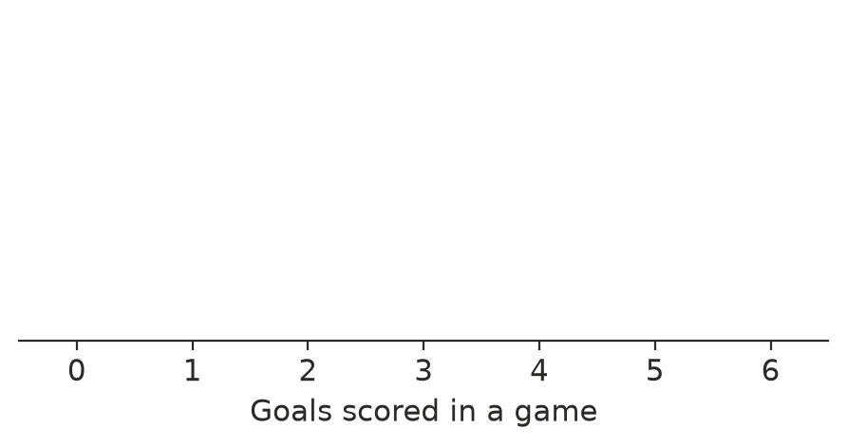
  - Draw a dot plot of the data on the number line above. (2 marks)

  - Find the median. (1 mark)

  - Describe the shape of the data. (1 mark)

- The column graph shows the rainfall at a farm near Darwin for six months.
- 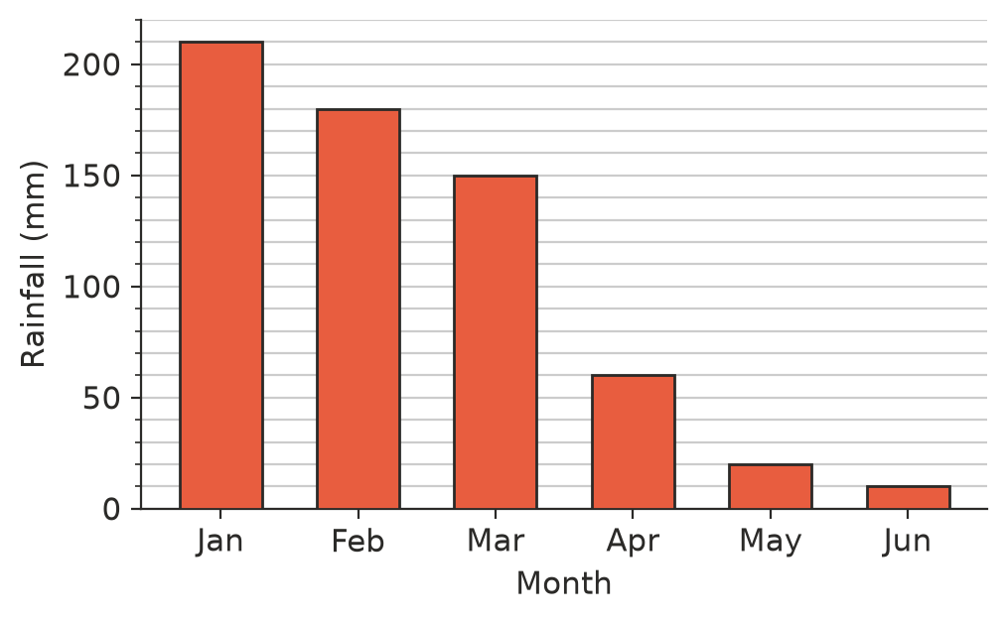
  - How much more rain fell in February than in April? (1 mark)

  - Find the total rainfall for the six months. (1 mark)

- The back-to-back stem-and-leaf plot shows the points scored by two basketball teams in 9 games each.
Hawks | Stem | Eagles
 | 2 | 9
8 | 3 | 5
7 5 2 | 4 | 4 8
8 6 3 1 | 5 | 2
4 | 6 | 0 7
 | 7 | 1 3

- Key: 8 | 3 | 5 means 38 points for the Hawks and 35 points for the Eagles
  - What was the Eagles’ highest score? (1 mark)

  - Find the median score for the Hawks. (1 mark)

  - Which team’s scores are more consistent? Use the range of each team to explain. (2 marks)

- 60 students were asked to name their favourite fruit. The pie chart shows the results and the angle of each sector.
- 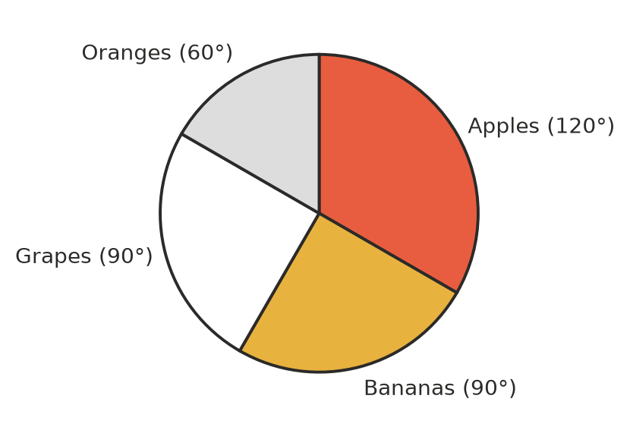
  - What fraction of the students chose apples? (1 mark)

  - How many students chose oranges? (1 mark)

- Mia measured the height of her sunflower at the end of each week. The line graph shows her results.
- 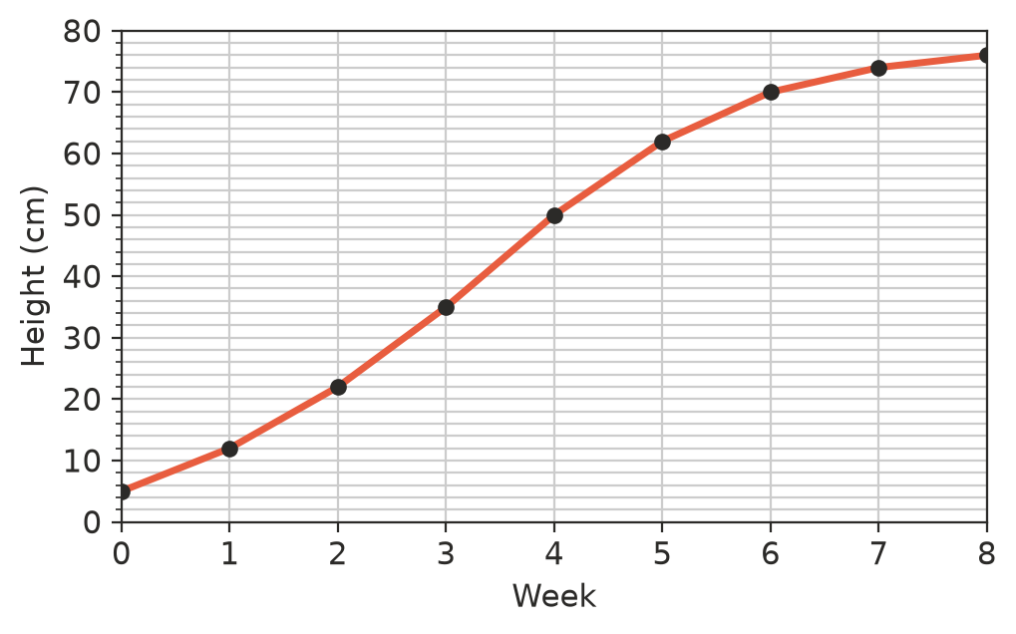
  - How tall was the sunflower at the end of week 4? (1 mark)

  - Between which two weeks did the sunflower grow the most? (1 mark)

  - Describe how the sunflower’s growth changes after week 6. (1 mark)

 Section B: Calculator allowed
- Students counted the number of people in each of 30 cars that drove past the school gate.
People in the car | 1 | 2 | 3 | 4 | 5
Number of cars | 12 | 9 | 5 | 3 | 1

  - How many people were in the 30 cars altogether? (1 mark)

  - Find the mean number of people in a car, correct to one decimal place. (1 mark)

  - Find the median number of people in a car. (1 mark)

- At a church camp, 72 campers each chose one activity. The camp leader wants to show the results in a pie chart.
Activity | Number of campers | Angle
Canoeing | 24
Archery | 18
Hiking | 12
Rock climbing | 15
Craft | 3

  - Complete the angle column. (2 marks)

  - What percentage of the campers chose archery? (1 mark)

- Tahlia’s mean score for her first 6 maths tests was 74. After her 7th test, her mean score went up to 76. What did she score on her 7th test? Show your working. (2 marks)

- A coach timed two sprinters over 100 m in five races. The times are in seconds.
Race | 1 | 2 | 3 | 4 | 5
Jade | 13.2 | 13.5 | 13.1 | 13.4 | 13.3
Zoe | 12.9 | 14.1 | 13.0 | 13.8 | 12.7

  - Find the mean time and the range of times for each sprinter. (2 marks)

  - The coach needs to pick one sprinter for a relay. Who would you pick? Use your answers to part a) to explain. (2 marks)

 Answer sheet
Name: ____________________
Write your final answer for each question in the table.
Question | Answer | Marks | Question | Answer | Marks
1a |  | /1 | 7a |  | /1
1b |  | /1 | 7b |  | /1
1c |  | /1 | 7c |  | /2
2a |  | /1 | 8a |  | /1
2b |  | /1 | 8b |  | /1
2c |  | /1 | 9a |  | /1
3a |  | /1 | 9b |  | /1
3b |  | /2 | 9c |  | /1
3c |  | /1 | 10a |  | /1
4a |  | /1 | 10b |  | /1
4b |  | /2 | 10c |  | /1
5a | (on the number line in Question 5) | /2 | 11a | (in the table in Question 11) | /2
5b |  | /1 | 11b |  | /1
5c |  | /1 | 12 |  | /2
6a |  | /1 | 13a |  | /2
6b |  | /1 | 13b |  | /2
 |  |  |  | Total | /40

