Statistics: Practice test 1
Year 7 Maths · Test · Test 1
Name: ____________________ Date: ______________
Time: 45 minutes
Total: 40 marks
Show your working in the boxes. Then write each final answer on the answer sheet on the last page.

 Section A: No calculator
- Is each variable categorical, discrete numerical or continuous numerical?
  - The number of goals kicked by each player in a footy match (1 mark)

  - The time each runner takes to finish a 100 m race (1 mark)

  - Each student’s favourite canteen lunch (1 mark)

- Twenty Year 7 students were asked how many brothers and sisters they have. Here are their answers.
- 2, 1, 0, 3, 1, 2, 1, 1, 4, 0, 2, 1, 3, 1, 2, 0, 1, 2, 1, 2
Number of brothers and sisters | Tally | Frequency
0
1
2
3
4

  - Complete the frequency table. (2 marks)

  - What is the mode? (1 mark)

- A netball team scored these goals in its first 7 games of the season.
- 34, 28, 41, 28, 37, 30, 26
  - Find the range. (1 mark)

  - Find the median. (1 mark)

  - Find the mean. (2 marks)

- A roadside fruit stall counted its customers on 6 days. On one day there was a big storm.
- 42, 38, 44, 10, 37, 39
  - Which value is an outlier? (1 mark)

  - Find the mean of all 6 values. (1 mark)

  - Find the mean when the outlier is left out. (1 mark)

- The dot plot shows how many books each student in a class read in the school holidays.
- 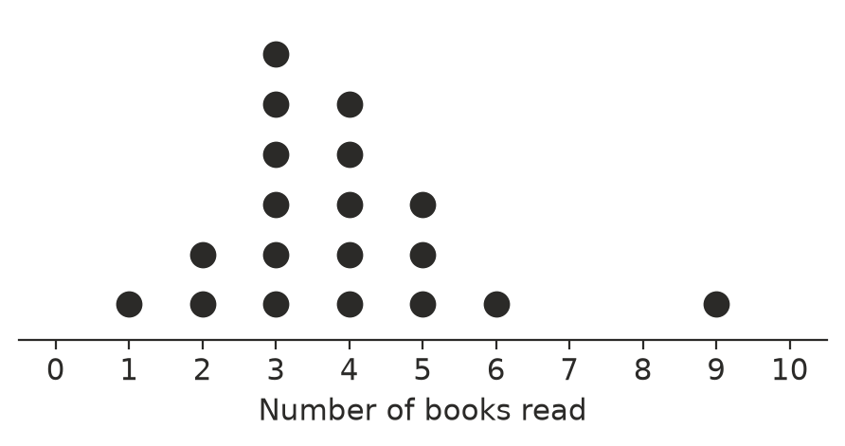
  - How many students are in the class? (1 mark)

  - What is the mode? (1 mark)

  - What is the median? (1 mark)

- The column graph shows how the students in 7B travel to school.
- 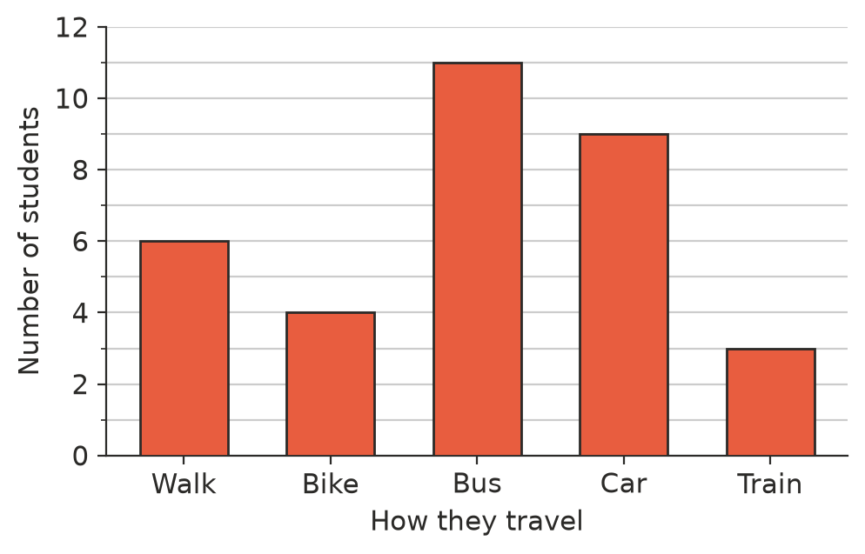
  - How many more students catch the bus than walk? (1 mark)

  - How many students are in 7B? (1 mark)

- The stem-and-leaf plot shows how many minutes 15 patients waited at a doctor’s surgery.
Stem | Leaf
0 | 8 9
1 | 2 5 5 7
2 | 0 3 4 4 4 9
3 | 1 6
4
5 | 2

- Key: 1 | 5 means 15 minutes
  - How many patients waited more than 20 minutes? (1 mark)

  - Find the median waiting time. (1 mark)

  - Find the range. (1 mark)

- 80 people at a sports club were asked to name their favourite sport. The pie chart shows the results.
- 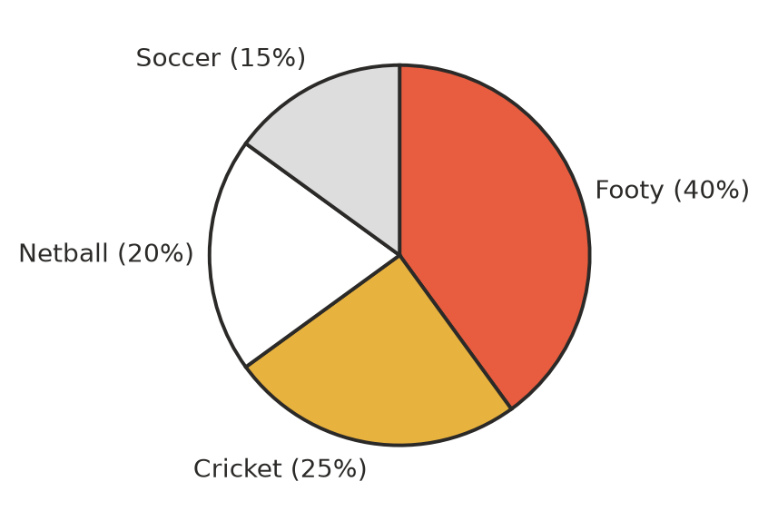
  - How many people chose soccer? (1 mark)

  - What is the angle at the centre of the cricket sector? (1 mark)

- The line graph shows the temperature at a farm in outback Queensland during one day.
- 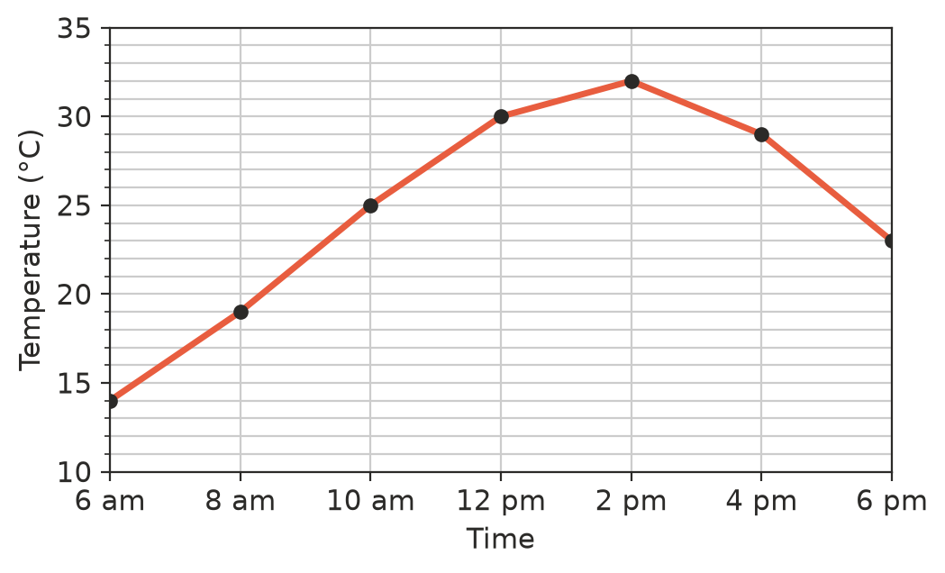
  - What was the temperature at 10 am? (1 mark)

  - At what time was it hottest? (1 mark)

  - Between which two times shown did the temperature rise the most? (1 mark)

- Five numbers have a mean of 8. Four of the numbers are 6, 9, 5 and 10. Find the fifth number. Show your working. (2 marks)

 Section B: Calculator allowed
- A cricketer made these scores in her last 8 innings.
- 45, 12, 0, 67, 23, 104, 31, 18
  - Find her mean score. (1 mark)

  - Find her median score. (1 mark)

  - Which is the better measure of her typical score, the mean or the median? Explain your answer. (2 marks)

- A family spends $3600 each month. The table shows how it is spent. The family wants to show this in a pie chart.
Item | Amount | Angle
Rent | $1350
Food | $900
Transport | $450
Bills | $540
Other | $360

  - Complete the angle column. (2 marks)

  - What percentage of the money is spent on food? (1 mark)

- Four whole numbers have a mode of 5, a median of 6 and a mean of 7. Find the four numbers. Show how you worked them out. (2 marks)

- The 24 students in a class have a mean score of 65 on a test. A new student joins the class and does the same test. She scores 90.
  - What is the total of the 24 students’ scores? (1 mark)

  - Find the new mean for all 25 students. (2 marks)

 Answer sheet
Name: ____________________
Write your final answer for each question in the table.
Question | Answer | Marks | Question | Answer | Marks
1a |  | /1 | 7b |  | /1
1b |  | /1 | 7c |  | /1
1c |  | /1 | 8a |  | /1
2a | (in the table in Question 2) | /2 | 8b |  | /1
2b |  | /1 | 9a |  | /1
3a |  | /1 | 9b |  | /1
3b |  | /1 | 9c |  | /1
3c |  | /2 | 10 |  | /2
4a |  | /1 | 11a |  | /1
4b |  | /1 | 11b |  | /1
4c |  | /1 | 11c |  | /2
5a |  | /1 | 12a | (in the table in Question 12) | /2
5b |  | /1 | 12b |  | /1
5c |  | /1 | 13 |  | /2
6a |  | /1 | 14a |  | /1
6b |  | /1 | 14b |  | /2
7a |  | /1
 |  |  |  | Total | /40

