16.08 Line graphs
Year 7 Maths · Worksheet · Level 3 · Challenge
Name: ____________________ Date: ______________
This worksheet practises reading line graphs of real data, describing the relationship between the two variables, and working out how fast one changes as the other changes. A straight line means the amount changes at a steady rate. A curved line means the rate is changing: the line gets steeper when the change speeds up and flatter when it slows down. Tip: rate of change = change in the vertical amount ÷ change in the horizontal amount. You may use a calculator.

 Understanding
- The graph shows the approximate distance a car needs to stop on a dry road (including the driver’s reaction time) at different speeds.
- 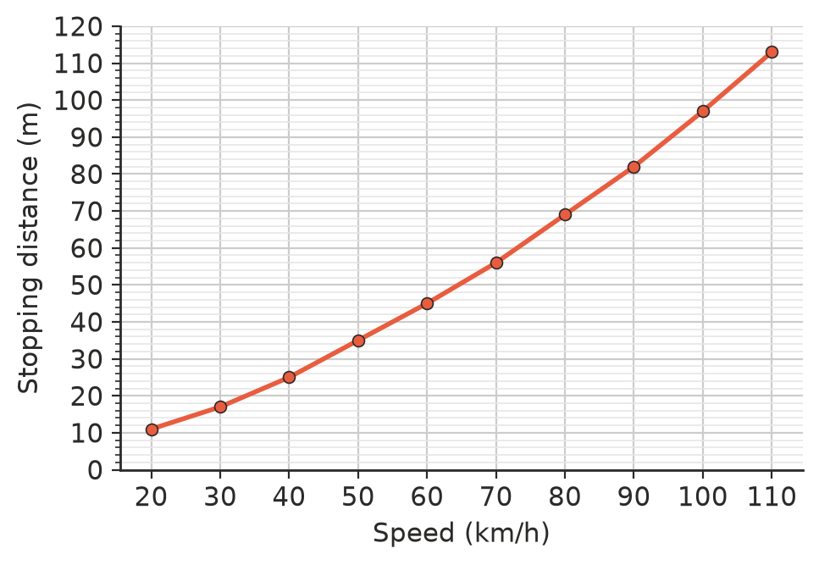
  - What is the stopping distance at 60 km/h? ______________
  - At about what speed is the stopping distance 56 m? ______________
  - Is the graph a straight line or a curve? What does this tell you about the relationship between speed and stopping distance?

  - Find the stopping distance at 50 km/h and at 100 km/h. When the speed doubles, does the stopping distance double? ______________

  - Use the graph to explain why speed limits near schools are 40 km/h instead of 60 km/h.

- Ana made a cup of tea and measured its temperature every 5 minutes.
- 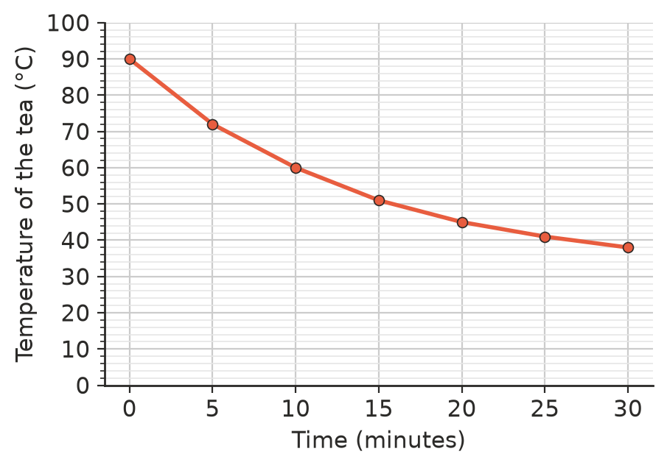
  - By how much did the temperature fall in the first 5 minutes? And in the last 5 minutes? ______________
  - Find the average rate of cooling (°C per minute) for the first 10 minutes. ______________
  - Describe how the tea cooled, using the shape of the graph.

  - The room temperature is 22 °C. Sketch on the graph how you think the line would continue for the next 30 minutes. Explain your sketch.

 Fluency
- A petrol station made this graph of its price for a litre of petrol.
- 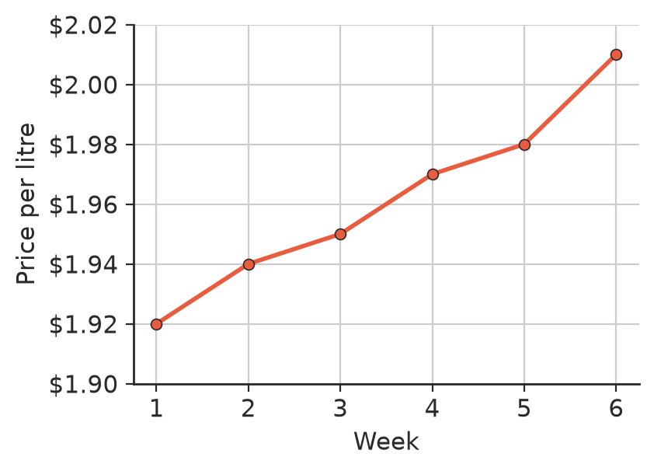
  - By how much did the price rise from week 1 to week 6? ______________
  - What was the percentage increase? Round to 1 decimal place. ______________
  - A news report used this graph with the headline “Petrol prices skyrocket!”. Explain why the graph makes the rise look bigger than it is.

- Water in a pot was heated on a stove. Draw a line graph of the data.
Time (minutes) | 0 | 1 | 2 | 3 | 4 | 5 | 6 | 7 | 8
Temperature (°C) | 20 | 35 | 50 | 65 | 80 | 92 | 98 | 100 | 100

- 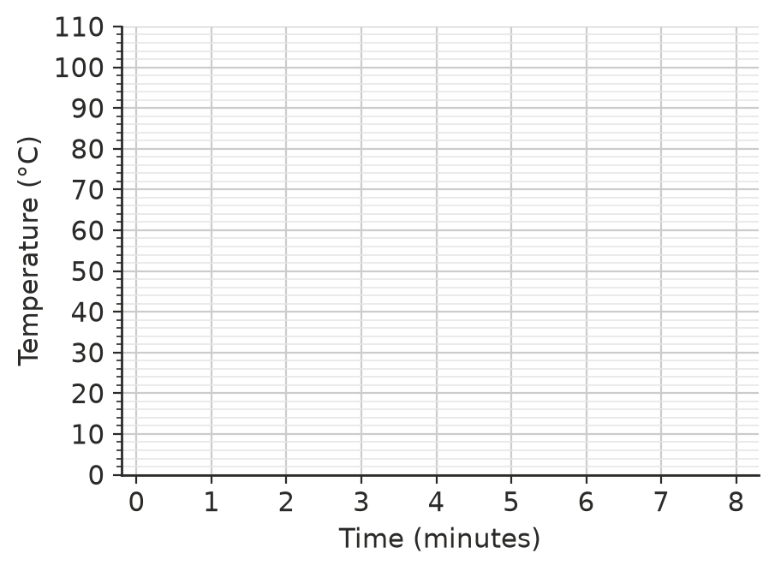
  - For how many minutes did the temperature rise at a steady rate of 15 °C per minute? ______________
  - What happened after 7 minutes? Why? ______________

 Reasoning
- Use Question 1. Leo says, “Every extra 10 km/h adds the same distance to the stopping distance.” Use two pairs of values from the graph to show that he is wrong.

- Use Question 2. Explain why it would not make sense to continue the line in a straight line from 25 to 30 minutes for another hour.

- Match each story to a graph.
- 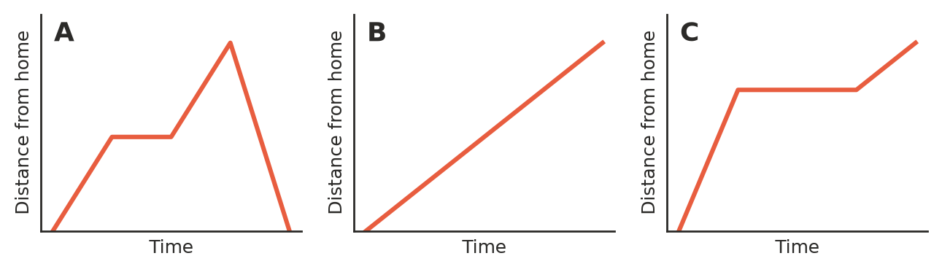
  - Ty walked to a friend’s house at the same speed the whole way. ______________
  - Kim rode to the park, rested, rode on faster to the lookout, then rode straight home. ______________
  - Dad drove quickly to the shops, stayed there a while, then drove slowly further on to the farm. ______________

 Problem solving
- Use Question 1. A driver travelling at 80 km/h sees a fallen tree 60 m ahead. Can the car stop in time? What is the fastest speed at which the car could stop in time?

- Use Question 4. If the heater had kept heating at 15 °C per minute and the water could get hotter than 100 °C, what would the temperature have been after 8 minutes? Why is the real graph different?

- Use Question 2. Ana likes to drink her tea at 50 °C. Estimate from the graph when she should drink it. ______________
- An empty tank holds up to 600 L. It is filled at 40 L per minute for 10 minutes, then nothing happens for 5 minutes, then water is drained at 20 L per minute until it is empty. Sketch a line graph of the volume of water in the tank. Show the key values on your axes.

- Use Question 1. Estimate the stopping distance at 75 km/h. ______________

