16.08 Line graphs
Year 7 Maths · Worksheet · Level 2 · Core
Name: ____________________ Date: ______________
This worksheet practises reading, drawing and describing line graphs made from real data. A line graph shows the relationship between two variables, such as temperature and time. The steeper the line, the faster the amount is changing. A flat line means no change. Tip: read the scale on each axis carefully before you read a value, and describe a graph in words such as “increases”, “decreases”, “stays the same”, “quickly” and “slowly”.

 Understanding
- The graph shows the average top temperature in each month for Darwin and Melbourne (rounded to the nearest degree).
- 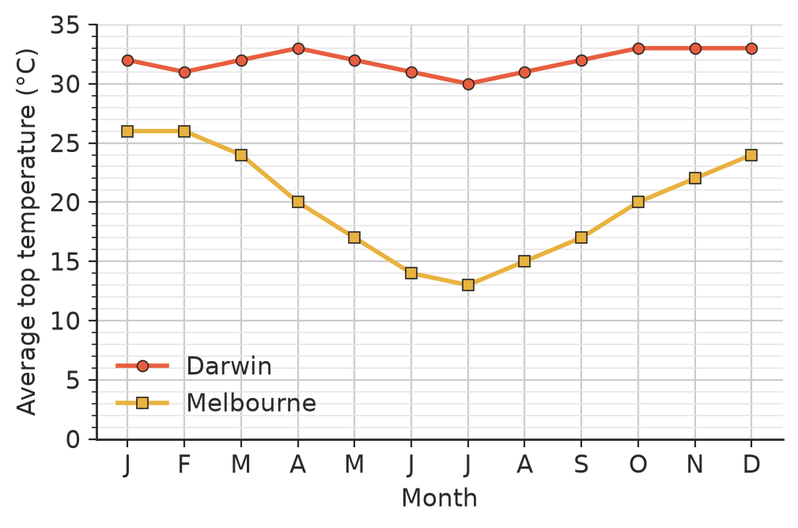
  - What is Melbourne’s average top temperature in July? ______________
  - Which is Melbourne’s coldest month? ______________
  - How much hotter is Darwin than Melbourne in July? ______________
  - Find the range of the monthly temperatures for each city. ______________
  - Describe how the temperature changes through the year in each city.

- Josh rode his bike to his grandma’s house. The graph shows his distance from home.
- 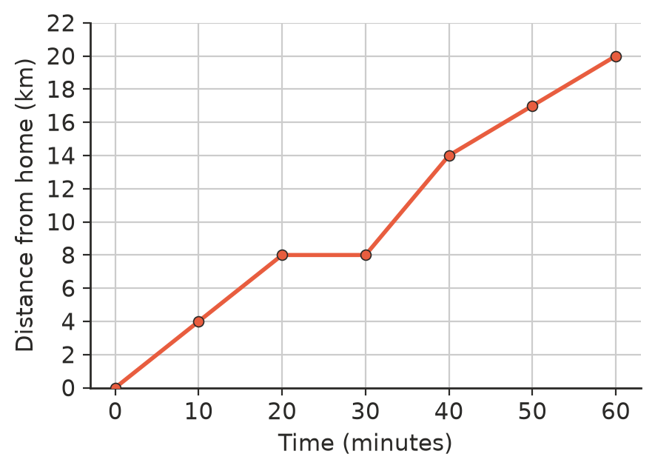
  - How far is it from Josh’s home to his grandma’s house? ______________
  - What happened between 20 and 30 minutes? ______________
  - How far did Josh ride in the first 20 minutes? ______________
  - In which 10-minute period did he ride the fastest? How can you tell from the graph? ______________

 Fluency
- A new school opened in 2019. Draw a line graph of the number of students each year.
Year | 2019 | 2020 | 2021 | 2022 | 2023 | 2024 | 2025
Students | 120 | 150 | 185 | 210 | 260 | 300 | 330

- 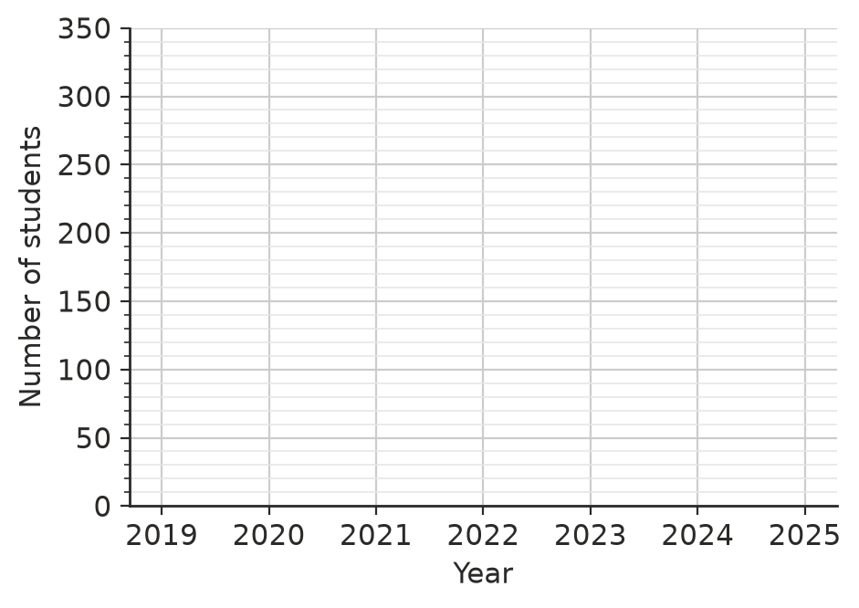
- The graph shows the battery charge of a phone while a video is playing.
- 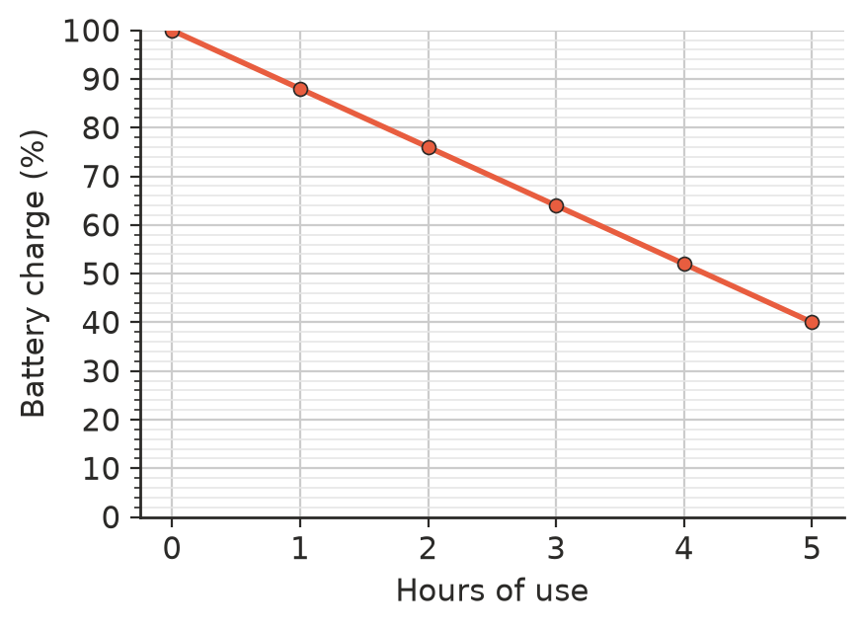
  - What was the charge after 3 hours? ______________
  - By how much does the charge drop each hour? ______________
  - Estimate the charge after $2\frac{1}{2}$ hours. ______________

 Reasoning
- Use the graph in Question 1. Your family wants a warm holiday in July. Which city should you visit? Use the graph to explain.

- Describe the relationship between hours of use and battery charge in Question 4 in one sentence.

- Use your graph from Question 3.
  - In which year did the number of students increase the most? ______________
  - Ben predicts there will be about 360 students in 2026. Is this a sensible prediction? Explain why predictions beyond the data can be risky.

 Problem solving
- Use Question 4. If the phone keeps losing charge at the same rate, after how many hours will the battery be flat? Show your working.

- Use Question 2. Josh’s average speed for the whole trip is the total distance divided by the total time. Find his average speed in kilometres per hour.

- Use Question 3. By how many students did the school grow from 2019 to 2025? What was the mean increase per year? ______________
- Draw a sketch of a line graph showing the water level in a bath as it is filled, someone gets in, then the plug is pulled out. Label the parts of your graph.

- Use Question 1. In how many months is Melbourne’s average top temperature 20 °C or more? Name them. ______________

