16.08 Line graphs
Year 7 Maths · Worksheet · Level 1 · Warm-up
Name: ____________________ Date: ______________
This worksheet practises reading and drawing line graphs. A line graph shows how something changes, usually over time. Time goes along the horizontal axis. The line goes up when the amount is increasing, down when it is decreasing, and stays flat when nothing changes. Tip: to read a value, go up from the horizontal axis to the line, then across to the vertical axis.

 Understanding
- The line graph shows the temperature in Alice Springs during a winter day.
- 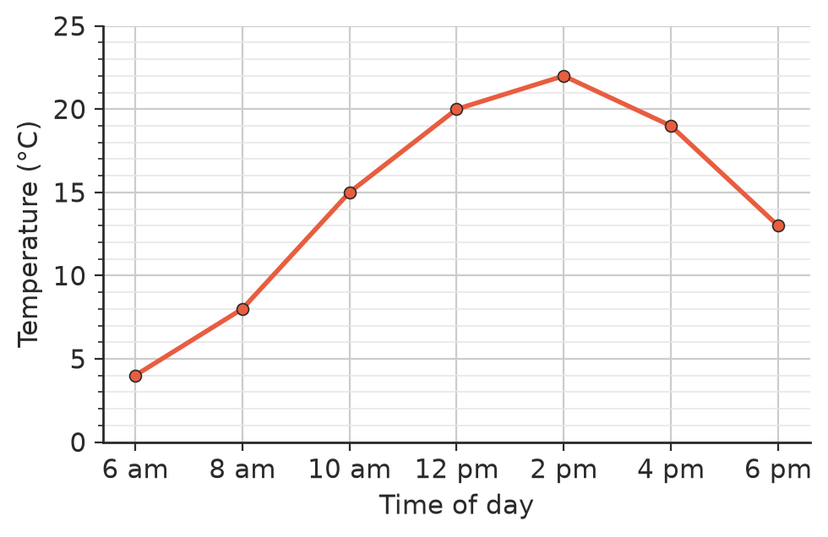
  - What was the temperature at 10 am? ______________
  - What was the highest temperature, and at what time? ______________
  - How much did the temperature rise from 6 am to 12 pm? ______________
  - Between which two times did the temperature fall? ______________
  - Estimate the temperature at 11 am. ______________
- Mia measured the height of a bean plant each week.
- 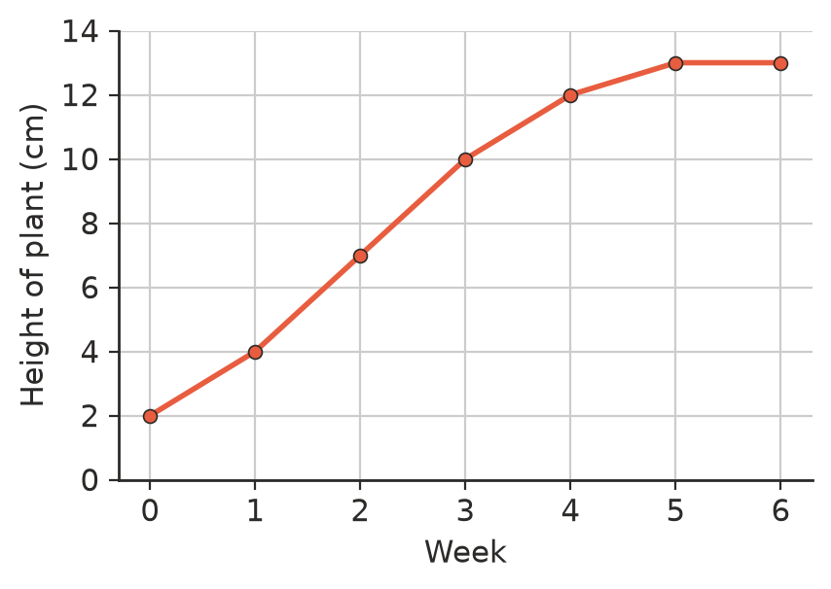
  - How tall was the plant at week 3? ______________
  - How much did the plant grow from week 0 to week 4? ______________
  - In which week did the plant stop growing? How can you tell from the graph?

 Fluency
- A puppy was weighed every month. Draw a line graph of the data on the grid. Plot each point, then join the points with straight lines.
Age (months) | 0 | 1 | 2 | 3 | 4 | 5
Mass (kg) | 1 | 3 | 5 | 8 | 10 | 11

- 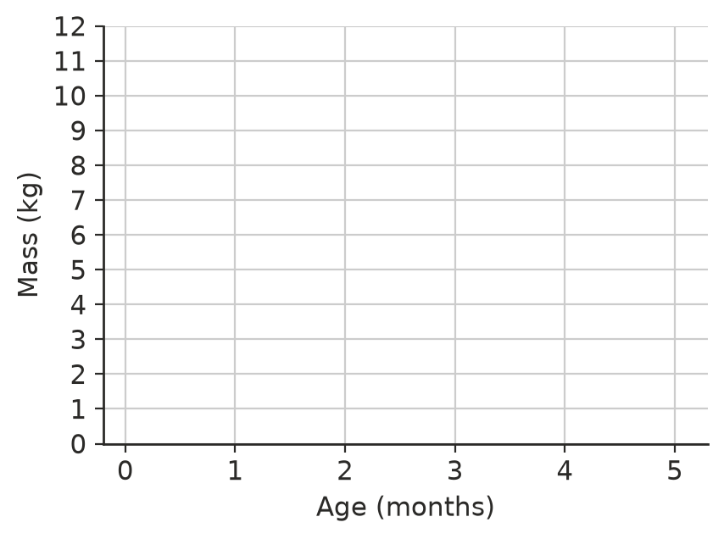
- Match each line graph to a description.
- 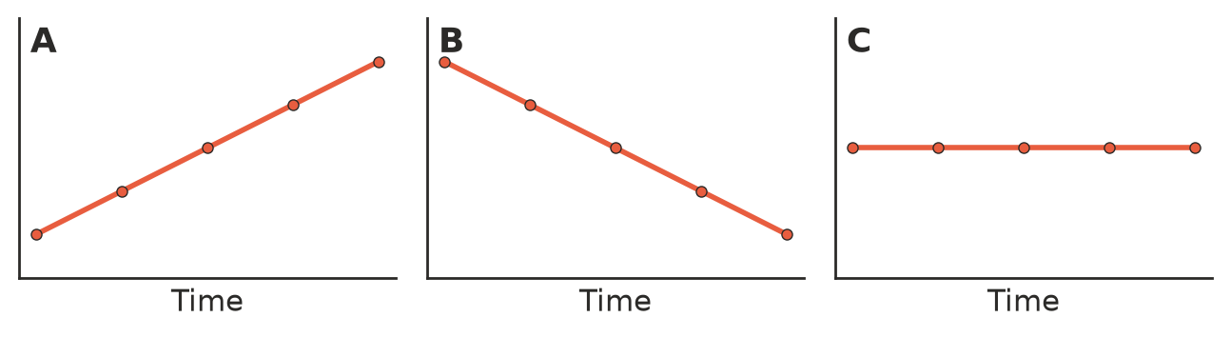
  - The amount stays the same. ______________
  - The amount goes up. ______________
  - The amount goes down. ______________

 Reasoning
- Look at the puppy graph you drew in Question 3. In which month did the puppy gain the most mass? How can you tell by looking at the line?

- Use the temperature graph in Question 1. Ella says, “The temperature at 7 pm will be 5 °C.” Can you be sure? Explain.

 Problem solving
- The line graph shows the amount of water in a rainwater tank on a farm over 10 days. It rained once.
- 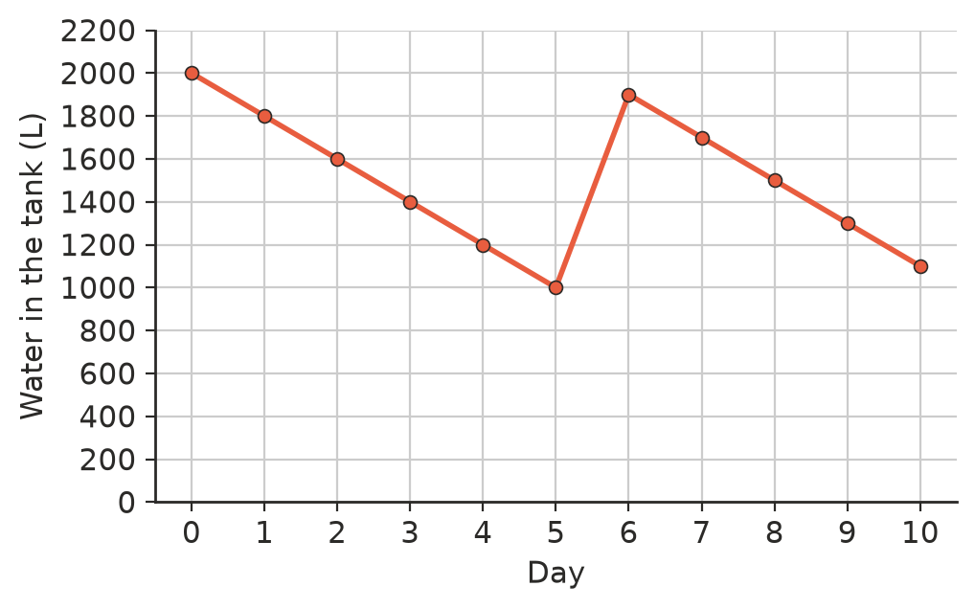
  - How much water was in the tank on day 0? ______________
  - How much water was used each day when it did not rain? ______________
  - Between which two days did it rain? ______________
  - How much water was in the tank on day 10? ______________
  - If the family keeps using water at the same rate and it does not rain, on which day will the tank be empty?

- Use the plant graph in Question 2. Write one sentence that describes how the height of the plant changed over the six weeks.

- Would a line graph or a column graph be better for each data set? Write line or column.
  - a child’s height measured on each birthday ______________
  - the favourite colours of 30 students ______________
  - the number of people at the beach each hour of a summer day ______________
- Use your puppy graph from Question 3. Estimate the puppy’s mass when it was $2\frac{1}{2}$ months old. ______________

