16.07 Pie charts
Year 7 Maths · Worksheet · Level 1 · Warm-up
Name: ____________________ Date: ______________
This worksheet practises reading and making pie charts. A pie chart shows how a whole is split into parts. The whole circle is all the data (100%, or 360°), and each sector (slice) shows one part. Tip: the bigger the sector, the bigger the part. All the percentages in a pie chart add up to 100%, and all the angles add up to 360°.

 Understanding
- Twenty students were asked their favourite fruit.
- 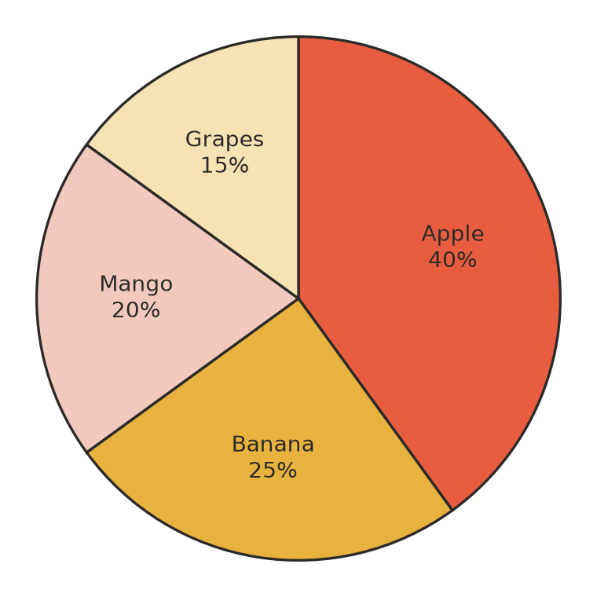
  - Which fruit is the most popular? ______________
  - What percentage of the students chose banana? ______________
  - Add up all the percentages. What do you get? ______________
  - 10% of 20 students is 2 students. How many students chose apple? ______________
- The pie chart shows how Sam uses his $40 pocket money each month.
- 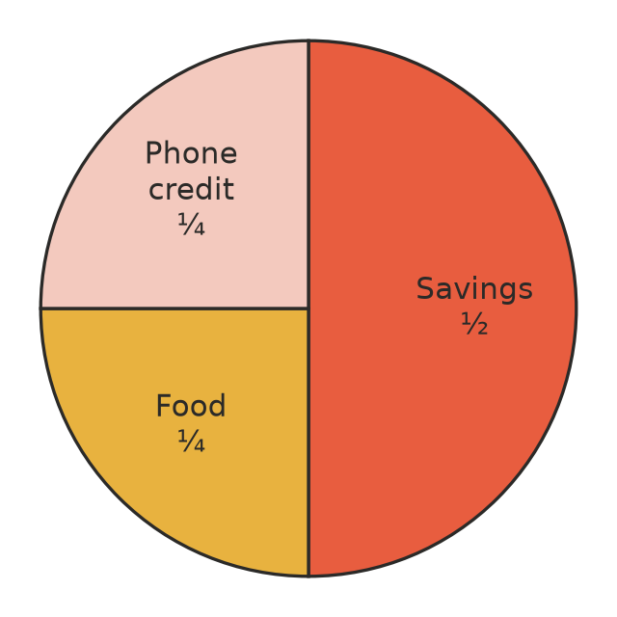
  - How much does Sam save? ______________
  - How much does he spend on food? ______________
  - How much does he spend on phone credit? ______________

 Fluency
- Twelve students were asked how they get to school: 6 walk, 4 come by car and 2 come by bus. The circle is split into 12 equal sectors, one for each student. Shade and label the sectors to make a pie chart.
- 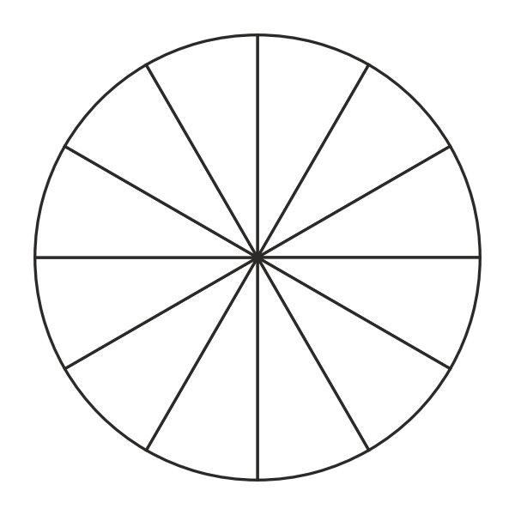
- A full turn is 360°. Find the angle of each sector.
  - $\frac{1}{2}$ of the circle ______________
  - $\frac{1}{4}$ of the circle ______________
  - $\frac{1}{3}$ of the circle ______________
  - $\frac{1}{6}$ of the circle ______________
- Thirty-six students chose their favourite sport. There are 360° in a circle, so each student gets 360° ÷ 36 = 10°. Complete the table.
Sport | Number of students | Angle
Football | 18 | 18 × 10° = 180°
Netball | 9
Cricket | 6
Soccer | 3
Total | 36

- Forty people chose their favourite colour.
- 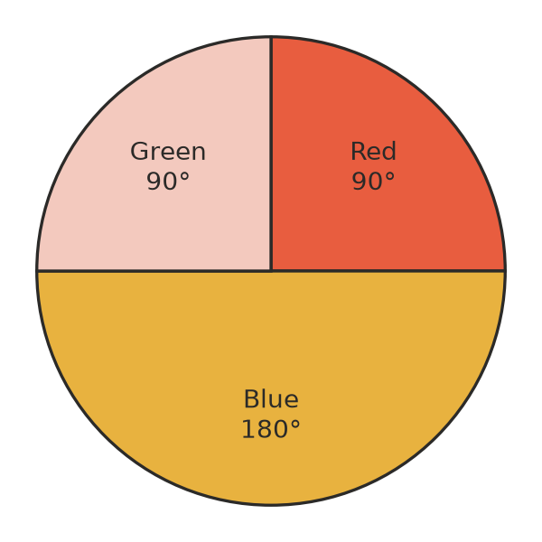
  - What fraction of the people chose blue? ______________
  - How many people chose blue? ______________
  - How many people chose green? ______________

 Reasoning
- Tia drew a pie chart with sectors labelled 50%, 30% and 30%. Explain why her pie chart must be wrong.

- Would a pie chart be a good way to show each data set? Write yes or no, with a reason.
  - how 25 students get to school ______________
  - the height of each student in your class ______________

 Problem solving
- In a survey of 120 people, a quarter of the pie chart shows people who like cricket. How many people like cricket? ______________
- A pie chart shows the favourite pets of 30 students. The sector for dogs is $\frac{1}{3}$ of the circle, and the sector for cats is $\frac{1}{5}$ of the circle.
  - How many students chose dogs? ______________
  - How many students chose cats? ______________
  - What angle is the sector for dogs? ______________

