16.07 Pie charts
Year 7 Maths · A5 question sheet · Level 3 · Challenge
This worksheet practises calculating sector angles, drawing pie charts accurately and solving problems with pie charts, including working backwards from an angle to the data. Angle of a sector = fraction of the total × 360°. Tip: a pie chart shows proportions (fractions or percentages of a whole), not actual numbers, so be careful when you compare two pie charts. You will need a protractor and a calculator.

 Understanding
- Forty-eight students chose their favourite indoor sport: netball 20, basketball 15, volleyball 9 and hockey 4.
  - Calculate the angle for each sector. Show your working.
  - Draw the pie chart in the circle, starting at the line that is drawn. Label each sector.
- 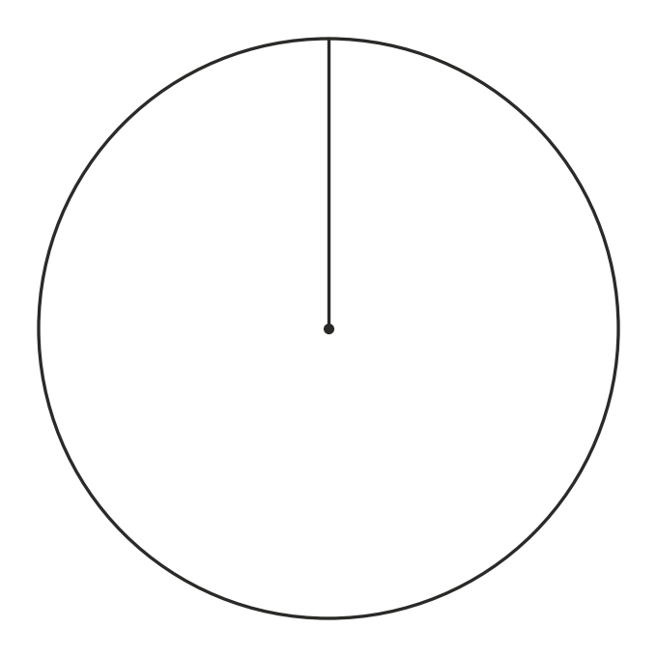
- The pie charts show how the students at a school got to school in 2024 (400 students) and in 2025 (500 students).
- 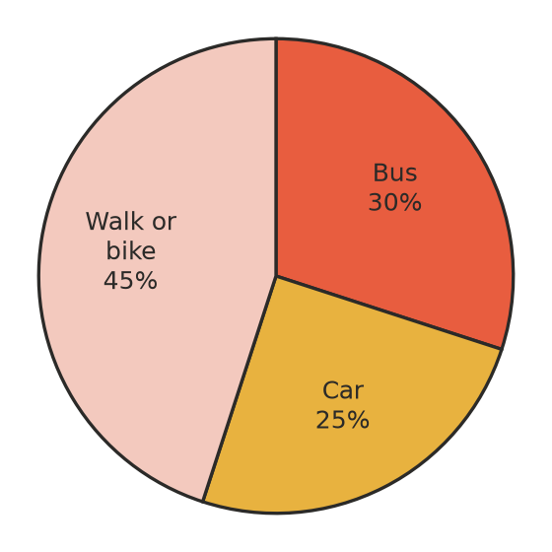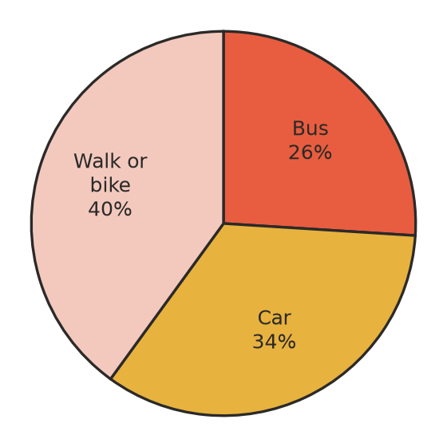
- The left chart is 2024 and the right chart is 2025.
  - How many students came by bus in each year?
  - Lucy says, “Fewer students came by bus in 2025, because the bus sector is smaller.” Is she right? Explain.
  - By how many students did the number of car travellers change from 2024 to 2025?

 Fluency
- The sectors of a pie chart are in the ratio 1 : 2 : 3 : 4. Find the angle of each sector.
- A pie chart has four sectors with angles x°, 2x°, 3x° and 90°. Find x and the angle of each sector.
- A household uses 360 L of water a day.
Use | Shower | Toilet | Laundry | Kitchen | Garden
Percentage | 35% | 25% | 20% | 12% | 8%

  - How many litres are used for each purpose?
  - Explain why, for this household, the angle of each sector in degrees is the same as the number of litres.
  - The family halves the amount of water used in the shower. Find the new daily total, and the new percentage used in the shower, to 1 decimal place.

 Reasoning
- Three teams each won one third of the games in a competition. A pie chart labels each sector as 33%. Sam says the chart is wrong because 33% + 33% + 33% = 99%. Explain what has happened.
- A survey asked, “Which sports do you play? Tick all that apply.” Explain why a pie chart is not suitable for the results.
- Use Question 2. Would a pie chart or a side-by-side column graph be better for showing how many students used each type of transport in 2024 and 2025? Explain.

 Problem solving
- In a pie chart of 90 people, the sector for “beach” is 28° bigger than the sector for “bush”. How many more people chose the beach than the bush?
- In a pie chart, each person is shown by 4.5° of the circle. How many people were surveyed?
- In a survey, 35% of people chose tennis and 15% chose golf. Fourteen more people chose tennis than golf. How many people were surveyed altogether? What is the angle of the golf sector?
- Seven people in a family chose a movie to watch: 3 chose a comedy, 2 chose an action movie and 2 chose a cartoon. Calculate each sector angle to the nearest degree. Do your rounded angles add up to 360°?

