16.07 Pie charts
Year 7 Maths · A5 question sheet · Level 2 · Core
This worksheet practises reading pie charts and working out the angle for each sector so you can draw one. The whole circle is 360°, so the angle for a group is its fraction of the total × 360°. For example, 10 out of 40 people is $\frac{10}{40}$ × 360° = 90°. Tip: check that your angles add up to 360° before you draw. You will need a protractor and a calculator.

 Understanding
- A school fundraiser spent $2400. The pie chart shows how the money was spent.
- 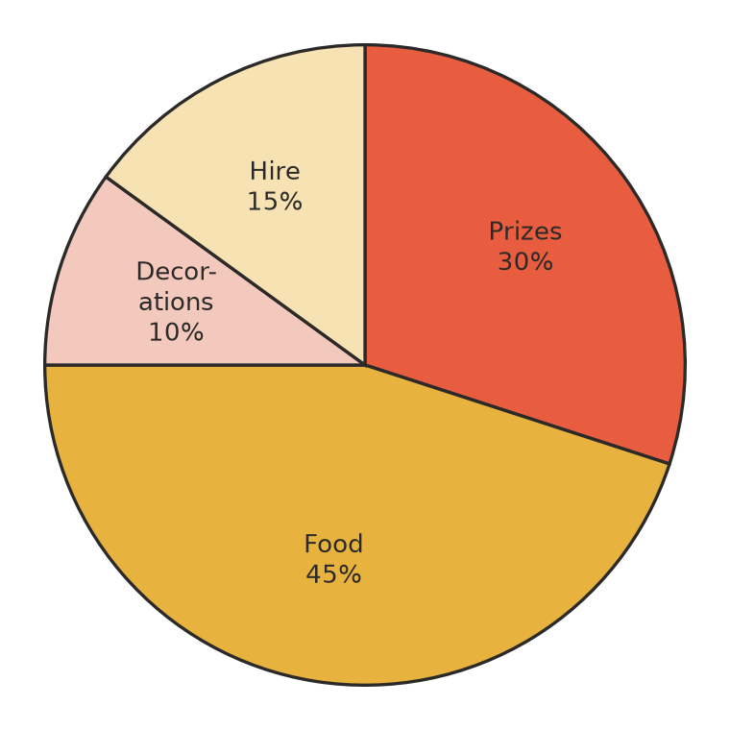
  - What was the biggest cost?
  - How much was spent on prizes?
  - How much more was spent on food than on hire?
- Seventy-two people were asked their favourite season.
- 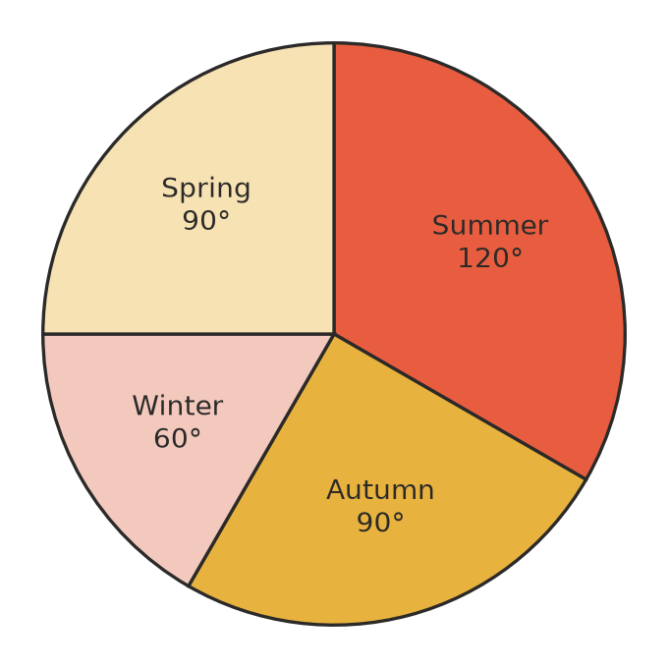
  - What fraction of the people chose summer?
  - How many people chose each season?
  - Check that your answers to b) add up to 72.

 Fluency
- Forty students chose their favourite elective.
Elective | Number of students
Music | 14
Sport | 12
Art | 8
Drama | 6
Total | 40

  - Each student gets 360° ÷ 40 = ______________° of the circle. Copy and complete the table.
  - Use a protractor to draw the pie chart in the circle. Start at the line that is drawn. Label every sector.
- 
- Change each percentage to an angle in a pie chart. (Hint: 1% of 360° is 3.6°.)
  - 25%
  - 10%
  - 35%
  - 30%
- A sector of a pie chart has an angle of 72°. What percentage of the data does it show?

 Reasoning
- Ella worked out the angles for her pie chart: 140°, 95°, 70° and 45°. Without drawing anything, how can you tell she has made a mistake?
- A pie chart for Hilltop School and a pie chart for Riverside School both have a “walk” sector of 90°. Jake says, “The same number of students walk to each school.” Is he right? Explain.
- Would you use a pie chart or a column graph to show the number of goals scored in each round of the footy season? Explain.

 Problem solving
- In a pie chart, a sector of 54° stands for 12 people. How many people were surveyed altogether? Show your working.
- Three sectors of a pie chart have angles of 100°, 130° and 75°.
  - What is the angle of the fourth sector?
  - The pie chart shows 72 people. How many people are in the 100° sector?
- A family spends $1200 a month. In a pie chart of their spending, the sector for rent is 150°. How much do they spend on rent?
- In a survey of 60 people, a pie chart shows that 45% chose camping as their favourite holiday. How many people chose camping, and what is the angle of that sector?

