16.05 Dot plots and column graphs
Year 7 Maths · Worksheet · Level 3 · Challenge
Name: ____________________ Date: ______________
This worksheet practises reading, drawing and comparing dot plots and column graphs, and writing about the shape, centre and spread of data. Shape words: symmetrical, positively skewed (tail to the right), negatively skewed (tail to the left), clusters, gaps and outliers. Tip: when you compare two data sets, compare a measure of centre (mean or median) and a measure of spread (range), and quote the numbers.

 Understanding
- The dot plot shows the screen time of 24 students on a school day. You may use a calculator.
- 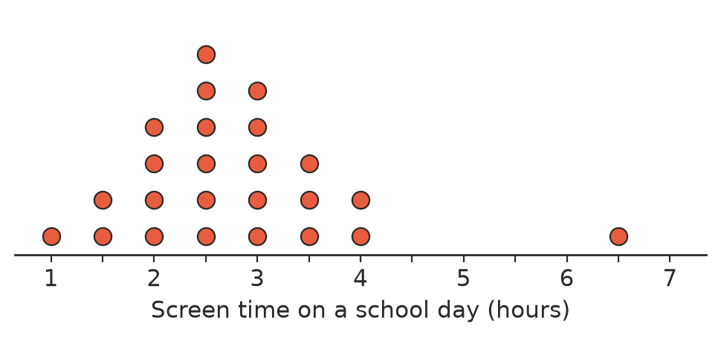
  - Find the mode, the median and the range. ______________
  - Find the mean, correct to 2 decimal places. ______________
  - Describe the shape of the data. ______________
  - Which measure of centre would you use to describe a typical student’s screen time? Explain.

- Fifteen students did a six-week fitness program. The dot plots show how many push-ups each student could do in one minute before and after the program.
- 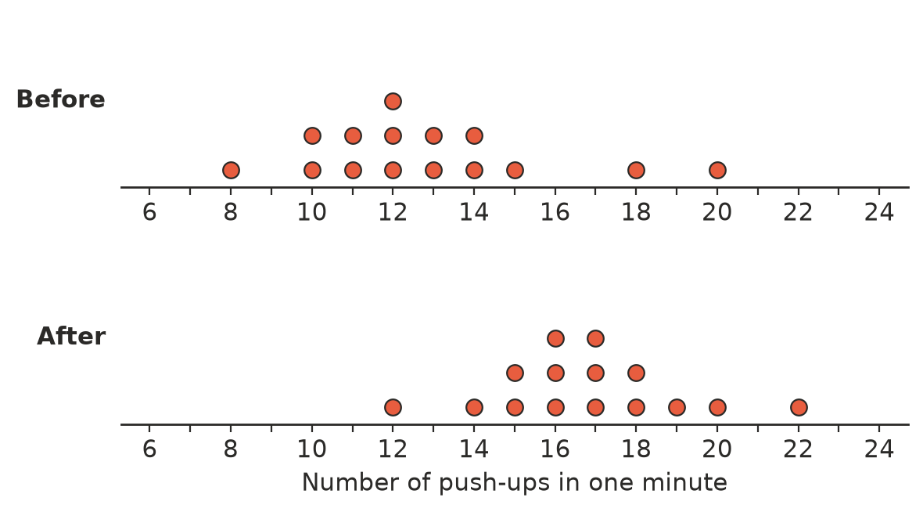
  - Find the median and range before and after. ______________
  - Did the program work? Write two or three sentences comparing the centre and spread of the two dot plots.

 Fluency
- The column graph shows the heights of the students in a Year 7 class. The data is grouped, so the columns touch.
- 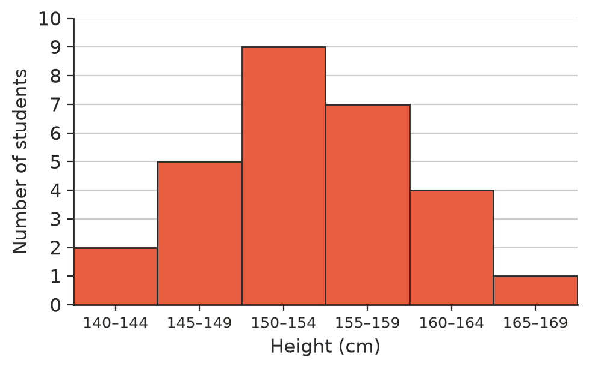
  - How many students are in the class? ______________
  - What is the modal class? ______________
  - In which class is the median height? ______________
  - What percentage of the students are 155 cm or taller? Round to the nearest whole percent. ______________
- The side-by-side column graph shows how 50 Year 7 students and 40 Year 8 students get to school.
- 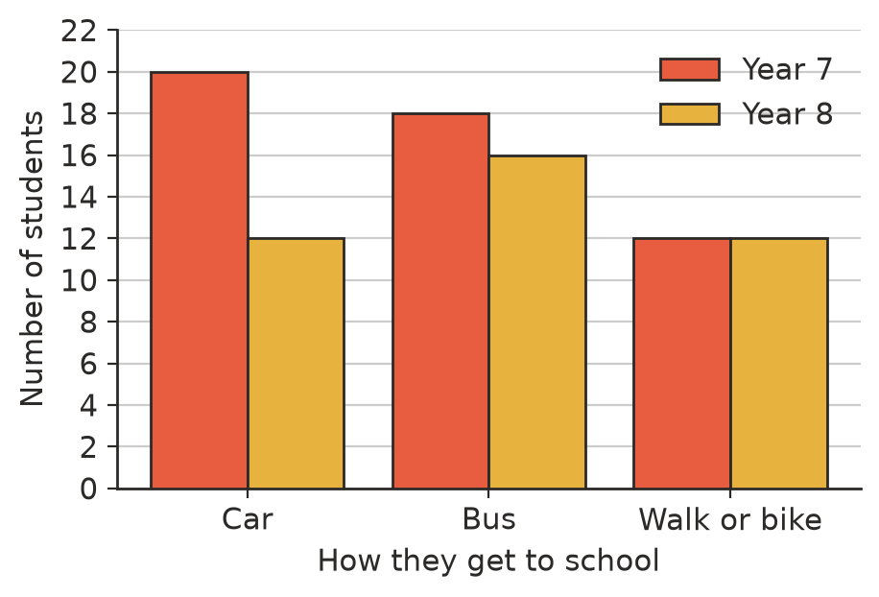
  - How many more Year 7 students than Year 8 students travel by bus? ______________
  - Which year group has the greater percentage of students who travel by bus? Show your working.

  - Why was the column graph for Question 3 drawn with no gaps between the columns, while this one has gaps?

- The canteen made this graph to show that lunch orders have “tripled”.
- 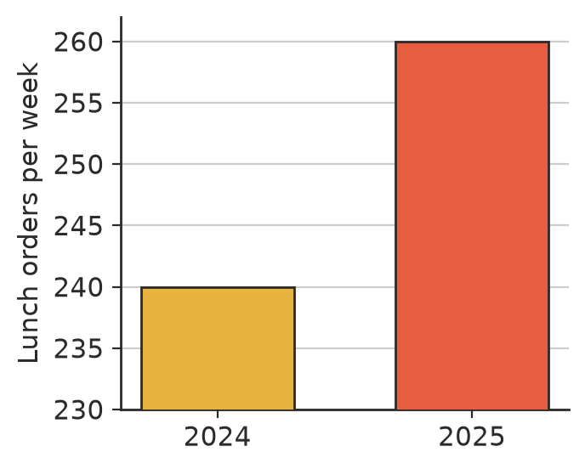
  - By how many orders a week did sales really increase? ______________
  - What was the real increase as a percentage of the 2024 orders? Round to 1 decimal place. ______________
  - Explain why the graph is misleading.

 Reasoning
- These are the numbers of letters in the first names of 25 students.
- 5, 4, 3, 6, 4, 5, 7, 5, 4, 3, 8, 5, 6, 4, 5, 6, 9, 5, 4, 5, 6, 3, 5, 7, 4
  - Draw a dot plot of the data.
- 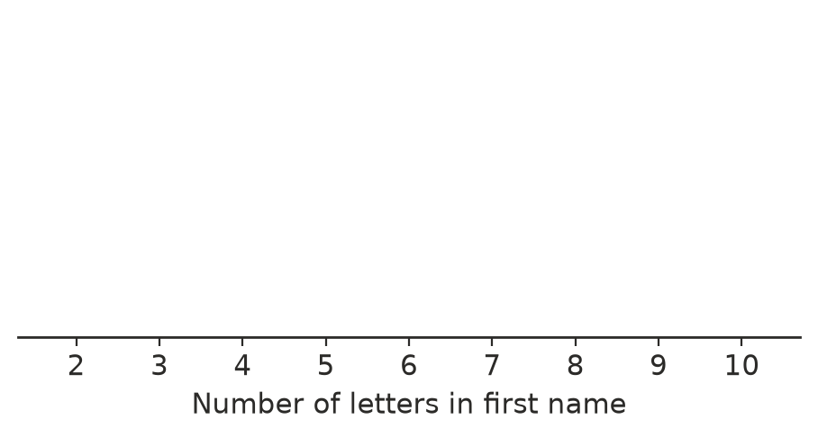
  - Write a short paragraph describing the shape, centre and spread of the data.

- Part of this dot plot is hidden. The mean of all the data is 4. How many dots are hidden above 5? Show your working.
- 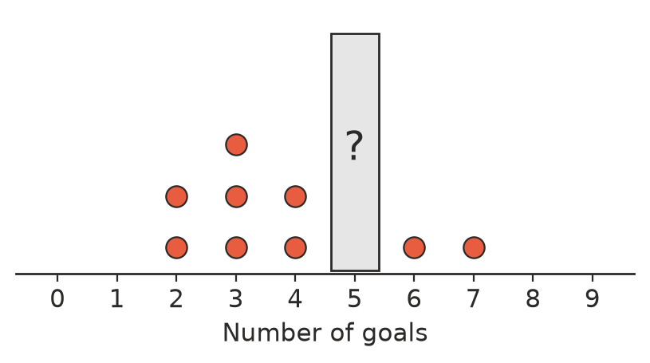

 Problem solving
- Nine whole numbers from 1 to 6 have a mode of 2, a median of 3, a mean of 3 and a range of 5. Draw their dot plot. (There is only one answer.)
- 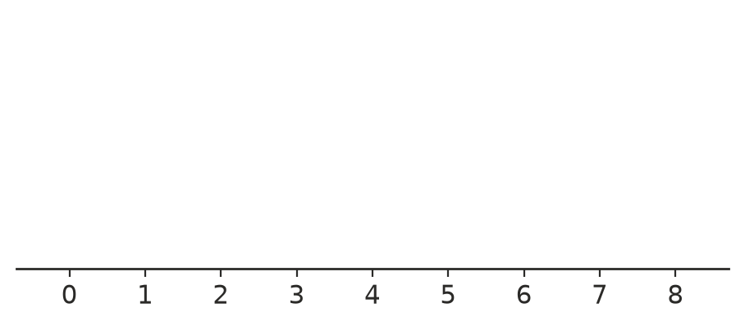

- A symmetrical dot plot of 20 values has a mean of 7 and a median of 7. A new value of 15 is added. Describe what happens to the shape, the mean, the median and the range. Calculate the new mean.

- A coach must choose one of two runners for a race. These are their last six times for 400 m (in seconds).
Runner | Times (s)
Mia | 62, 63, 61, 62, 64, 60
Ruby | 58, 66, 59, 67, 57, 65

  - Find the mean and the range of each runner’s times. ______________

  - Which runner would you choose? Justify your answer using the statistics. (Remember: a lower time is better.)

- A survey recorded the heights of 200 students to the nearest centimetre. Explain why a grouped column graph would be a better display than a dot plot.

- In Question 1 the mean is bigger than the median.
  - Explain why the mean is usually bigger than the median when data is positively skewed.

  - Write a data set of five values where the mean is smaller than the median. ______________

