16.05 Dot plots and column graphs
Year 7 Maths · Worksheet · Level 2 · Core
Name: ____________________ Date: ______________
This worksheet practises reading and drawing dot plots and column graphs, and describing the shape, centre and spread of data. Data can be symmetrical (both sides look about the same), positively skewed (bunched on the left with a long tail to the right) or negatively skewed (bunched on the right with a long tail to the left). Look out for clusters (groups of values), gaps and outliers too. Tip: the centre is described by the mean, median or mode; the spread by the range.

 Understanding
- The dot plot shows how many minutes late a school bus was on 20 mornings.
- 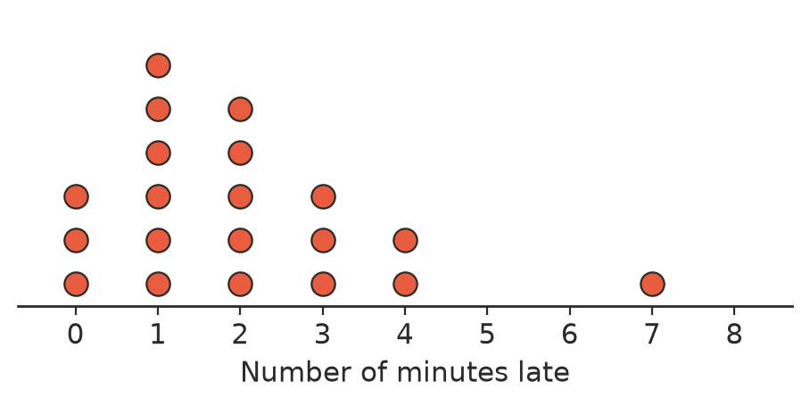
  - Find the mode and the median. ______________
  - Find the range. ______________
  - Find the mean. ______________
  - On what percentage of mornings was the bus more than 3 minutes late? ______________
  - Describe the shape of the data. ______________
- Twenty students did as many chin-ups as they could.
- 5, 7, 5, 3, 6, 7, 5, 4, 7, 6, 6, 6, 6, 6, 4, 5, 8, 9, 8, 7
  - Draw a dot plot of the data.
- 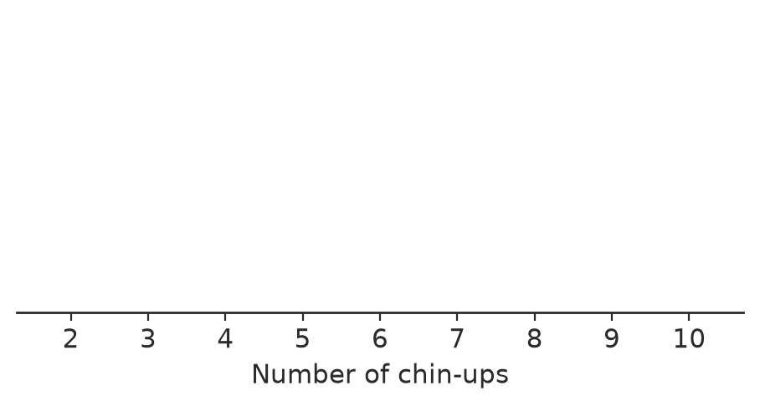
  - Describe the shape, centre and spread of the data.

 Fluency
- The column graph shows the number of goals a hockey team scored in each game of its season.
- 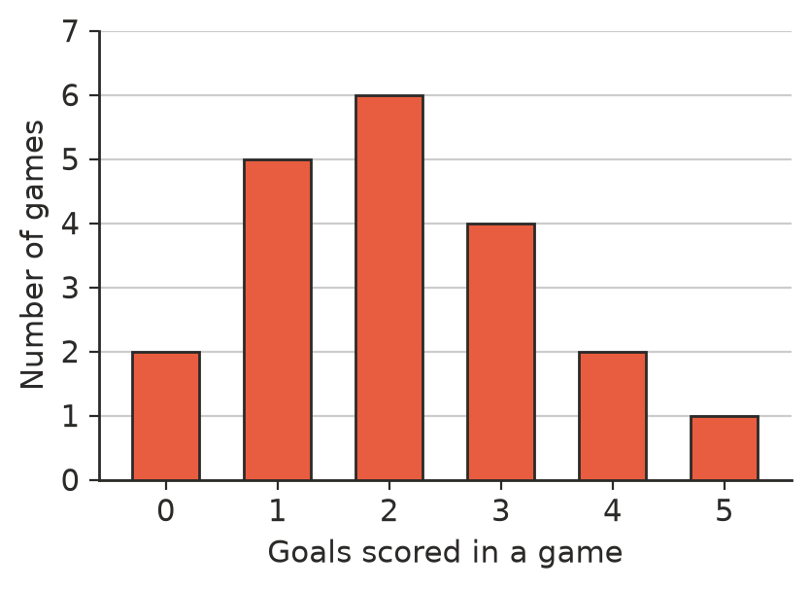
  - How many games did the team play? ______________
  - How many goals did the team score altogether? ______________
  - Find the mean number of goals per game. ______________
  - Find the median and the mode. ______________
- Draw a column graph of this data on the grid.
People in the car | 1 | 2 | 3 | 4 | 5
Number of cars | 8 | 12 | 6 | 3 | 1

- 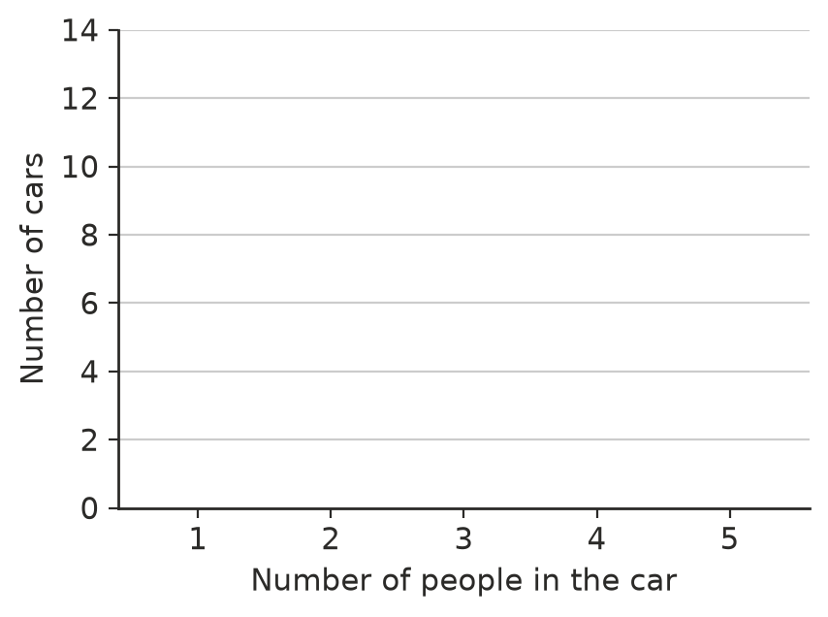
- Describe the shape of each dot plot. Choose from: symmetrical, positively skewed, negatively skewed, two clusters with a gap.
- 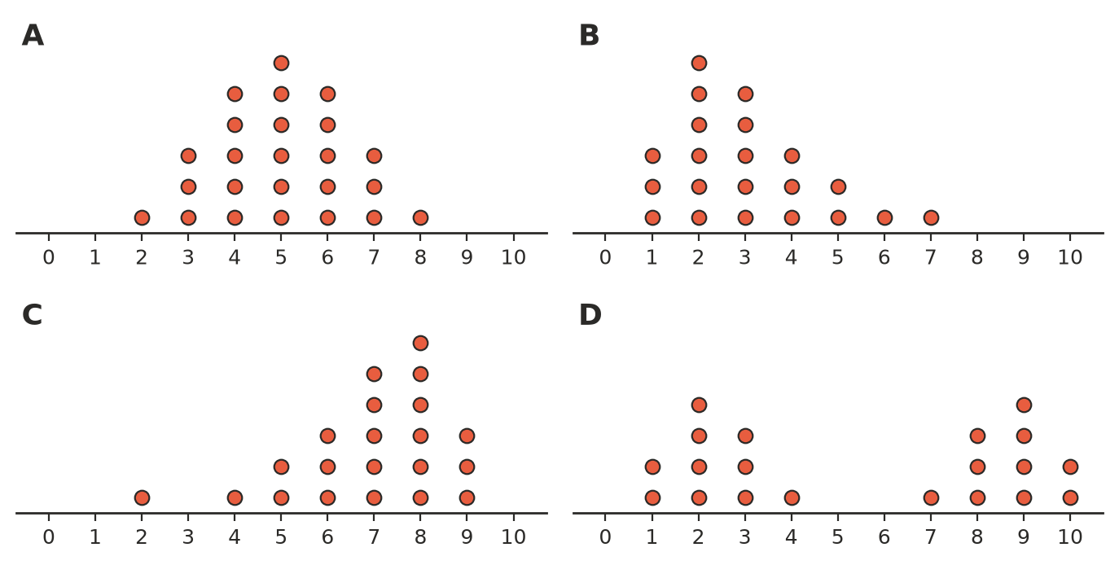
  - A ______________
  - B ______________
  - C ______________
  - D ______________

 Reasoning
- A company made this graph to compare its sales with another company’s.
- 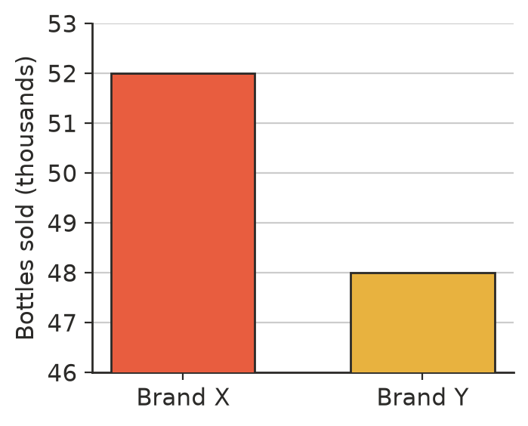
  - From the heights of the columns, Brand X looks about how many times bigger than Brand Y? ______________
  - How many bottles did each brand really sell? ______________
  - Explain why the graph is misleading, and how to fix it.

- The dot plots show the scores of two classes on the same quiz.
- 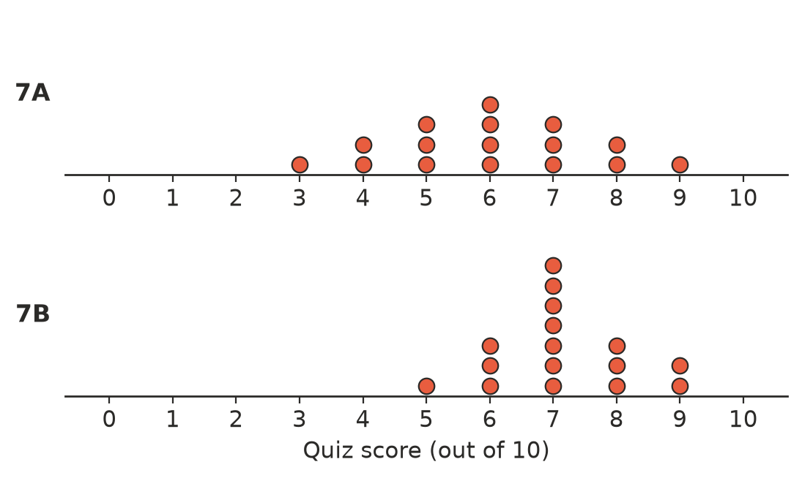
  - Find the median and range for each class. ______________
  - Compare the two classes. Which class did better overall, and which class was more consistent? Use the statistics.

 Problem solving
- Thirty students were asked their favourite sport. The column for tennis is missing. Work out its height and draw it in.
- 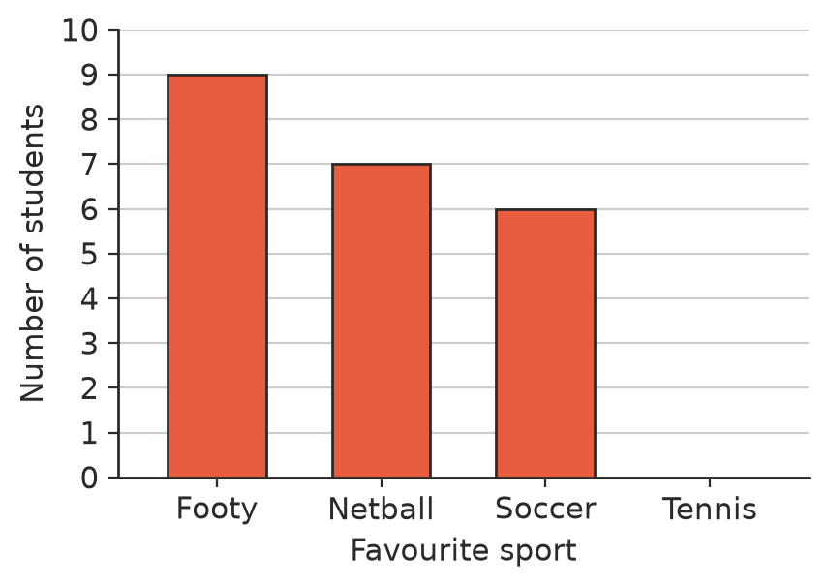
- Tennis: ______________
- Draw a dot plot of 10 values on the number line so that the mode is 4, the median is 5 and the range is 6.
- 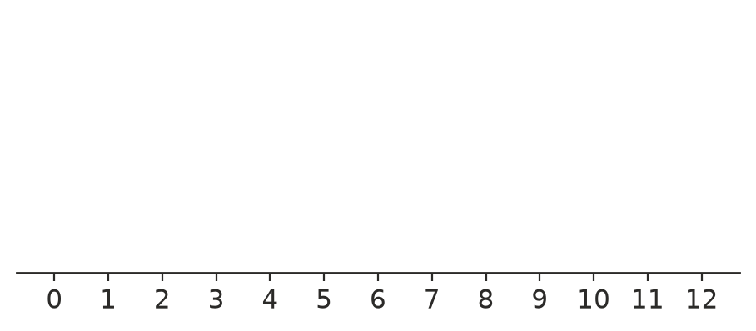
- Choose the best display for each data set: dot plot or column graph. Give a reason.
  - the favourite type of music of 50 students

  - the number of pets owned by each of 20 students

  - the number of tourists who visited Uluru in each month of last year

- Use the hockey graph in Question 3. In what percentage of games did the team score 3 or more goals? ______________
- A dot plot of 15 values has a median of 6. Two new values, 2 and 11, are added. What is the new median? Explain.

