16.05 Dot plots and column graphs
Year 7 Maths · Worksheet · Level 1 · Warm-up
Name: ____________________ Date: ______________
This worksheet practises reading and drawing dot plots and column graphs. In a dot plot, each dot stands for one piece of data, stacked above a number line. In a column graph, the height of each column shows a frequency. Tip: space the numbers evenly along the axis, and give every graph labels on both axes.

 Understanding
- The dot plot shows how many books some students read in the holidays.
- 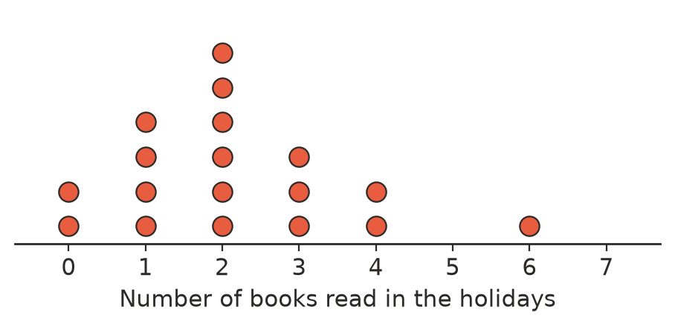
  - How many students are shown? ______________
  - What is the mode? ______________
  - How many students read more than 3 books? ______________
  - What is the range? ______________
  - What is the median? ______________
- The number of people living in 12 households is: 2, 4, 3, 3, 5, 2, 4, 3, 6, 3, 4, 2
- Draw a dot plot of the data on the number line.
- 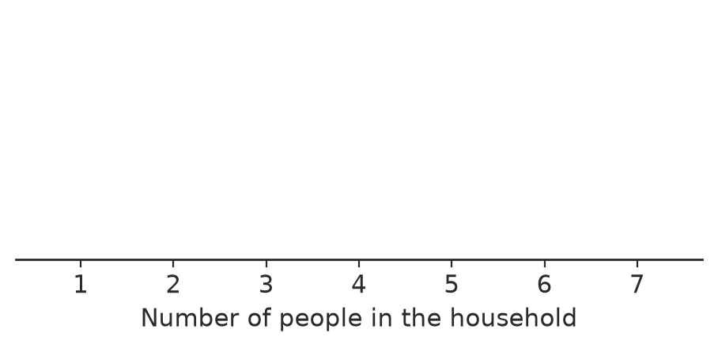

 Fluency
- The column graph shows the favourite sports of a group of students.
- 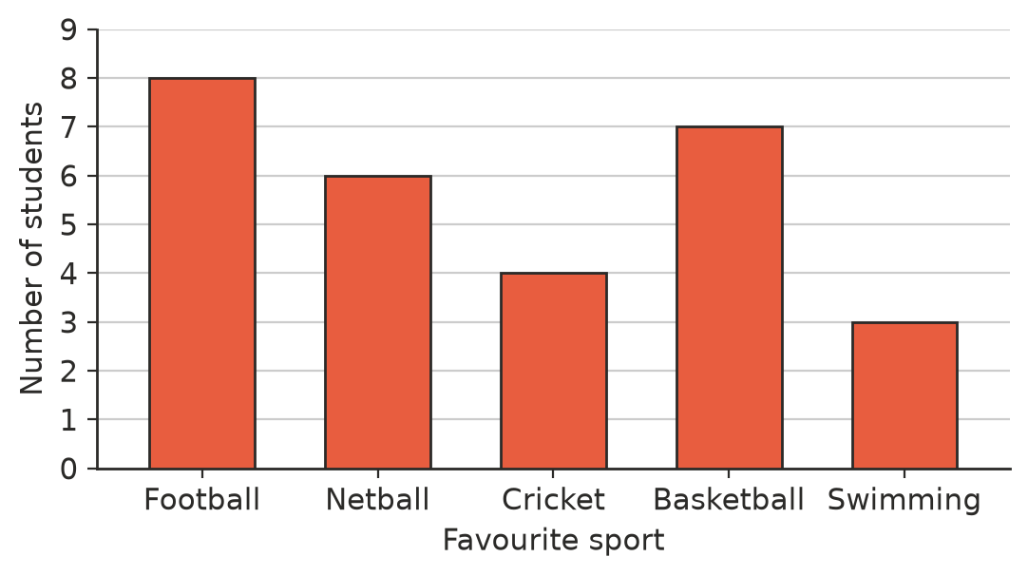
  - Which sport is the most popular? ______________
  - How many students chose basketball? ______________
  - How many students were surveyed? ______________
  - How many more students chose football than cricket? ______________
- A shop sold these ice creams one afternoon. Draw a column graph of the data on the grid.
Flavour | Chocolate | Vanilla | Strawberry | Mango
Number sold | 9 | 5 | 4 | 6

- 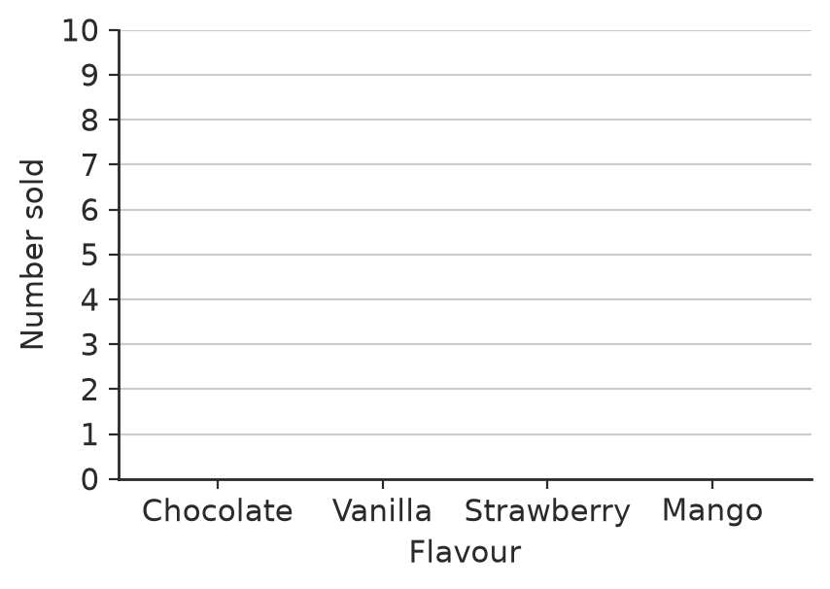
- The column graph shows how many siblings the students in a class have.
- 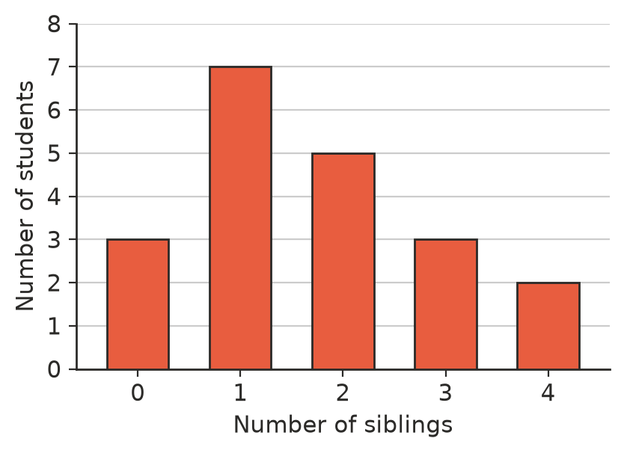
  - How many students are in the class? ______________
  - What is the mode? ______________
  - How many students have 2 or more siblings? ______________

 Reasoning
- Match each dot plot to its description.
- 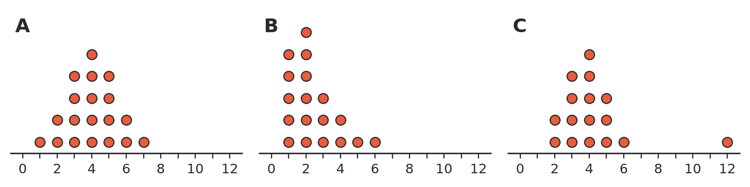
  - Symmetrical: the two sides look about the same. ______________
  - Has an outlier. ______________
  - Skewed: most of the data is bunched at one end, with a long tail on the other side. ______________
- Ben drew a dot plot with the numbers 0, 1, 2, 5, 6 evenly spaced along the line, leaving out 3 and 4 because no data had those values. Why is this a problem?

- Would you use a dot plot or a column graph for each data set? Explain one of your choices.
  - the favourite colours of 30 students ______________
  - the number of goals scored in 15 netball games ______________

 Problem solving
- Draw a dot plot of 8 values on the number line below so that the mode is 5 and the range is 3.
- 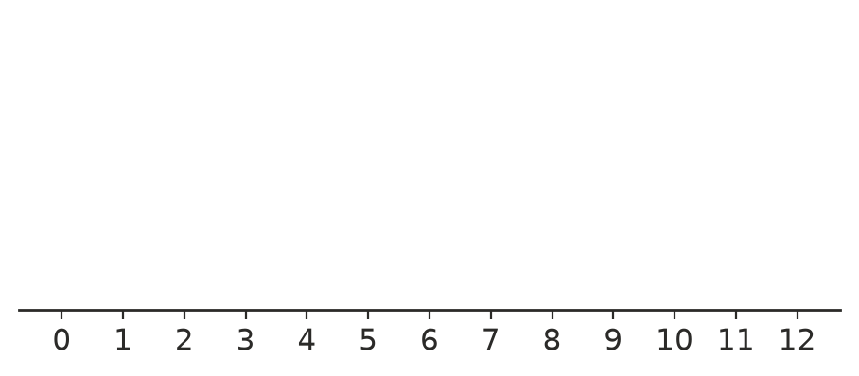
- Use the column graph in Question 3. What fraction of the students chose netball? Simplify your answer.

